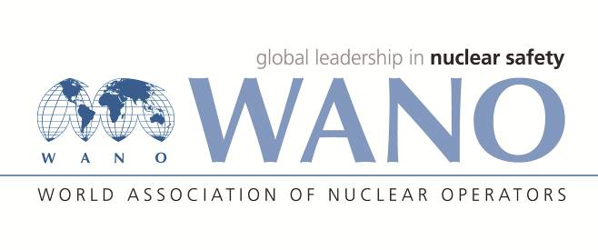 | World Association of Nuclear Operators  Moscow Centre  WANO – MC  25 Ferganskaya st, Moscow, 109507, Russia  Phone. +7 495 376 15 87  Fax: +7 495 376 08 97  info@wanomc.ru

REQUEST
to provide technical and organizational information via WANO.

- NPP/Organization: Bohunice NPP
- Information request topic: Unexpected employees loss

- Information request objective: Organizational rules in case of unexpected employees loss taking into account safe operation of NPP.

- Problem description:
An unexpected drop in more employees due to various reasons. This concerns for specific groups e.g. shift workers, Main Control Room crew, maintenance groups during outages, etc. Those situations could have impact to ability safely operate units and could affect Nuclear Safety.
- Specific questions:
- Are you considering at your NPP what to do with units when there is a lack of employees for safe units operation (for example due to epidemic, strikes, …)?
- Are you ready for situations when for example a half of MCR crew will not be able to get to work?
- Do you have some instructions what to do in this specific situation?
- Organizations proposed for distribution of this request:
WANO Centers (Moscow, Atlanta, Paris, Tokyo)
- Department – request initiator:
Nuclear Safety, Mr. Peter Mihalička, Bohunice NPP

- Contact details of the requester:
peter.mihalicka@seas.sk , radovan.mraz@seas.sk
- Request date: 30.01.2018

Bohunice WANO On-site representative Radovan Mráz

