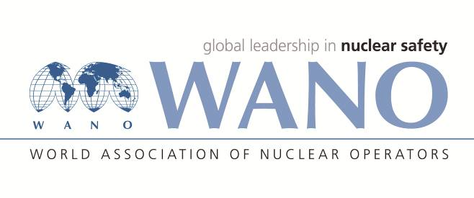
REGISTRATION FORM
WANO Moscow Centre Training Seminar
«Nuclear Safety Culture»
«Mosuzcentr Hotel»,
http://www.uzhotel.ru/
September 20-23, 2016
Family name: | MOAZZENJAHROMI
First name: | MOHSEN
Date of birth: | 25/06/1969
Place of birth: | JAHROM
Citizenship: | IRANIAN
Organization: | Nuclear Power Production & Development Co. of Iran
Organization address: | No.8, Tandis Str., Africa Ave., Tehran, Iran
Position: | Substitute of Deputy Plant Manager for Safety
Mobile phone: | +989173713411
Phone/Fax: | +987731112589/+987731112586
E-mail: | bnpp@nppd.co.ir
Passport number: | K38089368
Date of issue: | 15/08/2016
Date of expiry: | 16/08/2021
Do you need an invitation letter for entry visa (YES/NO): |  | YES
City with Russian Consulate (for visa application): |  | TEHRAN
Do you want us to book the hotel for you in Moscow? («Mosuzcentr Hotel) |  | YES
Please send a copy of the picture page of your passport (a scanned copy in JPEG format) to Seminar coordinators (please see the contact details below).

Date / Flight / Time/Airport of arrival in Moscow
Tuesday – September 20, 2016; Morning; Flight No.SU513, Sheremetyevo Airport
Date / Flight / Time/ Airport of departure from Moscow
Friday – September 23, 2016; Night; Flight No.SU512, Sheremetyevo Airport

Please send the completed form to the Seminar Coordinators by August 01, 2016.
WANO-MC Coordinators:
Sergey Lesin  Tel: +7 495 221 02 83  Fax: +7 495 376 15 87  E-mail: lesin@wanomc.ru  Andrey Lukyanenko  Tel: +7 495 221 03 07  Fax: +7 495 376 15 87  E-mail: lukianenko@wanomc.ru | Anna Tatarinova  Tel:+7 495 221 02 78  Fax:+7 495 376 08 97  E-mail: tatarinova@wanomc.ru

