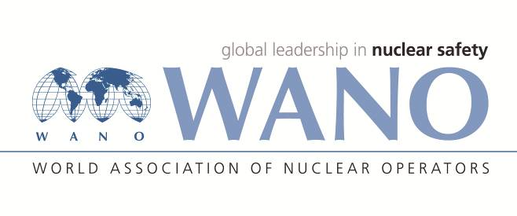 | Московский центр  Всемирная Ассоциация Организаций, эксплуатирующих Атомные Электростанции  ВАО АЭС – МЦ  Россия, 109507, Москва, Ферганская ул., 25  Тел. +7 495 376 15 87  Факс: +7 495 376 08 97  info@wanomc.ru

REQUEST
to provide technical and organizational information via WANO

- NPP/Organization:
Rivne NPP / SE NNEGC "Energoatom"
- The topic of information request:
Repair of the VAZ 215/109-6AM05 electrical motor's rotor (RCP drive)
- The goal of information request:
List of defects detected during operation of rotor of the VAZ 215/109-6AM05 electrical motor;
List of latent defects identified during repair of the VAZ 215/109-6AM05 electrical motor's rotor
- Description of the problem:
Necessity of repair with replacement of rotor winding in VAZ 215/109-6AM05 electrical motor (RCP drive)
- Questions:
- Do you repair VAZ 215/109-6AM05 electrical motors' rotors with replacement of the rotor winding at the plant?
- What is the scope of repair works?
- Did you claim on quality of rotor winding replacement work due to defects detected during operation or further outages?
- Do you still operate repaired (with rotor winding replaced) VAZ 215/109-6AM05 electrical motors?
- Have you replaced VAZ 215/109-6AM05 electrical motors' rotors? If the answer is "yes", why?

- Proposed organizations for sending this request:
VVER-1000 plants
- Department – request initiator:
Maintenance department, SS "Rivne NPP"
- Contact details of the requester:
Oleg Khalandach, tel. + 380 3636 64 5 68, HaON@rnpp.atom.gov.ua
- Date of request:
09.08.2021

