

M o s c o w C e n t r e
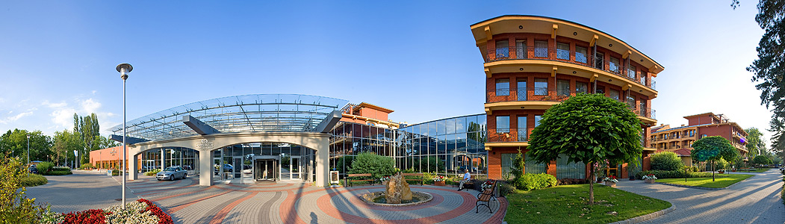

PROGRAMME
of
WANO-MC Governing Board Meeting,
Extraordinary General Meeting
and
Directors’ Meeting

20 - 24 April 2015

Siofok

Hungary
20 April, Monday
 | Participants and accompanying persons arrive in Budapest. Airport pickup and transfer  to hotel | Per schedule
 | Hotel Check-in (Azur Hotel) | Participants of WANO-MC Directors’ and Governors’ Meetings and Accompanying Persons
14:30  15:00 | Light Dinner in Azur Hotel
19:00 | Dinner in the restaurant  Azur Hotel

21 April, Tuesday
Time
07:00 | Breakfast | Participants of WANO-MC Directors’ and Governors’ Meetings and Accompanying Persons
08:30  10:20 | WANO-MC Directors’ Meeting | Participants of WANO-MC Directors’ Meeting
10:20  10:40 | Coffee Break | Participants of WANO-MC Directors’ Meeting
10:40  12:00 | WANO-MC Directors’ Meeting | Participants of WANO-MC Directors’ Meeting
12:00  13:00 | Lunch | Participants of WANO-MC Directors’ Meeting
13:00  15:10 | WANO-MC Directors’ Meeting | Participants of WANO-MC Directors’ Meeting
15:10  15:30 | Coffee Break | Participants of WANO-MC Directors’ Meeting
15:30  17:40 | WANO-MC Directors’ Meeting | Participants of WANO-MC Directors’ Meeting
9:00  16:00 | Accompanying persons tour programme | Accompanying persons
18:00 | Participants Depart for Dinner | Participants and accompanying persons
19:00-22:00 | Dinner in Anna Grand Hotel Ballroom | Participants of WANO-MC Directors’ and Governors’ Meetings and Accompanying Persons

22 April, Thursday
Time
07:00 | Breakfast | Participants of WANO-MC Directors’ and Governors’ Meetings and Accompanying Persons
08:30  09:50 | WANO-MC Directors’ Meeting | WANO-MC Directors’ Meeting Participants
09:50  10:10 | Coffee Break
10:10  12:00 | WANO-MC Directors’ Meeting | WANO-MC Directors’ Meeting Participants
12:00  13:00 | Lunch | Participants of WANO-MC Directors’ and Governors’ Meetings
13:00  13:30 | WANO-MC Extraordinary General Meeting | WANO-MC General Meeting Participants
13:30  15:00 | WANO-MC Governing Board Meeting | WANO-MC Governors’ Meeting Participants
15:00  15:20 | Coffee Break
15:20  17:30 | WANO-MC Governing Board Meeting | WANO-MC Governors’ Meeting Participants
09:00  16:00 | Accompanying persons tour programme | Accompanying Persons
17:50 | Participants Depart for restaurant | Participants of WANO-MC Directors’ and Governors’ Meetings and Accompanying Persons
18:30  21:30 | Dinner in the Füred Catamaran Ship Restaurant | Participants of WANO-MC Directors’ and Governors’ Meetings and Accompanying Persons

23 April, Thursday
Time
07:00 | Breakfast | Participants and accompanying persons
08:00  14:30 | Visit to Paks NPP | WANO-MC Directors’ and Governors’ Meetings Participants
08:00  16:00 | Accompanying persons tour programme | Participants and accompanying persons
17:30 | Participants depart for dinner | Participants of WANO-MC Directors’ and Governors’ Meetings and Accompanying Persons
19:00  21:00 | Dinner in the Rádpuszta Restaurant | Participants and accompanying persons
 | Participants return to Hotel

24 April, Friday
Time
7:00 | Breakfast | Participants and accompanying persons
 | Departure per Schedule | Participants and accompanying persons

