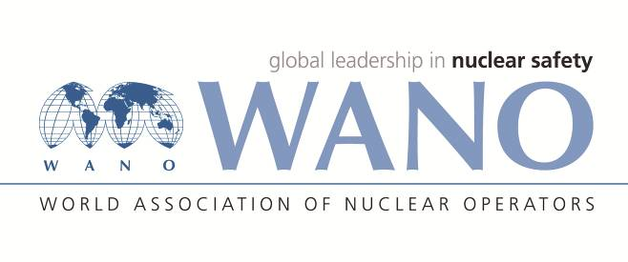 | World Association of Nuclear Operators  Moscow Centre  WANO – MC  25 Ferganskaya, Moscow, 109507, Russia  Phone. +7 495 376 15 87  Fax: +7 495 376 08 97  info@wanomc.ru

REQUEST
to provide technical and organizational information via WANO

NPP/Organization: Kudankulam NPP
1.The topic of information request:
Information request on spent fuel storage level measurement below the pipe penetration available in the fuel pool.
2.The goal of information request:
To get information for improvement from other member plants.
3.Problem description:
The fuel pool is provided with process connection at +8.7 mtr and continuous level measurement through analog sensor is available from +8.7 mtr. For measuring the level below +8.7 mtr, level switches are provided which works on impedance variation (resistance variation or conductivity based) principle. These switches are mounted through Stainless Steel tubes supported on the Stainless Steel lining on the fuel pool walls. For any maintenance on these switches the fuel pool section has to be drained as the removal of these sensors require cutting of the bottom tip.
4.Specifis questions:
- What is the type of sensor(measuring principle and make) used for monitoring level below the process tapping point(when process tapping point is available from fuel pool, the level transmitter tapping can be taken from these process tappings and level can be measured based on head (pressure) of the water column. Below process tappings head(pressure) measurement through impulse tubing is not possible) available in spent fuel storage pool.
- What are the qualifications available for these sensors for making it qualified for using in spent fuel storage application.
5.Proposed organizations for sending this request:
WANO MC, PC, AC,TC
6.Department – request initiator: Control Maintenance Unit
7.Contact details of the requester:

8.Date of request: 13.01.2020

