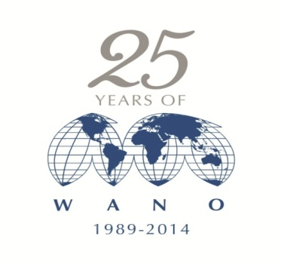

**World Association of Nuclear Operators  
Moscow Regional Centre**

**Approved by**

**66thWANO-Moscow**

**Centre Governing Board**

**Sandor Nagy**

*WANO-MC Governing Board Chairman*

*April 2015*

**WANO-MC Advisor Selection Committee Session**

**MINUTES**

17 March 2015

Moscow



In February-March 2015, WANO-MC Secretariat conducted the competition to fill seconded positions of WANO-MC advisers in the WANO-MC Office according to the WANO-MC Long Term Business Plan approved by the 55th WANO-MC Extraordinary Governing Board Meeting and WANO-MC and Coordinating Centre Secondment Policy.

A Selection Committee comprising WANO-MC Office and WANO-MC member representatives was set up and approved by the WANO-MC Chairman. The Selection Committee members included as follows:

**Chairman:** **Anatoly Lupishko,** Deputy Director General, VNIIAES OJSC

**Co-Chairman: Vasily Aksenov,** WANO-MC Director

**Committee Members: Anatoly Kirichenko,** First Deputy Director, WANO-MC

**Sergey Frolov,** Deputy Director, WANO-MC

**Sergey Vybornov,** Deputy Director, WANO-MC

**Vadym Tarykin,** Coordinator**,** WANO-MC Improvement

The Selection Committee met in Moscow on 17 March 2015. Video conference and office interviews were held on 05 February / 16 March and 10 February / 27 February 2015, respectively.

The Selection Committee considered the information on competition members presented in writing (application forms, resumes, interviewed competitors, and thoroughly discussed the competitors’ compliance with the Secondment Policy criteria for WANO-MC seconded positions and positions of WANO-MC Representative in Coordinating Centre with due account of the specific nature of work in London and Moscow Offices and in WANO-MC On-Site Representations.

The following competitors were selected to fill the seconded positions in WANO-MC Office and positions of WANO-MC On-site Representatives:

|  | **Name** | **Previous or Current Position, NPP/Utility** | **Nomination for WANO-MC position** |
| --- | --- | --- | --- |
| **1.** | **Yang Dong** | European Equipment Oversight Group, Tianwan NPP | Category В Advisor |
| **2.** | **Gao Haiyang** | Operator, Nuclear Iceland, Tianwan NPP | Category В Advisor |
| **3.** | **Evgeny Turilov** | Shift Supervisor, Reactor/Turbine Hall, Bilibino NPP | Category B Advisor |
| **4.** | **Dmitry Chichikin** | Deputy Quality Assurance Director, Kola Affiliation, Atomenergoremont OJSC | Category A Advisor |
| **5.** | **Janos Turanski** | Lead Engineer, Nuclear Fuel, Paks NPP | Category В Advisor |

As a result of discussions the Selection Committee **agreed as follows:**

1. With due account of the specific nature of WANO-MC Secretariat activities the following nominees to fill the position of WANO-MC Advisers will be submitted for WANO-MC Governors’ approval:

|  | **Name** | **Previous or Current Position, NPP/Utility** | **Nomination for WANO-MC position** |
| --- | --- | --- | --- |
| **1.** | **Gao Haiyang** | Operator, Nuclear Iceland, Tianwan NPP | Category В Advisor |
| **2.** | **Evgeny Turilov** | Shift Supervisor, Reactor/Turbine Hall, Bilibino NPP | Category B Advisor |
| **3.** | **Dmitry Chichikin** | Deputy Quality Assurance Director, Kola Affiliation, Atomenergoremont OJSC | Category A Advisor |
| **4.** | **Janos Turanski** | Lead Engineer, Nuclear Fuel, Paks NPP | Category В Advisor |

1. WANO-MC Secretariat will prepare necessary materials for consideration / approval of the decision of the WANO-MC Advisor Selection Committee at the WANO-MC Governing Board Meeting in April 2015.

**Chairman:** **Anatoly Lupishko**

**Co-Chairman: Vasily Aksenov**

**Committee Members: Anatoly Kirichenko**

**Sergey Frolov**

**Sergey Vybornov**

**Vadim Tarykin**