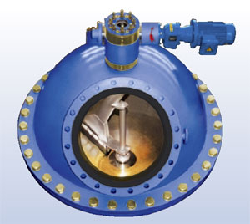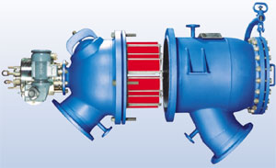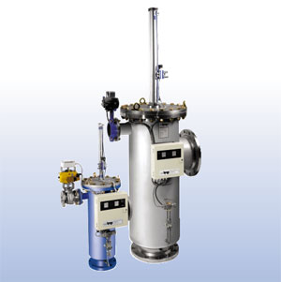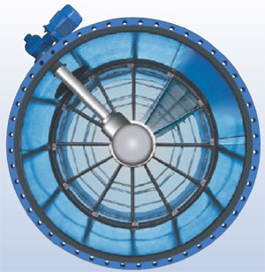

**QUESTIONNAIRE**

**TAPROGGE** intact-logo

## Automatic High-Performance Backwash Filter

##### ➀ Project Details and Contact

|  |  |  |  |  |  |  |  |  |  |  |  |  |  |  |  |  |  |  |  |
| --- | --- | --- | --- | --- | --- | --- | --- | --- | --- | --- | --- | --- | --- | --- | --- | --- | --- | --- | --- |
| **1** | **Operator** | |  | | | | | | | | | | | | | | | | |
| **2** | **Power Station** | |  | | | | | | | | | | | **Turbine no.** | | |  | **MW** |  |
| **3** | **Type** | | ❑ | Nuclear | ❑ | Hydro | | | ❑ | Thermal | ❑ | CCPP | | **Year of Construction** | | | |  | |
| **4**  ***please tick* 🗷 *relevant field*** | **Contact person** | |  | | | | | | | | | | **Title/function** | | |  | | | |
| **5** | **Phone** |  | | | | | **Fax** |  | | | | | **E-mail** | |  | | | | |

**➁ Basic Data required for Proposal**

|  |  |  |  |  |  |  |  |  |  |  |  |  |  |  |  |  |
| --- | --- | --- | --- | --- | --- | --- | --- | --- | --- | --- | --- | --- | --- | --- | --- | --- |
| **6** | **Project / Ref. no.** |  | | | | | | | | | | | | | | |
| **7** | **Number of Filters** |  | | | | | | | | | | | | | | |
| **8** | **TAPROGGE Reference** |  | | | | | | | | | | | | | | |
| **9** | **Type of cooling water** | ❑ | sea | ❑ | river | | ❑ | brackish | | ❑ | cooling tower | | ❑ | well | | |
| **10** | **CW Flow rate** | **min.** | |  | | **normal** | | |  | **max.** | |  | | | kg/s / m³/h | |
| **11** | **Pipe connection – nominal diameter** | | | **inlet DN** | |  | | | | **outlet DN** | |  | | | | |
| **12** | **Operating / design pressure** | | |  | | | | | |  | | | | | | bar |
| **13** | **Operating / design temperature** | | |  | | | | | |  | | | | | | °C |
| **14** | **Required filter perforation** | | |  | | | | | | | | | | | | mm |

**➂ Additional Data**

|  |  |  |  |  |  |  |  |  |  |  |  |  |  |  |  |  |  |
| --- | --- | --- | --- | --- | --- | --- | --- | --- | --- | --- | --- | --- | --- | --- | --- | --- | --- |
| **15** | **Type of cw prescreening** | ❑ | travelling band screens | | | | ❑ | coarse screens | | | ❑ | fine screens | | | ❑ | skip rakes | |
| ❑ | other: |  | | | | | | | | | | | | | |
| **16** | **Chemical treatment of CW?** | ❑ | chlorination | | ❑ | ferrous sulfate | | | ❑ | phosphate | | | ❑ | acids | | | |
| **17** | **Type of debris** | ❑ | sand | | ❑ | silt | | | ❑ | mussels | | | ❑ | concrete | | | |
| **18** | ❑ | plastic | | ❑ | wood | | | ❑ | fibres | | | ❑ | algae | | | |
| **18** | **Max. particle size** |  | | | | | | | | | | | | | | | mm |

**➃ Filter Design**

***please tick* 🗷 *relevant field***

|  |  |  |  |  |  |  |  |  |  |  |  |  |  |  |  |  |  |  |  |  |  |  |  |  |  |  |  |  |  |  |  |  |  |  |  |  |
| --- | --- | --- | --- | --- | --- | --- | --- | --- | --- | --- | --- | --- | --- | --- | --- | --- | --- | --- | --- | --- | --- | --- | --- | --- | --- | --- | --- | --- | --- | --- | --- | --- | --- | --- | --- | --- |
| **19** | **Design code** | ❑ | ASME | ❑ | European standard | | | | | | ❑ | | | others | | | | |  | | | | | | | | **Flanges** | |  | | | | | | | |
| **20** | **TAPROGGE Standard accepted?** | | | | | | **Δp System** | | | | | | | ❑ | | Yes | | | | | | ❑ | | No | | **Actuators** | | | ❑ | | Yes | | | ❑ | | No |
| **21** | **Discharge flap** | | | | | | ❑ | | Yes | | | | | | ❑ | | No | | | | | | | | | | | | | |
| **22** | **Location of filter** | | | | | ❑ | indoors | | ❑ | outdoors | | | | | | | | | | | | | | | | | | | | | | | | | | |
| **23** | **Location of control panel** | | | | | ❑ | indoors | | ❑ | outdoors | | | | | | | | | | | | | | | | | | | | | | | | | | |
| **24** | **Voltage / type of enclosure** | | | | |  | | | | | | V | | | | |  | | | | | | | | | | | **Ex proof** | | | | |  | | | |
| **25** | **Plant drawings submitted?** | | | | | ❑ | Yes | ❑ | No | | | **Water analysis submitted?** | | | | | | | | | | | | | | | | ❑ | | Yes | | | ❑ | | No | |
| **26** | **Specification available?** | | | | | ❑ | Yes | ❑ | No | | | **Delivery date required** | | | | | | | | | | | | | | | |  | | | | | | | | |
| **27** | **Condenser tube cleaning system installed?** | | | | | | | | | ❑ | | Yes | | | | | | ❑ | | No | | | | | **Head loss of condenser** | | | | | | |  | | | | |

|  |  |
| --- | --- |
|  |  |
| filled up by: | place, date: |

**Remarks:**