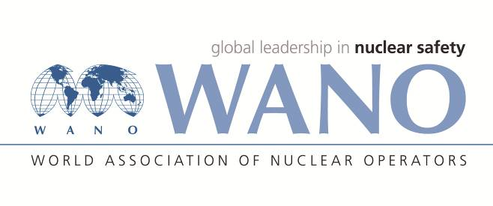 | World Association of Nuclear Operators  Moscow Centre  WANO – MC  25 Ferganskaya, Moscow, 109507, Russia  Phone. +7 495 376 15 87  Fax: +7 495 376 08 97  info@wanomc.ru
REQUEST
to provide technical and organizational information via WANO

- NPP/Organization: Jiangsu Nuclear Power Corporation, Tianwan NPP
- The topic of information request:
The operating hand wheel of main steam valve get stuck
- The goal of information request:
During the full power operation, the operating hand wheel of low pressure main steam valve actuator (2MAC02AE140) of steam turbine of Tianwan nuclear power plant get stuck, which affected the partial travel test of the main steam valve. Our maintenance plan is to manually close the 2MAC02AE140/240 actuators and valves during the power operation, then fully dismantle the whole hand wheel parts. We hope to get information from VVER colleagues.
- Specific questions:
1)The current partial trip test of the valve of unit 1 / 2 is conducted once a week. How long is the current test frequency of your plant? Can it be optimized for once a month?
2) Does your Plant has similar defects of actuator operating hand wheel stuck, and how to handle them during power operation?
3) Can the partial travel test of the main steam valve be paused in case of operating hand wheel failure? How long can the pause last?
4) Is the maintenance plan above feasible? What emergency measures need to be taken if it is feasible? How long can the state of the closing of actuator and valve last online?

- Proposed organizations for sending this request:
VVER NPPs
- Department – request initiator:
Maintenance branch, Tianwan NPPP.
- Contact details of the requester:
Mr. Fang Xiaofeng, maintenance branch
Tel. (office): +86 518 82205556
E-mail: fangxf@cnnp.com.cn
- Date of request: 06.09.2021

