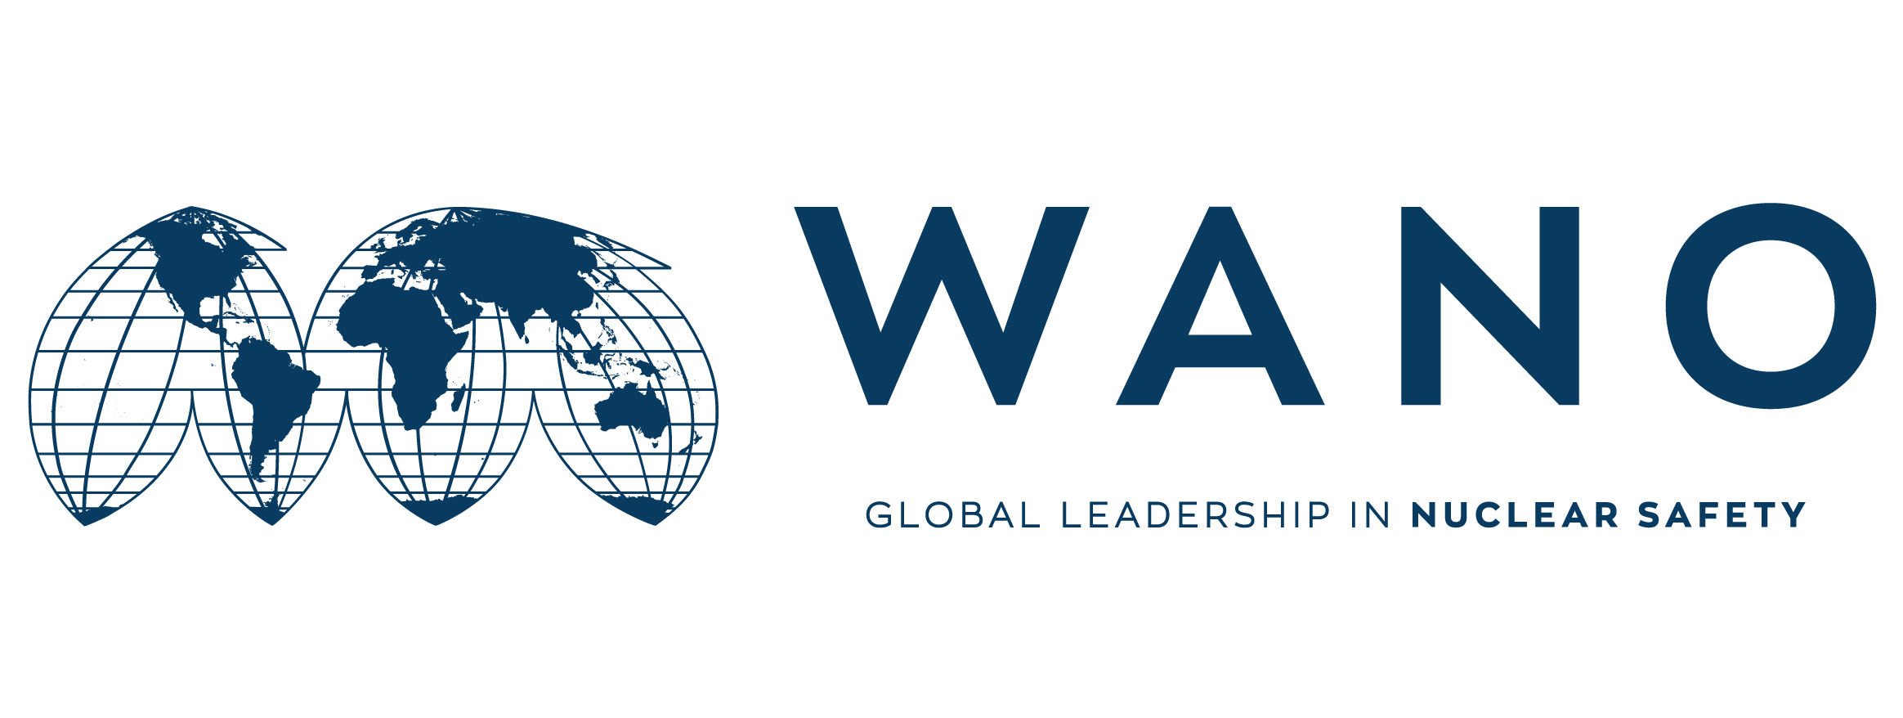 | Moscow Centre  WANO-MC  25 Ferganskaya, Moscow, 109507, Russia  Phone: +7 495 376 15 87  Fax: +7 495 376 08 97  info@wanomc.ru

MSM expert personal form

General information

MSM place: Nuclear Power Production & Development Co. of Iran (NPPD Co.)
MSM topic: Improving Communication Process
MSM date: 21-25 February 2022
MSM working language: English
MSM leader (MC coordinator): Semenenko Oleg
Phone number: +7 495 2210273
e-mail: semenenko@wanomc.ru

Expert data

Name | Vera
Surname | Lukiyanova
Date of birth | 28.02.1971
Place of birth | Novovoronezh
Citizenship | Russian Federation
Passport number  (please send the scan copy) | 75 9822716
Passport issue date | 29.12.2018
Passport expire date | 29.12.2028
Job Title | Adviser
Station | n/a
Company / Organization | WANO Moscow Centre
Work Address | Moscow, Ferganskaya street 25
Telephone | +7 (495) 376 15 87
Home address | Moscow Skobelevskaya 1/7-13
Fax | +7 (495) 376 08 97
Work e-mail | lukyanova@wanomc.ru
Personal e-mail | lukyanova_vera@mail.ru
Mobile phone | +7 906 722 25 80
Laptop brand and serial number | DELL Latitude 7320  7SJSZ33
Size of clothing  Shoes  Height | 44  39  169
Presentation title | WMC Communications

Technical experience in the MSM area
International communications at Novovoronezh for 9 years
International communications at Rosenergoatom for 18 years
International communications at WMC for 2 years

Foreign languages knowledge

Native language(s) | Russian
Foreign languages | Poor | Medium | Good | Excellent
English |  |  |  | x
Others: 1)
2)
3)

