

WANO Moscow Centre
WANO MC ANNUAL REPORT
Performance Analysis Programme

Table of Contents

CHAPTER 1. EXECUTIVE SUMMARY.………………………....................................................................4
CHAPTER 2. SUBMISSION OF MC AFFILIATED PLANT EVENT REPORTS TO WANO……………………....6

GENERAL DATA OF MC REPORTING……...……………………....…………………………………………….…...6

MC EVENT CLASSIFICATION BY SIGNIFICANCE………..…………………………………………….……..…..11

ON-SITE SAGETY-SIGNIFICANT EVENT REPORTS…………………………………..……………………….….16

CHAPTER 3. ANALYSIS OF MC AFFILIATED PLANT EVENT TRENDS..…………………………….…………....24

EVENT ANALYSIS BY AREAS OF OPERATIONS……………………………………………………………..….….24

EVENT CAUSE ANALYSIS AS PER WANO CLASSIFICATION…………..….……………………….………...28
CHAPTER 4. DISSEMINATION AND USE OF WANO OPERATING EXPERIENCE IN MC..….……….….…34

OE PIBLICATIONS IN 2018……………………………………………………………………………………………....34

DISSEMINATION OF WANOE EVENT REPORTS IN MC……………………………………………………...35

OE INFORMATION EXCHANGE DURING SEMINARS AND MEETINGS……………………..….…..…35

OE INFORMATION EXCHANGE IN MC UPON TECHNCIAL REQUESTS………………………….…....36
CHAPTER 5. SOER RECOMMENDATIONS IMPLEMENTATION IN MC..……….…………………………….…39
CHAPTER 6. OE PROGRAMME INDICATORS..………………..………………………………………………….…..….47

APPENDIX 1. MC WERS FOR 2018………………………………………………………………………………..……….…..…50

APPENDIX 2. WANO SIGNIFICANT OPERATING EXPERIENCE REPORTS (SOER).…….……………….…..….65

APPENDIX 3. WANO SIGNIFICANE EVENT REPORTS (SER)…………………………………….………………….……67

APPENDIX 4. TECHNICAL REQUESTS FROM PLANTS AND COMPANIES……………………………………......70

CHAPTER 1. EXECUTIVE SUMMARY

In September 2016, in the course of reorganization of the WANO London Office (LO) the Performance Analysis Programme (PAP) was established by means of combining the existing Operating Experience programme and the Performance Indicators sub-programme. Furthermore, the Industry Analysis programme was also included into the PAP. This sub-programme focuses on identification and analysis of the industrial trends as well as in-depth review of the WANO membership performance.
In the subsequent years the WANO regional centers adapted their organizational structure in order to incorporate the PAP in their own activities.
In October 2018, the Performance Analysis Programme was established in the MC.
The MC PAP consists of the following three sub-programmes:
- Operating Experience;
- Performance Indicators;
- Industry Analysis.
The MC Operating Experience programme and the Performance Indicators sub-programme were combined into the PAP with no change and to the full extent. It is expected that the main functional areas for the new Industry Analysis sub-programme will be as follows:
- Identification and analysis of industrial trends;
- In-depth review of membership performance.
At present, a PAP manual is being developed, and issues of efficient interfaces with the other WANO MC programmes and the site representatives are being discussed.
This report presents results of the main activities of the WANO MC Secretariat in terms of the PAP in the year 2018, inter alia:
- submission, to the WANO MC members, of the event reports (WER);
- analysis of event trends in the MC affiliated plants;
- dissemination and use in the MC of the WANO operating experience;
- implementation of the SOER recommendations in MC.
In the period from 1989 to 2018, 2 895 reports of the events in the WANO Moscow Center affiliated plants were published within the PAP. The WANO global OE database includes 29 050 plant event reports from all the regional centers.
The WANO MC contribution to the common database is approximately 10 % of the total reports number. In the meantime, the «weight» of the power units being in operation in the WANO MC, is 17 % (78 units) of the total number of the world’s operating power units (449).
For each area of the main activities, the report presents the results achieved in the year 2018 and the current issues; where possible, further actions were identified for the purpose of improvement.
Results of the main activities within the Performance Indicators sub-programme are not included in the report and will be documented in a separate report.
The report also includes the indicators of the OE sub-programme and the MC OE indicators/other WANO regional indicators comparative analysis.
Following the WANO MC internal assessment in 2016, an area for improvement (AFI) was identified as to the problem of a low number of the event reports being submitted to the WANO by the MC affiliated plants. In 2018, the WANO MC internal assessment follow-up was conducted. Following the assessment follow-up, the AFI status was assessed to be on track.

CHAPTER 2. SUBMISSION OF MC AFFILIATED PLANT EVENT REPORTS TO WANO

GENERAL DATA OF MC REPORTING
During the calendar year, works were carried out to provide the WANO MC affiliated members with the WANO event reports (WER) which by virtue of their causes or consequences are noteworthy for the other WANO members.
In 2018, the WANO MC prepared and published, in the WANO Operating Experience DB, 357 reports (WER), i.e. 64 reports more than in the year 2017, which amounts to 13 % of the total number of the reports submitted by all the WANO regional centers. In addition, in 2018 the number of the MC reports increased from 3.8 to 4.5 reports per unit. In spite of significant visible progress, the MC is still behind the other regional centers with this indicator: the centers have at least 6 reports per unit.
Event Reports (WER and PWER) from WANO RCs for 2014-2018
Year | АC | МC | PC | ТC | Total
2018 | 847 | 357 | 1013 | 612 | 2829
2017 | 1393 | 289 | 1023 | 601 | 3306
2016 | 1533 | 274 | 1134 | 478 | 3419
2015 | 1443 | 273 | 1038 | 329 | 3082
2014 | 1098 | 194 | 882 | 178 | 2352
Percentage (%) in 2018 | 30 | 13 | 36 | 21 | 100
Number of reports per unit in 2018 | 6,7 | 4,5 | 6,9 | 6,1 | 6,3
Number of operating units | 125 | 78 | 147 | 99 | 449
Number of silent units in 2018 | - | - | - | - | -

Timeframes for Publication of Reports (WER) at RC in 2014-2018 (days)
Year | АC | МC | PC | ТC
2018 | 103 | 102 | 165 | 93
2017 | 116 | 112 | 156 | 128
2016 | 118 | 102 | 133 | 126
2015 | 99 | 108 | 127 | 118
2014 | 89 | 117 | 133 | 119

The recommended deadline for publishing the reports (WER) in the WANO OE DB is 140 days from the event identification. As compared with the year 2017, one can observe a decline of the median value for duration of the report issue from 112 down to 102 days. Since the year 2016, this MC indicator has been the best one among the indicators of the WANO regional centers.

Timeframes for Publication of Preliminary Reports (РWER) at RC in 2014-2018 (days)

Year | АC | МC | PC | ТC
2018 | 23 | 1 | 35 | 32
2017 | 42 | 2 | 29 | 128
2016 | 14 | 2 | 61 | 123
2015 | 23 | 2 | 58 | 54
2014 | 3 | 3 | 82 | 38

The recommended deadline for uploading the preliminary event reports (РWER) to the WANO OE DB is 30 days from the event identification. During the recent 5 years, the MC has had the best PWER submission deadline indicator among the WANO regional centers where the 2018 median value being one (1) day. In 2018, 105 preliminary event reports were uploaded. As of the end of 2018, 20 reports still have a preliminary status and shall be subject to data updating and information packing within 140 days from the event identification. Of 357 posted events, 59 events occurred in 2017 and 298 events - in 2018.
As a result of efficient interactions with the nuclear power plants and other organizations, during the recent years there were no silent units in the MC (i.e. units for which no event information is provided over one or more years). In 2018, for all MC affiliated nuclear power units (Atomflot included) the event reports were provided.
The diagrams below show trends for posting the on-site event reports by the WANO MC and other regional centers.
Тrends of WANO MC Event Reporting to WANO in 2006-2018
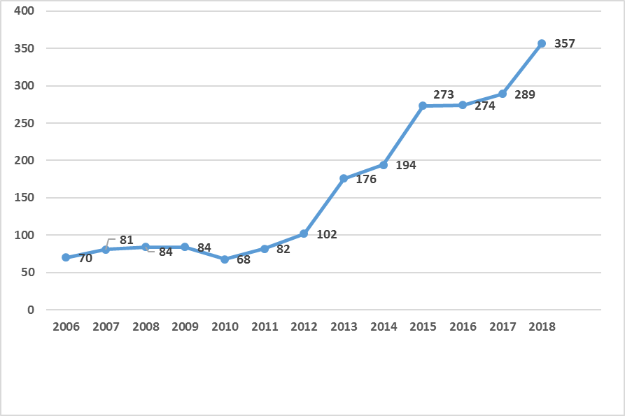
In 2018, one can observe a significant improvement (approximately by 25 %) in the WER reporting from the MC affiliated plants, as compared with the period of 2015-2017. In 2018, an average value for the MC reports per unit was 4.5, which is a lot more than the level of the year 2017 (3.8 reports per unit). This was achieved as a result of implementation of a number of the activities as well as more effective interfaces of the MC Secretariat with the plant, Atomflot and plant support organization representatives. Amongst the above activities are:
- continuous interactions with the sites in order to receive the preliminary event reports;
- quarterly analysis of the site representative reports and provision of the feedback following the event reports;
- a member support mission at Temelin on the topic of Implementation of Internal and External Operating Experience;
- a follow-up visit to Kudankulam and discussion of the issue of obligations in terms of site event reporting as requested by the WANO regulatory documents.
Plant Event Reporting from All RCs in 2013-2018
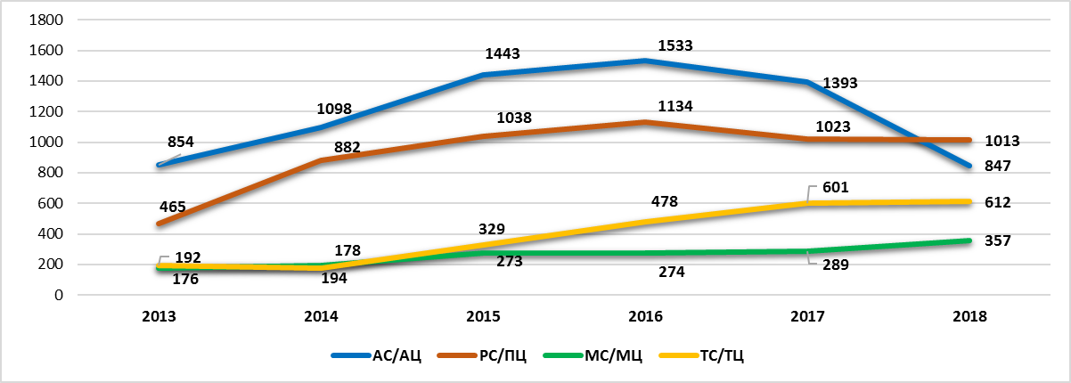
Appendix 1 contains a WANO MC WER list for the year 2018.
WER Distribution by MC Sites in 2016-2018
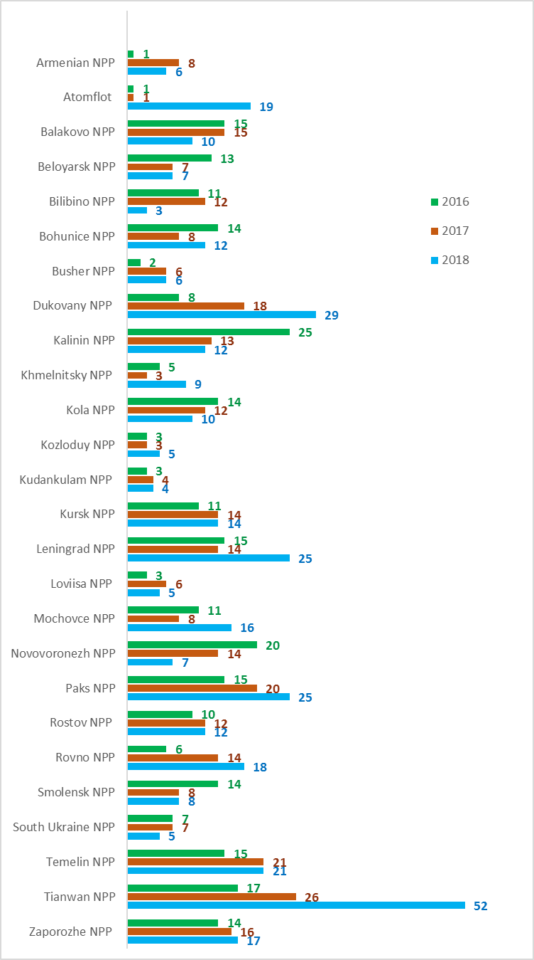
As compared with the year 2017, in 2018 a smaller number of the event reports (WER) was observed at the following six plants: South-Ukraine, Novovoronezh, Loviisa, Kalinin, Bilibino and Balakovo.
The indicator for 15 power units is 2 reports per year. The indicator for nine power units (South-Ukraine 1 and 2, Kalinin 4, Leningrad 3, Bilibino 4, Balakovo 4, Novovoronezh 4, Rostov 3, Loviisa 1) is one (1) report per year, which is a lot less than the mean value. In 2017, three power units showed this low indicator. South-Ukraine 1 is the only MC unit whose indicator, for the second consecutive year is one report per year. All these units are in the WANO worst quartile as to the event reports.
Moreover, according to analysis of the available information not all events that occurred at these plants and potentially fall within the established reporting criteria were reported in the WANO OE DB for the purpose of review and lessons learning by the other WANO members.

As for the positive trends, in 2018 one must note a significant increase in the number of WERs from Tainwan, Dukovany, Paks, Rovno, Leningrad and Atomflot. The reporting indicator of Tainwan 1, 2 and 3, Temelin 1, Leningrad-II 1 and Atomflot is in average 3-4 times higher than the MC mean value (4.5 event/unit per year). For example, Atomflot provided 19 WERs per year; Tainwan 3 - 16 WERs per year; Tainwan 1, 2 and Temelin 1 – 15 WERs each per year.

WER Distribution Per Unit By MC Countries in 2016-2018
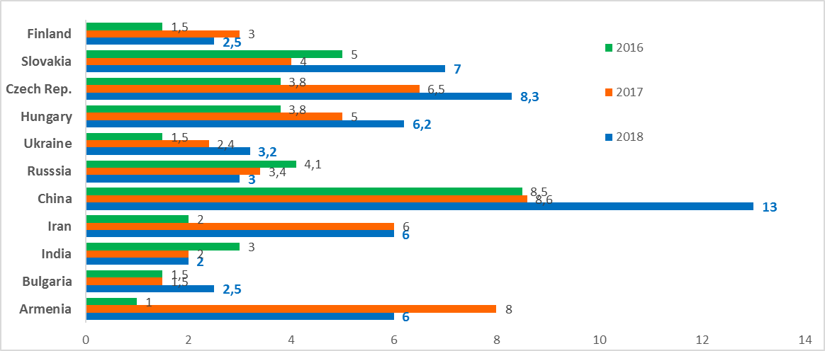
As compared with the year 2017, one can observe a significant improvement in the report number per unit in the following countries: China, Czech Republic, Slovakia and Hungary.
The highest increase in event reporting is observed at the plants of China and Czech Republic: from 8.6 reports per unit in 2017 to 13 and from 6.5 reports per unit to 8.3, accordingly.
In 2018, 108 events were reported by the plants of Russia, and for the two recent years a trend of decline is observed, i.e. from 4.1 to 3.0 reports per unit.
In spite of insignificant increase in the number of event reports from the plants of Bulgaria and Ukraine in 2018, the reporting indicators of the units in these countries still remain well below the MC mean value.
The number of reports from Loviisa is observed to be lower as compared with the year 2017.
During the recent two years, the reporting indicator for the plants of Armenia and Iran was stable, i.e. on the average 6 WERs per year.

MC EVENT CLASSIFICATION BY SIGNIFICANCE

All events being uploaded to the WANO OE DB are reviewed and analyzed in the WANO London Office by the Performance Analysis Central Team (PACT) to determine, inter alia, their significance with consideration of the following four levels: Significant, Noteworthy, Trending and Other.
The classification is based upon the event type, severity and consequences as well as probability of more severe consequences.

MC Plant Event Distribution by Significance in 2014-2018
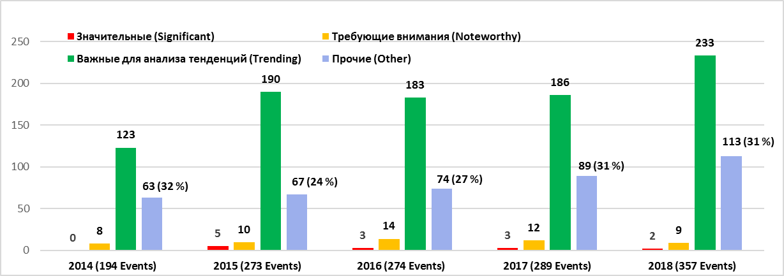

In 2018, 11 significant and 88 noteworthy events were reported cumulatively by all regional centers.
In 2018, two (2) fatalities on the MC affiliated plants were caused by electric shock and classified as significant:
– WER MOW 18-0094 A contracted maintenance worker entered a room via a switch actuator room. He climbed the switch actuator, got over the air ducts and found himself at an inadmissibly short distance from the conductive parts being under voltage 20 kV. The event resulted in a fatality.
Below are the event causes:
- Unauthorized entrance to the room of the operating electric facility; lack of self-control.
- Insufficient control of actions of the contracted personnel (personnel routes, and cargos, materials and fittings transportation etc.) in the plant territory.
– WER MOW 18-0126 A contracted team performed works associated with dismantling/mounting of the voltage transformers in a high-voltage line 330 kV in the territory of an open switchyard 330 kV. Two team members being in a sky-lift cradle performed operations on mounting of the earthing knives of the 330 kV HVL A phase voltage transformer. In the course of the operations, the worker disconnected a warning protection clamp and thus came under 330 kV HVL induced voltage. The event resulted in a fatality.
In 2018, nine (9) events in the MC affiliated plants were classified as noteworthy.
– Two (2) of them are associated with the nuclear safety impact:
During the operation at 10 %, a gas temperature increase was detected in two cells of a pressure tube integrity monitoring system. The power unit was shut down by a fast power reduction key and brought to a four-month outage for investigating the primary leak causes. The event causes were 1) non-detection of defects of the pressure tube welds and 2) inefficient diagnostics. WER MOW 18-0167.
During the unit outage, maintenance and diagnostics works were under way at a substation 120 kV when actuation of a short circuit-to-earth protection caused a full loss of off-site power (LOOP) at a unit No. 3. A direct cause was use of an improper bus isolator for diagnostic works at the substation 120 kV, which resulted in a short circuit through a temporary earthing. An event root cause was not identified. WER MOW 18-0267.
– One (1) event is associated with the plant reliability impact:
During the operation at nominal power, a plant unit was disconnected from the grid because of a liquid in a generator’s stator housing. A direct cause was loss of leak-tightness of a nozzle flanged connection and a generator’s stator active-steel cooling-system box. WER MOW 18-0225.
– One (1) event is associated with the radiological safety:
An event resulted in unplanned radiation exposure as a result of improper handling, by a worker, of a source during metal radiography inspection. The received dose was 1.228 mSv. The event causes were 1) non-compliance with the established radiological safety codes and standards; 2) non-compliance with ALARA principles and lack of self-control requested for error prevention. WER MOW 18-0193.
– Five (5) events are associated with the industrial safety:
Four of them were linked to electric safety, and there was a risk of severe/fatal injuries in relation to electric shocks.
For example, in one case contracted personnel started their work in the area of high voltage 400 kV without necessary permissions. The works were terminated by an electric department employee who saw a crane arm extended above a high-voltage line 400 kV. The event could have severe consequences. The event root causes were 1) violation of the electric safety codes and standards for operations in high-voltage areas; 2) non-compliance with regulatory requirements; 3) inappropriate supervision over contractors. WER MOW 18-0201.
In the other case, a worker came under voltage 1000 V during the transformer testing. The event is noteworthy due to probability of a severe injury or a fatality. The event root cause was violation of a procedure of works at electric facilities. WER MOW 18-0350.
During the plant outage, in the course of maintenance of RTZO-type unilateral-maintenance three-phase distribution assemblies being under voltage an operator received electric burns of his face and left hand as a result of a short circuit. The event is noteworthy due to the high risk of the worker’s severe injury. The event contributing factor was a fact that structurally a row of the RTZO-type assembly terminals had open conductive parts, which is a condition for a short-circuit during operations with a cabinet. WER MOW 18-0306.
During the normal operation, in the course of switchings between the high-voltage sections a short circuit occurred, which led to a loss of external power and violations of the safe operation limits and conditions (LCO). There was a risk of a fatality or a personnel injury due to a flashover. WER MOW 18-0251.
In the other case, during the plant outage three contracted workers received burns of different body parts in the process of operations relating to checking of the generator’s gas system tightness. The workers were transported and administered to a hospital. There was a risk of severe consequences or a fatality. WER MOW 18-0258.

According to the analysis, 7 out of 11 MC events classified as significant and noteworthy as well as 6 out of 233 events classified as trending are linked to industrial safety. Certain events resulted in electric shock related injuries including fatalities. Results of the event analysis show the following causes and contributing factors:
- Workers demonstrated self-complacency, inappropriate work practices and unacceptable behaviours, and ignored or violated the electric safety procedures, standards and requirements. The examples are: non-use of PPEs, non-fulfillment or improper performance of the voltage checks, entrance to the zones or rooms not identified by the work performance documents, and accidental contacts with the energized equipment.
- Human errors occurred due to the lack of training, knowledge and practical experience or insufficient use of error prevention tools, in particular as a result of inefficient pre-job briefings.
- Administrative or physical barriers were not used or were insufficient. They include gaps in the work supervision, e.g. risk assessment, lack of procedures and lack of enclosures or warning signs to mark the highly hazardous areas.
- Insufficient monitoring and supervision over the work of both plant personnel and contracted workers.

The plants still have problems in providing safety at preparation to and performance of the works on the electric components, and in learning lessons. The MC Secretariat recommends its members to get familiarized with the above mentioned event reports and other related documents, and to consider the learned lessons and corrective actions in order to identify appropriate measures for preventing similar events. Furthermore, following the analysis of nuclear industry trends in July 2018 a Hot Topic report HT 2018-2 on electric safety was issued by WANO.

233 MC events of the year 2018 were classified as trending. In the most cases these events resulted in unplanned automatic or manual reactor trips, unplanned safety systems actuation or degradation. Some events resulted in partial loss of off-site power, violations of Technical Specifications and application of emergency operating procedures.
About 35 % оf all the events (996 of 2829) reported by all regional centers in 2018 were classified as other, and as a rule these events were excluded from the scope of the WANO LO review due to insignificance of their consequences. In 2018, about 31 % of the MC events were classified as other. Their portion in TC was 54 %, in AC - 34 % and in PC - 26 %. In AC and PC one can observe a sharp drop of the portion of the other events (e.g. in PC - from 41 % to 26 %); this trend is stable in MC, i.e. its level is 31 %, and during the recent two years more than a half of the TC events were classified as other.
27 (7.5 %) events that occurred at the MC affiliated plants in 2018 were linked to SOERs or SERs, which means deficiencies in implementing the lessons learned from the significant operational experience reports (SOER and SER). Six (6) events showed shortcomings in implementing Recommendation 3 in SOER 2013-1 Deficiencies in the Adherence to Operator Fundamentals. Below are main deficiencies:
- Requirements towards the fundamentals are not established or not communicated to the operators;
- Operations leads (e.g. plant shift supervisors, operations manager and technical directors) do not always monitor efficiently the adherence to the fundamental principles of the operator performance. These activities can include supervision over the reactivity change associated operations, safety system component and safety-related system checks, and low-frequency operations as well as the operators doing the equipment inspections.
One event from this category was caused by serious deficiencies in the personal work and was classified as noteworthy due to loss of external power and electric shock risk. An electrician switched over a short-circuit device without switching an unlocking bridge over to a servicing position, which resulted in the short circuit. The event root causes were 1) poor communications, 2) non-compliance with the documentation, 3) non-use of error prevention tools, 4) lack of direct supervision by the leads and performers, 5) inappropriate work methods, 6) distracting factors and 7) lack of leadership during the management of works with the electric equipment. (WER MOW 18-0251).

Three (3) events are linked to deficiencies in implementing recommendations in SOER 2008-1 Rigging, Lifting and Material Handling. One event from this category was classified as noteworthy due to lifting works in the area of high voltage 400 kV without any permission and due to high risk of the fatality. (WER MOW 18-0201).

One (1) event linked to SOER 1999-1 Loss of Grid is to be noted by reason of a full loss of offsite power (LOOP) and was classified as noteworthy. During the unit outage, maintenance and diagnostics works were under way at a substation 120 kV when a full loss of off-site power (LOOP) occurred at a unit No. 3. A direct cause was use of an improper bus isolator for diagnostic works at the substation 120 kV, which resulted in a short circuit through a temporary earthing. An event root cause was not identified. (WER MOW 18-0267).
Two (2) events were linked to SOER 2002-1 Severe Weather. In one case the heavy snow and fitful wind resulted in a mechanical damage and rupture of an A-phase busbar wire of a 710 kV breaker of a main transformer, and in a further plant shutdown and unplanned maintenance. (WER MOW 18-0031).
In the other case, there was detected a leak from a non-essential (VB) service water pipeline system on an open pipe rack because of water freezing in a pipe elbow, with further cracking of the pipe wall. Valves were closed; consequently, there was no flow in the pipeline when the air temperature was below zero, thus the water was frozen in the pipeline elbow. (WER MOW 18-0153).
Nine (9) events were linked to shortcomings in learning the lessons from SERs, in particular four (4) of them were associated with errors during modification preparation and implementation: SER 2005-3.
Events Relating to SOER or SER in 2018
SOER | Events
SOER 2013-1, Deficiencies in the Adherence to Operator Fundamentals | 6
SOER 2008-1, Rigging, Lifting and Material Handling | 3
SOER 2002-1 Rev.1, Severe Weather | 3
SOER 1999-1 with Addendum of 2004, Loss of Grid | 2
SOER 2002-2, Emergency Power Reliability | 2
SOER 2015-2, Risk Management | 1
SOER 2007-2, Intake Cooling Water Blockage | 1
SER | Events
SER 2005-3, Errors in the Preparation and Implementation of Modifications | 4
SER 2002-4, Electrical Workers Severely Injured while Performing Maintenance on Medium-Voltage Switchgear | 2
SER 2006-2, Degradation of Essential Service Water Piping | 2
SER 2003-7, Reactivity Events during Performance of an Infrequently Performed Evolution | 1

ON-SITE SAFETY-SIGNIFICANT EVENT REPORTS

In 2018, there received and reviewed 38 reports for on-site safety-significant events that occurred at the MC affiliated plants; the reports were distributed through channels of the WANO Regional Emergency Response Center. All events were classified as trending.
18 reports were from the plants of Russia;
15 reports - from the plants of Ukraine;
2 reports - from the plants of Czech Republic;
1 report - from the plant of Armenia;
1 report - from the plant of Bulgaria;
1 report - from the plant of Slovakia.

Issues:
The analysis of status of the MC OE reports and available information showed the following, inter alia:
– Insufficient understanding, by some WANO MC members, of importance and necessity of providing the on-site event reports needed for reviewing and lessons learning by the other WANO members. The plants and operating organizations do not always pay sufficient attention to fulfillment of the event reporting obligations.
– Not all WANO preliminary event reports (PWER) are updated within a requested interval of 140 days as expected. Sometimes this includes significant events that are classified as noteworthy and are of certain interest for learning lessons by the other plants. As of the end of 2018, the preliminary report updating deadlines are still not violated, and 20 events are still of preliminary status and to be subjected to data updates and information details within 140 days from the event identification date.
– For many MC affiliated plants the CRE indicator (collective dose) is one of the main factors that affect the WANO Index. However, a number of MC reports on events associated with radiation protection deficiencies, is still very low. This trend was observed during the recent 3 years. In 2017, just 4 events out of 289 events reported by the MC affiliated plants were related to radiation protection issues. In 2018, the MC plants informed of three events associated with violated requirements in the radiation protection. One event is classified as noteworthy and caused unplanned exposure as a result of improper handling, by a worker, of a source during metal radiography inspection. The received dose was 1.228 mSv. The event causes were 1) non-compliance with the established radiological safety codes and standards; 2) non-compliance with ALARA principles and lack of self-control requested for error prevention. WER MOW 18-0193.
The other two events are linked to contamination and unplanned personnel overexposure.
In the first case, all three members of a contracted team received surface contamination of their heads, necks and hands up to 7 Bq/cm² in the process of operations on decontamination of the RCP parts. The event cause was violation of instructions and directions specified in a work order. The root causes were 1) inappropriate supervision over the radiological works, 2) failure to use radiological safety documents and 3) violation of the safety rules. WER MOW 18-0100.
In the second case, during the construction of a new plant unit in the course of an X-ray inspection a worker was overexposed by reason of entrance to a zone of the high ionizing radiation dose rate. WER MOW 18-0334.

The issue of the low number of MC reports on the events linked to radiation protection is still high on the agenda, and this is why it will be subject of discussions and opinion exchanges at the meetings / workshops with the site representatives (including meetings with WANO interface officers and site representatives) in the year 2019.
– In 2018, reports from 28 WANO MC site representatives (except for Kudankulam) were quarterly analyzed in terms of operational experience. The following approach towards the OE review of the MC quarterly reports was applied: event information contained in the site representative reports is compared with the WANO event database. For those events that are indicated in the reports but not reported to MC, compliance of the events with the reporting criteria (i.e. it is to be determined if these MC events meet the WANO established criteria or not) are assessed. In addition, the WANO Index values were comparatively assessed by units and number of event reports provided. Factors and on-site events that affect the WANO Index values for the related units were analyzed.
According to the results of the analysis of the quarterly MC site reports in 2018, for some plants there is a trend of big gaps between the actual number of site events that fall within the criteria and are to be reported to WANO and the number of the WANO event reports provided.
For example, for Kozloduy the WER number of 2016-2017 was in average 1.5 reports per unit. In 2018, for the first time during the recent 3 years, this indicator increased up to 2.5 events per unit. However, for a long time one can observe a trend for a big gap between the factual number of WERs and the actual number of events that occurred in this plant. Unit No. 6 had a very low reporting indicator for the recent two years (1-2 reports per year) in spite of the fact that reportable events occurred at the plant unit (including the events relating to the safety systems). In spite of the fact that for the recent two years the WANO Index for Kozloduy 5 and 6 is in the best quartile (or close to the best one), a number of important events to be obligatorily reported as per WANO criteria were recorded at the plant. These events resulted in decline of such indicators as SP1, SP2, CISA and FRI. The analysis of the 2018 quarterly reports showed that about 15 events potentially fall within the reporting criteria and could be of interest for the other plants, however for some reasons these events were not reported to MC or WANO OE DB, accordingly.
As concerns Kudankulam, in the years 2017 and 2018 two site visits of the MC Secretariat were organized in order to discuss administrative issues of more active involvement of the plant in the WANO programme activities. Among the topics there was discussion of the shortcomings in providing the plant event reports to WANO. Finally, an indicator of 2 events per year was achieved over the last two years. In the framework of the preparation to a plant peer review of February 2019 during a site pre-visit of an experts’ team in May 2018, 79 events that occurred at Units No. 1 and 2 in the recent 3.5 years were selected. According to the analysis of all the events, more than 50 events were associated with equipment failures. The main predominant groups are: electric components, pumps and valves. 28 events were linked to deficiencies in the safety control (procedural gaps (maintenance and operations) and human errors). All events fall within the WANO reporting criteria, however only 16 events out of 79 were reported to MC over the recent 4 years.
The analysis of the quarterly Loviisa site representative reports showed that at least 5 plant events of 2017-2018 fall within the reporting criteria, however these were not reported to MC. For example, in October 2018 a surface damage of a fuel assembly occurred during refueling at Unit No. 1. This event resulted in the replacement of the fuel assembly. But no event report was provided to MC.
As concerns Bushehr, only 6 events out of 14 that potentially fall within the WANO reporting criteria in the year 2018 were reported to MC. As concerns Mochovce, only 16 events out of 21 were reported.
It can be stated with a certain degree of assurance that the systemic analysis of the plant reports as well as the submission of the feedback to the plants as to need of the reports about specific events, contributed to a sharp increase in the number of the MC event reports in 2018. The site representatives arranged for discussion of the results of the quarterly report analysis done by the MC performance analysis team, with the plant leaders and specialists; comments were provided to MC for the individual events, which contributed to improved efficiency of the event reporting process.
According to the analysis of the quarterly reports from Zaporozhye, in the period from September 2017 to July 2018 the plant did not record any single event being in the abnormality plant category (department events). This category includes events that are not significant for safety, i.e. mainly failures of normal operation components. Zaporozhye units have the following WANO Indexes as of the end of quarter 1, 2018:
Unit No. 1 – 84.7 (near the median); Unit No. 2 – 84.4 (near the median);
Unit No. 3 – 84.4 (near the median); Unit No. 4 – 78.5 (below the median – 84.9);
Unit No. 5 – 85.8 (above the median – 84.9); Unit No. 6 – 84.9 (near the median).
The long operation of a multi-unit plant (6 units whose WANO Indexes are mainly near the median) with no abnormality in the equipment operation is a new trend, and MC will analyze the situation in order to understand reasons for this trend. As judged by the quarterly reports, characteristics of the long operation (for more than one year) of the multi-unit plant, with no component abnormality were observed at Bilibino and Khmelnitsky.
Consequently, ahead is a search for reasonable technical explanations in order to test if the zero level of events/abnormalities during the long operation of the multi-unit plant should be subject to concern or not. As judged by that, issues of equipment abnormalities to be documented and the plant criteria could be subject to opinion exchanges at the meetings / workshops with the plant personnel (including interface officers responsible for OE and site representatives). This could also be subject to plant event screening and review during the site preliminary visits prior to the peer reviews. During the peer reviews, it is necessary to be focused upon the production activities, to scrutiny the plant databases and event registration processes as well as comments on the long event zero level trend, and if possible to get detailed explanations. It is required to request the plants for provision, to MC, of the reports on minor events and process abnormalities that are potentially subject to the WANO reporting criteria.
In 2018, 28 events relating to actuation of the reactor emergency protection (17 automatic and 11 manual trips) were registered in the WANO OE DB. The information about the emergency protection actuations is also provided to the plant performance indicator database (DES). Provided that the data for the fourth quarter 2018 were uploaded to DES in the beginning of the year 2019, we are now to compare the MC 2018 emergency reactor trip information in the indicator database (DES) and the OE database. In case of information deviations in the bases and/or lack of emergency trip information, it is expected that the plants will submit the missing information or update the available information.
– To assess quality of the WANO event reports (WER) five indicators are used, and the WANO London Office has developed the assessment criteria and target values being common for all the regional centers:
- Acronyms/abbreviations are explained;
- Event causes are clearly specified;
- Event consequences are clearly specified;
- Event reports are comprehensible;
- Event reports are posted in time.
Quality of the reports is assessed by experts of the LO Performance Analysis Central Team during event classification. The comparative analysis of quality of the MC event reports with quality of the similar reports of the other regional centers in 2018 shows that MC has the best indicator (3.10) among the regional centers in terms of timely submission of the event reports. The average duration of MC event reporting in 2018 reduced from 112 down to 102 days instead of the expected duration of 140 days. In addition, MC has one of the best indicators for explaining acronyms/abbreviations in the text of the event report. The value of this MC indicator makes 3.98. However, for the year 2018 MC has the worst regional values for the three report quality indicators: event cause (3.41), event consequences (3.63) and report comprehensibility (3.55). The target values for these indicators in MC in 2018 were established at a level of at least 3.80. The low value of the event cause-related indicator is explained by a large volume of the preliminary WER publications. In 2018, their number was 105, and for these reports there is no requirement for specifying the event rout cause. For PWERs the event cause-related indicator would be 3 (against 0 to 4 scale) by default, prior to uploading of the final report update version.
Below is a comparative diagram of report quality factors for the WANO regional centers in 2018.
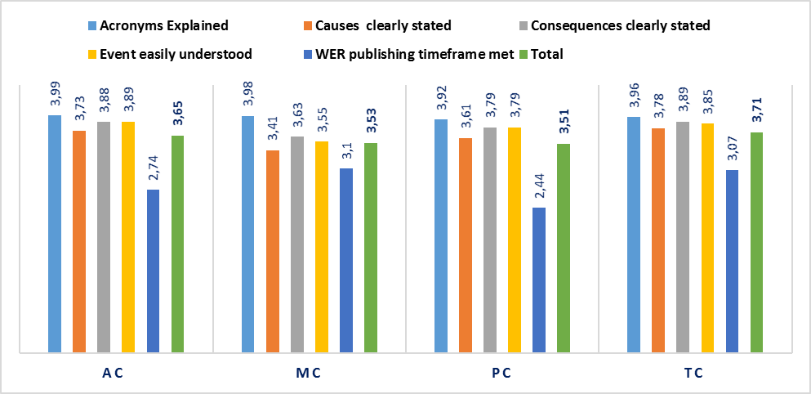
Report Quality Factors by MC Sites in 2018
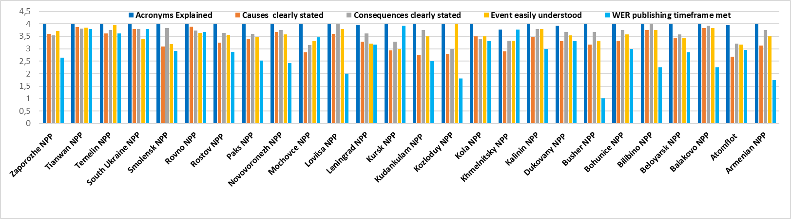
According to the review of the report quality factors for the MC affiliated sites:
– Mochovce, Kudankulam, Kursk, Kozloduy and Atomflot have the lowest indicator (within 2.75 to 2.85) among the MC plants in terms of specification of the event causes in the reports. Tainwan, Rovno and South-Ukraine have the highest values of the similar indicator (within 3.80 to 3.89).
– Atomflot, Mochovce, Kozloduy, Kursk, Kola and Khmelnitsky have the lowest indicator (within 3.0 to 3.40) in terms of specification of the event causes in the reports. Smolensk, Balakovo and Loviisa have the highest values of the indicator (3.92 to 4.0) for clear statement of the event consequences.
– The reports from Kursk, Smolensk, Leningrad, Atomflot, Khmelnitsky and Bushehr have the lowest indicator (within 3.0 to 3.33) in terms of the event understandability. The reports from Tianwan, Temelin and Kozloduy are easily understood and well documented. The indicator for these plants is within 3.85 to 4. One can observe a trend of quality degradation as to WERs from RBMK plants for the report comprehensibility factor. In 2018, a share of the reports from RBMK plants was 13 % of all the MC reports.
Issues of the MC report quality were discussed during the regular videoconferences of the Performance Analysis Team members and the LO experts. Comments of the MC Secretariat in relation to correctness of understanding of the quality criteria to be applied to the MC reports as well as clarifications to individual reports were provided to LO.
In spite of the fact that there were no areas for improvement (AFI) identified during the plant peer reviews and associated with the event investigation quality over the last two – three years, the issue of quality was recognized by many OE experts in the MC affiliated plants as a focus area. Moreover, it is clearly shown through deficiencies of a number of reports provided by the MC affiliated plants. At request of some plants, the target member support missions were conducted at several plants (e.g. Bushehr, Bilibino and Novovoronezh), however, this problem still needs to be resolved at many plants, and MC is to develop an approach in order to assist the plants in this area. One of the possible ways for resolving the problem could be a training seminar for departmental experts being responsible for the plant OE and involved in the event investigations and event information preparation.
Below are actions that were started in 2018 in order to improve the activities and are in various implementation phases. They were complemented with new activities and will be continued in the year 2019.
Potential improvement actions:
– The WANO MC member leaders shall consider, in the framework of the WANO membership obligations, a requirement of more active and timely dissemination of their own operating experience as per the event reporting criteria set forth in the WANO guideline for OE sub-programme (MN 01, Revision 8, January 2018).
– The plant and Atomflot representatives shall be involved, to a maximum extent, in the preparation and submission of the reports that meet the reporting criteria including emergency shutdowns but earlier were not provided for some reasons to the WANO OE DB.
– Interactions with the WANO MC members shall be carried on in terms of obligations towards the event reporting as per the WANO criteria, timely submission of the preliminary reports and their updates as required. If it is found out that, for some event categories, submission of information to MC is beyond the plant competence, then this issue can be discussed between the MC Secretariat and the related operator. The operator leaders shall be regularly informed of the current status of the MC member event reporting.
– Interactions with the WANO MC members shall be carried on as to improvement of the quality of the WANO event reports being issued. Special emphasis shall be given to the quality of the reports from the RBMK plants as well as Kudankulam, Mochovce, Khmelnitsky and Atomflot. Attention of the experts being responsible for the event report preparation shall be directed to understandability of the WER reports subject to specific features of the reactor and plant designs. MC will have to find an efficient method of interfacing with the members in order to achieve the visible progress in the WER quality improvement. At this stage, the MC actions can include submission of all LO comments given in relation to the MC reporting quality to specific plants for the purpose of lessons learning and feedback receipt; selection of the positive examples for preparing the MC WER reports and other regional reports, and their submission to the plants for using in work.
– Special emphasis shall be given to a full compliance with the requirements on WER formats, inclusion of appendices (including event root cause analysis, possibly – in the original language) as well as excerpts from schematics, diagrams, photos and other materials that support understanding of the event by the information recipients at plants of various types.
– A new Russian version of the guideline for WANO performance analysis programme (WPG 02), Version 6, December 2018, shall be prepared and disseminated in MC. Attention of the persons being involved in the MC OE programme (including experts responsible for event report preparation and submission, and site representatives) shall be directed to the MC organizational changes that took place in establishment of the new Performance Analysis Programme.
– A new Russian version of the guideline for WANO industry analysis programme (WPG 12), Version 1, December 2018, shall be prepared and disseminated in MC.
– To improve the quality of the event reports (WER), special emphasis shall be given to a requirement for incorporation, in the report, of the detailed information about types (brands) and technical characteristics of the failed equipment, manufacturers and the like.
– The quarterly reports shall be analyzed against the plant performance indicators (PI) in terms of events linked to the plant power reduction and if required the requests for providing information on such event shall be sent to the plants.
– The quarterly reports from the site representatives shall be regularly analyzed, and the event information shall be compared with the WANO event database. Attention of the plants shall be directed to the importance of providing the reports on those events that are mentioned in the reports but were not reported to MC.
– During the WANO MC on-site activities (e.g. reviews, seminars or visits), if possible the issues relating to the plant obligations for event reporting as per the WANO OE regulatory documents shall be discussed with the plant responsible representatives (OE responsible experts being involved from the departments). Primarily, it concerns Bilibino, South-Ukraine, Kozloduy, Kudankulam and Loviisa.
– During the WANO MC activities, leaders of the different plant and utility levels shall be informed of problems that exist at the plant(s) and are associated with provision of the event information to MC.
– As per the approach adopted by MC in 2016, during the peer review at the plant with a low indicator of event reporting the plant events shall be analyzed in order to reveal the events that meet reporting criteria but were not reported to WANO. To this end, the OE dissemination-related areas for improvement (AFI) shall be suggested.
CHAPTER 3. ANALYSIS OF MC AFFILIATED PLANT EVENT TRENDS

EVENT ANALYSIS BY AREAS OF OPERATIONS
The MC events reported in 2018 were statistically analyzed with use of the WANO coding system.

Distribution of 2018 MC Events by Areas of Operations

The analysis of events by the operational activities that were implemented at the moment of the event (or the event detection) shows that about 30 % of the events occurred at normal operation of the equipment.
As compared with the year 2017, one can observe an insignificant increase (from 18 % to 21 %) in the share of events that were detected during the walk-downs and equipment inspections; 12 % of the events occurred during the equipment tests, and 9 % were linked to activities during the scheduled maintenance.
According to statistics of the recent two years, on the average 10-12 events per year occur during the search and elimination of the failures, the equipment tests, the startup operations and the equipment connections/disconnections.

Event Distribution by Event Consequences

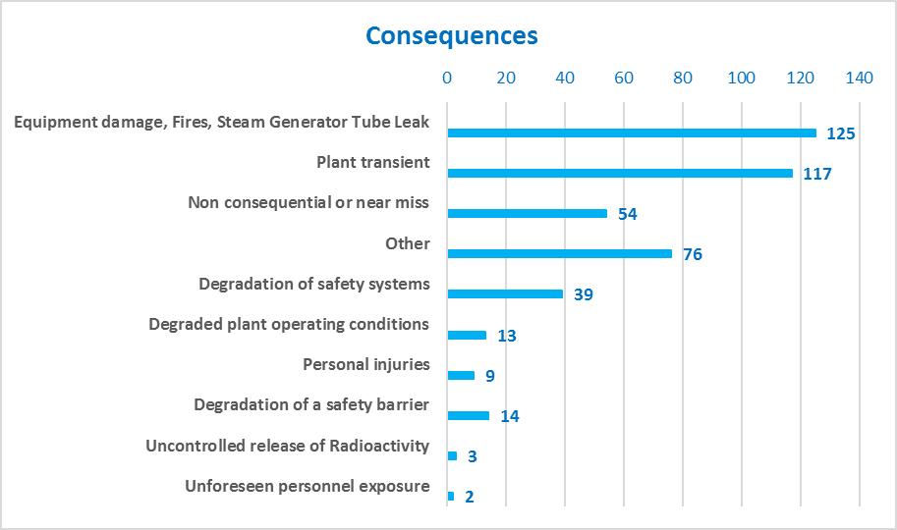

The prevailing event consequences were as follows:
- equipment damages, and
- plant transients.
As compared with the year 2017, in 2018 one can observe a decrease (from 48 % to 35 %) of the share of those events that resulted in the equipment damage. One can also observe a decrease (from 42 % to 32 %) of the share of those events that resulted in the plant transient although the number of events in 2018 increased significantly.
15 % of the events resulted in the degraded condition of the safety systems and the degraded plant operational conditions. Some events resulted in the reactor shutdown, turbine trip, reactor power reduction by 10 % or more, and loss of the safety system train. 54 events had no consequences and were classified as near-misses.
9 events resulted in the personnel injuries, and 3 events – in radioactivity releases and unforeseen personnel exposures.

Event Distribution by Failed/Affected Systems

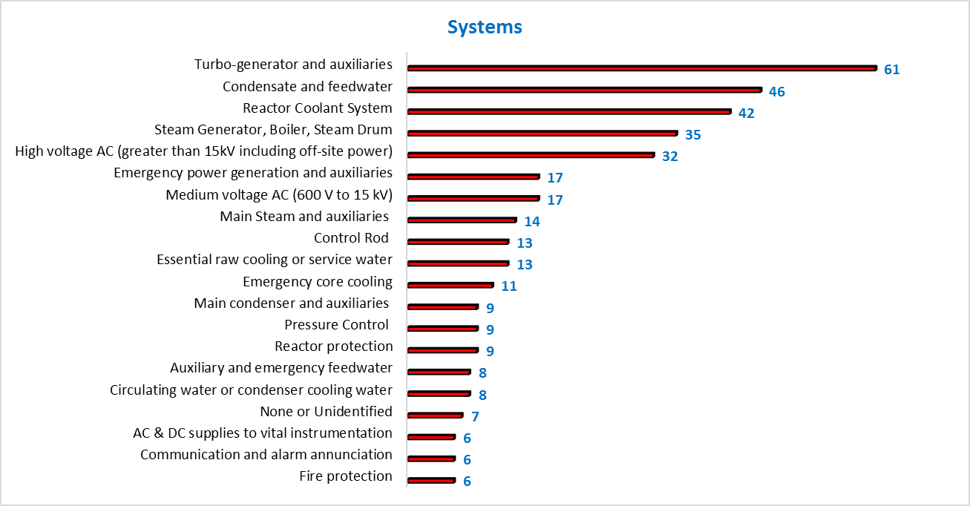

The event analysis done by the failed/affected systems shows as follows:
- 17 % of the events occurred due to failures, inappropriate performance or degraded conditions of the turbo-generator facility, and 13 % of the events – due to failures of the condensate and feedwater systems;
- 12 % of the events occurred due to failures, inappropriate performance or degraded conditions of the primary coolant systems;
- 66 events occurred due to failures of the high and medium voltage AC systems, and the emergency power supplies.

Event Distribution by Failed/Affected Components

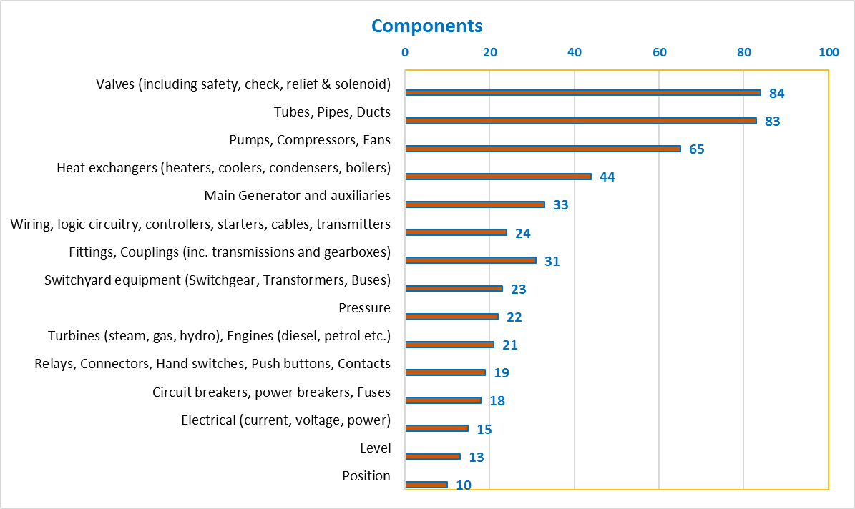

The event analysis done by the failed/affected components shows as follows:
- 276 of the events (63 %) were caused by the failure (inappropriate performance or degraded conditions) of the mechanical components. The main types of the mechanical failures were failures (damages) of the valves, pipelines, and pumping, heat-exchanging and ventilating equipment;
- 117 of the events (23 %) were caused by the failure of the electrical components. The main types of the electrical failures were failures (damages) of the main generators, electric wiring, switchgear equipment, cables, relays and switches;
- 60 of the events (12 %) were caused by the failure of the control and monitoring system elements. The main types of these failures were failures of the pressure, electric parameter (current, voltage), level and position I&C.

Event Distribution by Plant Status Prior to Event

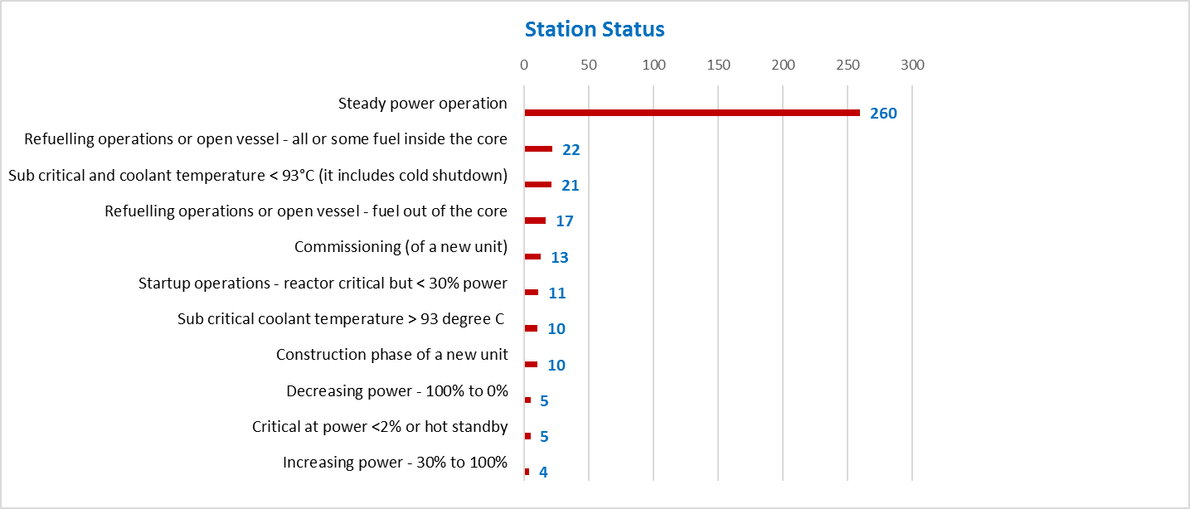

The analysis of the plant status at the time of the event occurrence or detection shows as follows:
- 69 % of the events occurred at the steady power operation;
- 17 % of the events occurred when the reactor was shut down (hot or cold) or during refueling;
- 20 of the events occurred during the startup operations, power buildup or decrease.

In 2018, 23 events occurred during construction of the new power units. The MC Secretariat encourages their members to report of the events that occurred at the power units being constructed and commissioned. The purpose is to reach an indicator of at least one event report from a new unit.
In 2017, 14 events that occurred at the MC new power units were reported.

EVENT CAUSE ANALYSIS AS PER WANO CLASSIFICATION

In WANO, an event cause analysis coding system being common to all the regional centres is used. The event causes are divided into the following three categories:
Direct Cause: | The failure, action, omission or condition which immediately produced (or led to) the event.
Root Cause: | The fundamental cause(s) that, if corrected, will prevent recurrence of an unusual event or adverse condition.
Causal Factor: | Cause(s) that, if corrected, would not alone have prevented the event, but are important enough to be recognized as needing corrective action to improve the quality of the process or the product.

The diagram below shows the trend of direct causes of events over the past three years.
The analysis of direct causes to the 2018 MC events shows as follows:
- 193 events (54 % of all the events) occurred due to the mechanical defect. As compared with the year 2017, one can observe a sharp increase of the event number (approximately by 13 %), where these events were caused by mechanical damages. The prevailing direct event cause was leaks. As compared with the year 2017, one can observe a sharp increase of the number of leaks from 39 to 87. 31 events were caused by the weld failure, rupture, cracking or defect. The other causes were strains, loose fastening, jamming or foreign materials, which resulted in 49 events.
- 61 events (17 % of all the events) occurred due to the failed electric components. In 2018, one can see a trend of decrease in the event number (approximately by 8 %, as compared with 2017), where the events were caused by the failed electric components. The main types of the electric failures were short circuit and sparkage, which resulted in 20 events. Poor contacts, disturbed insulation, overheated or ruptured circuit were the most widespread direct causes of the electric failures.
- The direct cause for 54 events (15 % of all the events) was human factor (erroneous human actions). This trend is there over the recent three years. The prevailing types of the human errors were omissions or lapses, which resulted in 20 events. 19 events were caused by deviations from the established standards, rules and procedures. 13 events were caused by the human error.
- 37 events (10 % of all the events) were caused by defects in the control and monitoring systems. The prevailing types of the instrumentation and monitoring device failures were spurious actuations, signal losses, drifted or displaced setpoints.
9 events were relating to abnormal site conditions. Direct causes of these events were fires, flame development, smoke spread and low temperatures.

Overall Distribution of MC Event Direct Causes (%) for 2016-2018

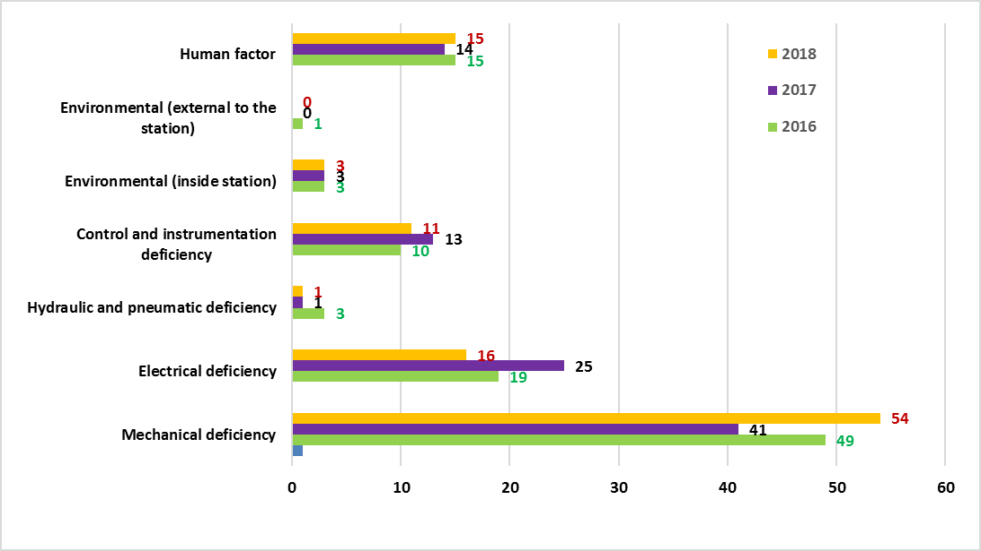

The distribution of the root causes and causal factors (see the diagram below) indicates the prevalence of the root causes associated with equipment (51 %). This trend remains stable for the last three or four years. It should be noted that there is a stably high percentage of the event root causes associated with the human performance (40 %).

Since 2016, there has been a 7 % decrease (from 16 % tо 9 %) in the share of the root causes associated with the managers’ actions, and an increase of the share of the root causes associated with the human performance as well as the root causes associated with the equipment, by 4 % and 3 %, accordingly. In 2018, the root causes and causal factors of 59 events were linked to shortcomings in the managers’ actions.
Overall Distribution of MC Event Root Causes and Causal Factors (%) for 2016-2018
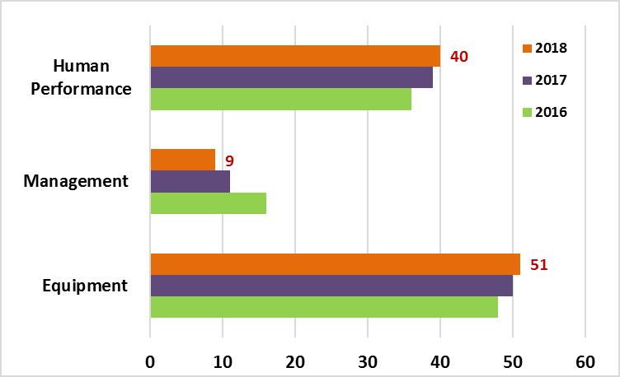
The diagrams below show the distribution of the MC event root causes and causal factors for the equipment, human performance, governance and management.
It should be noted that the Design Configuration and Analysis category is prevailing for the equipment related root causes (32 %); the Written Procedures and Documents category is prevailing for the human performance related root causes (40 %); and the Management Assessment and Monitoring category is prevailing for the management action related root causes (33 %).
Distribution of MC Event Root Causes and Causal Factors for 2015-2018
EQUIPMENT Sub-Category (%)
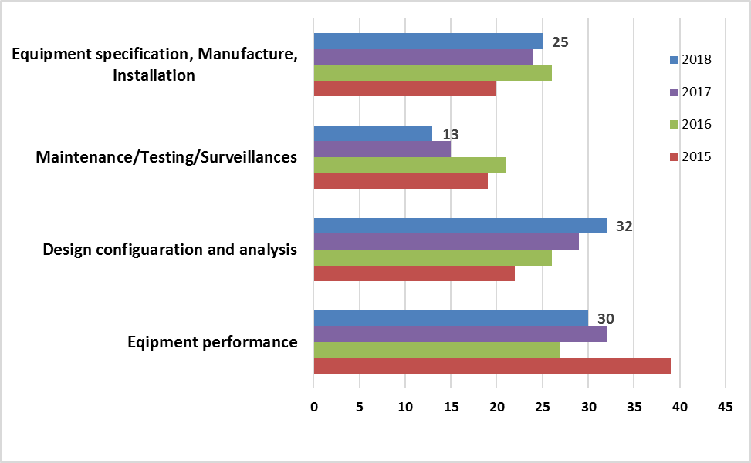

The main root causes associated with the equipment were as follows:
- Deficiencies in the initial design/construction and in the design analysis. This was a root cause for 63 events (18 % of all the events reported to MC in 2018). Deficiencies in the design analysis were the second prevailing root cause and resulted in 16 events.
- Inappropriate monitoring of equipment parameter status / trending. This led to 32 events. For 20 events the equipment failure was contributed by degraded characteristics of a component element. The component ageing was a root cause for 9 events, and the component erosion/corrosion - for 12 events. The failures within the design service-life period occurred in 13 events.
- Inappropriate equipment fabrication / installation. This was a root cause for 73 events (20 % of all the events reported to MC in 2018) and 54 events in 2017.
- Inappropriate equipment maintenance / testing. The inappropriate preventive maintenance was a root cause for 15 events, and a failure to take measures against the foreign materials resulted in 13 events. These events resulted in scrams and forced plant shutdowns, unavailability of the safety systems, and application of LCO.
Distribution of MC Event Root Causes and Causal Factors for 2015-2018
HUMAN PERFORMANCE Sub-Category (%)
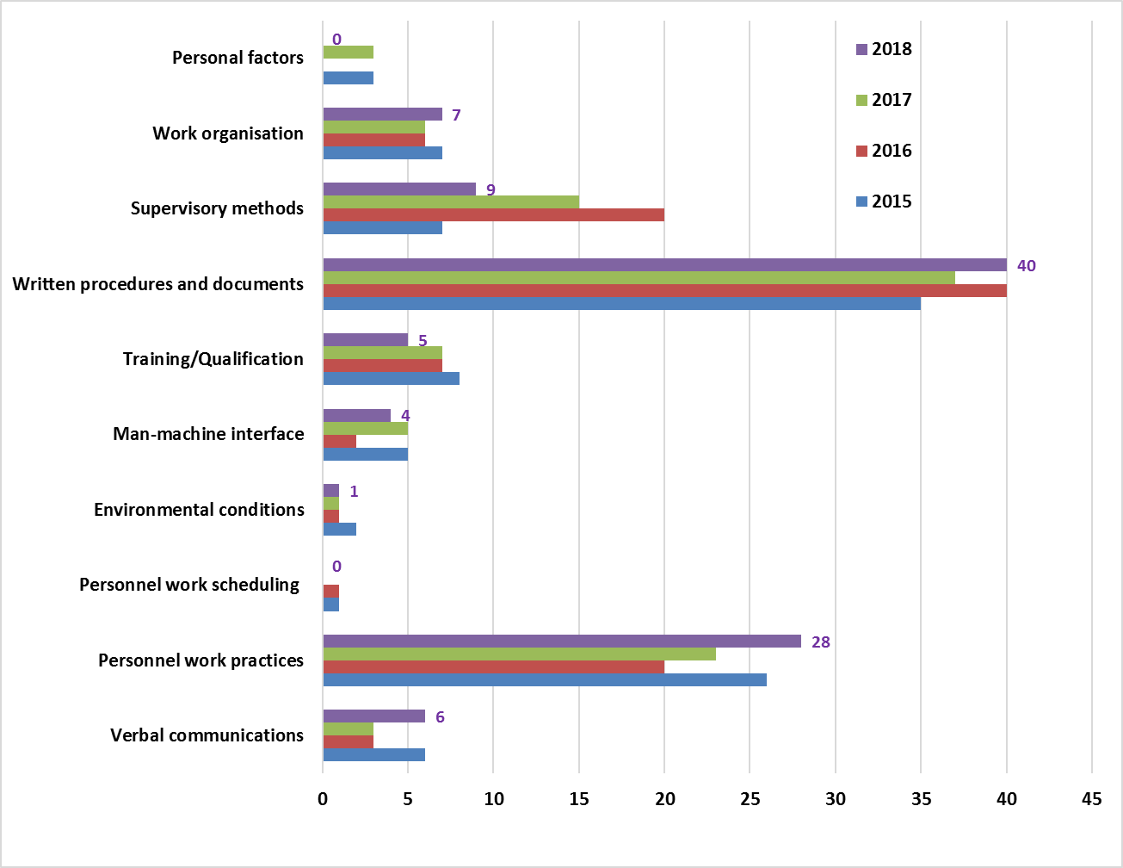

The main root causes associated with the human performance were as follows:
- Gaps in written procedures and documents. In 2018, one can see an increase (approximately by 4 %) in the share of the root causes associated with the procedures, as compared with the year 2017. The technically incomplete document was a root cause for 80 events (22 % of all the events reported to MC in 2018). Missing documents, missing warning information, and shortcomings in the technical review process were the second widespread category of root causes.
- Shortcomings in personnel work practices. In 2018, one can see an increase (approximately by 5 %) in the share of the root causes associated with the personnel work practices, as compared with the year 2017. Missing or inefficiently applied self-control, non-use of necessary procedures, drawings or other reference documentation, missing questioning attitude or violated policies/rules/procedures were root causes for 44 events.
- Shortcomings in managerial methods. Since 2016, there has been observed a trend of reduction (approximately by 11 %) in the share of the root causes associated with the managerial methods. This trend will have to be monitored in the year 2019 and this will be analyzed in order to find explanations to the reason for such a trend. Insufficient supervision over the work progress and the contractors is a prevailing root cause and led to 21 events.
- Shortcomings in work organization. A failure to specify the special working conditions or requirements was a root cause for 8 events.
Distribution of MC Event Root Causes and Causal Factors for 2015-2018
GOVERNANCE AND MANAGEMENT Sub-Category (%)
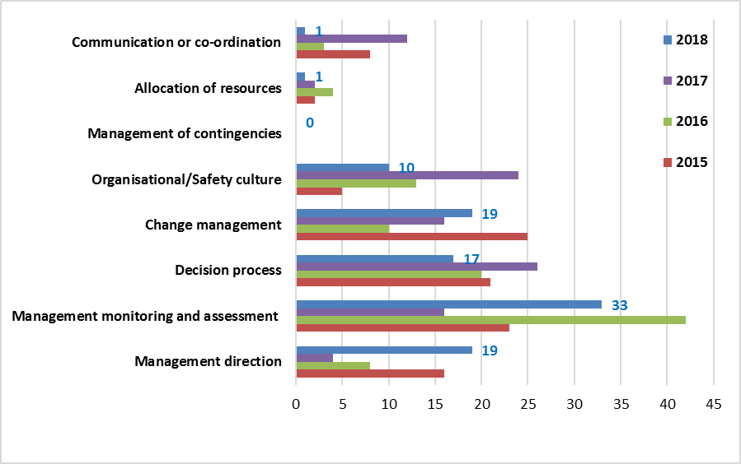
The MC management-related root cause and casual factor analysis shows as follows:
- For the past four years there observed a sharp fluctuation in the share of the root causes associated with the management assessment and monitoring. In particular, in 2017 as compared with 2016, a sharp reduction (from 42 % to 16 %) in the number of the root causes associated with the management assessment and monitoring was observed; and in 2018 the share of these root causes increased up to 33 %. The management assessment and monitoring was a root cause for 19 events in 2018. The detected trend will have to be monitored in the year 2019 and this will be analyzed in order to find explanations to the reason for such a trend.
- As compared with the year 2017, one can observe a sharp increase (from 4 % to 19 %) in the number of the root causes associated with the managerial documents. The main root cause was contradictory, incomplete or invalid policy statements, formal instructions (standards), requirements or administrative control documents.
- As compared with the year 2017, in 2018 one can observe a sharp reduction (from 24 % to 10 %) in the share of the root causes associated with the safety culture. Low moral state of the plant personnel, lack of the conservative approach at MCR and repeated violations of the rules were root causes for six (6) events. This trend will be analyzed in the year 2019 in order to search and find possible explanations.
- Within the past three years, one could observe a trend of gradually increasing root causes associated with the change management. A failure to identify a need of changes, erroneous assessment of the change consequences and late implementation of the change were root causes for 11 events.
CHAPTER 4. DISSEMINATION AND USE OF WANO OPERATING EXPERIENCE IN MC

OE PUBLICATIONS IN 2018
In 2018, no new significant event reports (SER) or significant operating experience reports (SOER) were issued. In the operating experience information series to be used for the purpose of just-in-time briefings (JIT), in 2018 WANO published a report on welding works in the safety systems (JIT 160) for monitoring and assessment of the welding works being performed at the safety systems. The defects were causes for the safety-related system leaks.
On the WANO MC website all the published reports were posted in the Russian language, i.e. 17 SOERs, 45 SERs and 160 JITs. Appendices 2 and 3 contain the lists of all the SOERs and SERs, accordingly.

The following Hot Topics were issued in 2018:
- Hot Topic on deficiencies of welded seams. Maintenance and testing of auxiliary and supporting systems (HT 2018-01);
- Hot Topic on electrical safety (HT 2018-02);
- Hot Topic on provision of cooling during shutdown (HT 2018-03).

In 2018, the London Office issued:
- RPT 2019-02 Annual Performance Analysis Report for 2018.
- OE sub-programme status monthly publications (event analysis and classification).
- CEO Update on relay failures in safety systems. This report is based upon the experience of events linked to diesel generators as a result of relay failures in the DG start control logic systems.
- CNO Update, RPT 2018-08, on important industry events as well as industry senior manager expectations.
- RPT 2018-07 on analysis of deficiencies in activities of maintenance personnel.
- RPT 2018-09 on analysis of deficiencies of preventive maintenance.

In January 2018, the London Office issued Version 8 of the WANO manual for the operating experience sub-programme (MN 01). In May 2018, the MC OE team prepared and disseminated a Russian version of this document.
In December 2018, WANO published Version 6 of the WANO guideline for the WANO Performance Analysis Programme (WPG 02), following results of the WANO London Office reorganization.
A new WANO guideline on the industry analysis (WPG 12) was also published; it describes a methodology and process for the industry trend analysis and assessment, with use of all opportunities provided by the WANO programmes.

DISSEMINATION OF WANO EVENT REPORTS IN MC

All MC event reports received and published are regularly posted in Russian on the WANO-MC secure website and are available to all MC Secretariat staff, WANO MC interface officers and site representatives. In addition, all WERs received from the MC members in English are translated into Russian by the MC OE team for the further use by the Russian-speaking specialists from the MC affiliated plants and other members.

In 2018, the WANO MC OE team regularly selected the event reports from the other regional centres for dissemination among the WANO MC members with the purpose of study and learning lessons. The events were selected with account for their significance and applicability for WANO MC power units, and they included practically all the events classified as significant and noteworthy as well as certain trending and other events. These selected events were translated into Russian, and the summary of the selected events along with the presentation materials in Russian and English was submitted on a monthly basis to all the MC members (including top managers) for familiarization and learning lessons. In 2018, 226 event reports from the other regional centres were issued in Russian, including 73 reports from AC, 92 reports from PC, and 61 reports from TC. In 2017, 141 event reports from the other regional centres were issued in Russian. Of 357 MC event reports of the year 2018, the WANO MC OE team translated 193 reports from Russian into English, and 146 ones – from English into Russian.

According to the MC plant feedbacks, the monthly overview of the events reported by the other regional centres allows the plant personnel study the most significant events that occurred in the industry over the recent several months. The presentation materials prepared are convenient for use during the topical discussions, meetings of different levels, and in the personnel training.

OE INFORMATION EXCHANGE DURING SEMINARS AND MEETINGSS

In 2018, the MC OE team issued 12 reports with analysis of the plant events for preparation of the peer reviews (including the pre-startup and corporate reviews) and one report for the member support mission.

In 2018, the MC representatives took part in a PC workshop on experience in implementation of the recommendation as per SOER 2013-1 Operator Fundamentals Weaknesses. Two members of the MC OE team took part in Rosenergoatom’s inspections as OE experts.
In cooperation with IAEA, MC prepared and conducted an annual seminar on information and experience exchange for improving the OE application, with participation of the MC experts. The below hot topics were chosen as topics for discussion:
- operating experience linked to significant and noteworthy events (e.g. loss of reactivity control, loss or degradation of efficiency of residual heat removal system, actuation of scrams along with complicated transients, common cause failures etc.);
- improvement of equipment reliability by using operating experience;
- lessons learned from experience of plant construction and significant upgradings;
- improvement of personnel work and safety culture due to use of operating experience.

The outcomes of topical event reviews were presented by MC at international meetings, workshops and seminars such as:

- an annual conference of Russian and foreign plant turbine department directors (Moscow, Rosenergoatom, February 2018);

- an electrical council for improvement of electric reliability (Moscow, Rosenergoatom, October 2018).
The OE team participated in the following MC programme activities:
- WANO peer reviews:
  - Kalinin (August 2018)
  - Atomflot (October 2018)
  - South-Ukraine (October 2018)
  - Rostov (December 2018);
- WANO peer review follow-ups:
  - Zaporozhye (April 2018)
  - Paks (April 2018);
- WANO pre-startup peer reviews:
  - Tianwan 4 (June-July 2018.);
  - Novovoronezh 7 (December 2018).

OE INFORMATION EXCHANGE IN MC UPON TECHNICAL REQUESTS

In 2018, MC received 340 technical and organizational information requests from 18 organizations and 29 plants (including 4 plants of the other regional centres, i.e. Borssele, Bruce, Pickering and Forsmark). This activity has been carried out by the MC OE team since 2001, and to date more than 4 440 technical requests have been received and processed.

Number of Technical Requests Processed by MC in 2001-2018
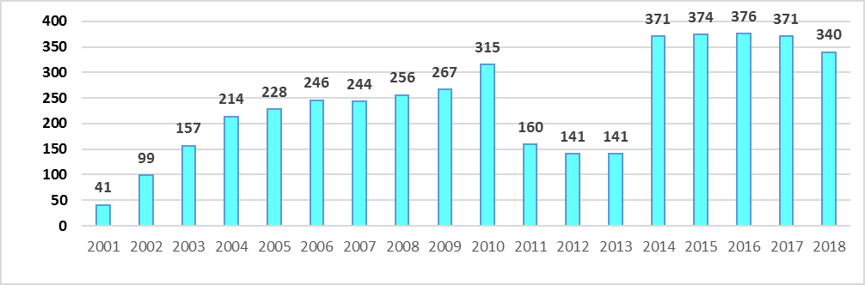

– Submission of the technical requests and the related feedback are one of the prompt and effective methods of OE exchange among the MC members.

– A list of the technical requests and the complete information for each request and response are available only to the limited number of personnel, i.e. MC Secretariat and MC site representatives. Increasing the possibilities, for the plants, to get familiarized with the lists of all the requests is becoming the important task.

– Over the recent three years, one can see a significant increase in the number of technical requests reaching on the average around 350 requests a year.

– There is an increasing trend for specific information requests that require analysis and processing of a large information volume both from the databases and other sources.

– In 2018 the following plants were the most active participants in the exchange of OE information upon the technical requests:
- Rovno (31 requests),
- Zaporozhye (21 requests),
- South-Ukraine (16 requests),
- Tianwan (15 requests),
- Kalinin (13 requests),
- Paks (13 requests).
– The following companies were the most active participants of issue of the technical requests:
- WANO MC (57 requests),
- WANO LO (39 requests),
- Rosenergoatom (17 requests),
- VNIIAES (6 requests).
Appendix 4 contains details on the number of the technical requests from the plants and companies in the year 2018.

Below are the main topics of the technical information requests in 2018:
- additional information on the plant events;
- practices of applying the state-of-the-art techniques, procedures, and guidelines;
- specific features and issues of operations and maintenance of the specific equipment and systems;
- issues, monitoring and repairs of heterogeneous welded connections of the equipment and pipelines;
- experience of the system and equipment upgradings;
- search for foreign national and international standards and methodologies;
- improvement of the plant performance delivery and management.

– The WANO OE database is limited and does not contain sufficient details needed for the reliable and comprehensive analysis on the certain specific requests. For instance, the database contains the limited information on types (brands), technical characteristics or manufacturers of the failed equipment, etc. This problem was noted in the year 2017 and is still important for the MC reports in 2018.

Potential improvement actions:

– Assistance and support to the MC members in the prompt exchange of OE information using the technical information request practice shall be continued. The lists of the MC technical requests by years are posted in the Secretariat’s internal information system Pluto and are not accessible for the plants. One of the possibilities for familiarizing with the requests lists is posting the annual request lists on the new MC website. This can help the plants in using the existing requests/responses (they are above 4 440) and, which is equally important, would prevent duplication of the requests already done.

– The existing practices of use of the monthly event reports at the plants shall be studied; good practices shall be identified, and their distribution among the MC members be arranged. In 2018, no significant actions were done in this area, and in the year 2019 the related activities will be continued. It is expected that analytical information will be collected in the course of the peer reviews, support missions, OE seminars and workshops. Questionnaires could be one of the possible ways of collecting the information of interest.

CHAPTER 5. SOER RECOMMENDATIONS IMPLEMENTATION IN MC

In 2018, implementation of all the 239 recommendations contained in 17 SOERs was checked during the WANO peer reviews.

As of the end of 2018, MC affiliated plants demonstrated the following results regarding implementation of SOER recommendations:
- 80 % of recommendations – implemented (including recommendations earlier classified as satisfactorily implemented (PRS));
- 12 % of recommendations – awaiting implementation (AI);
- 04 % of recommendations – not reviewed (NRV);
- 03 % of recommendations – further actions required (FAR);
- 01 % - not applicable (NOT).

Status of SOER Recommendations Implementation in MC as per Peer Reviews in 2018

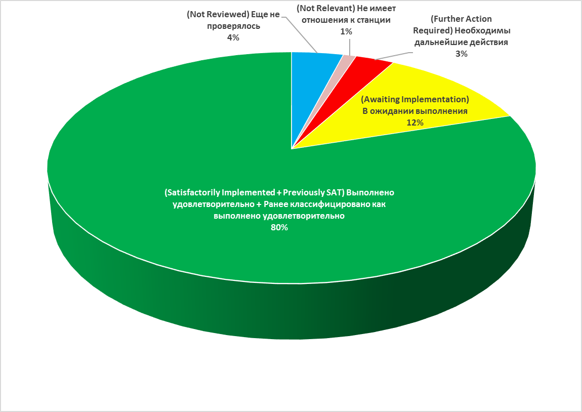

Among the WANO regional centers, MC is still a center with the highest number of recommendations of AI (Awaiting Implementation) status (about 12 %). In addition, the reviews revealed that about 1 % of the recommendations are not applicable to the plant performance.

During the Rovno PR of 2016, SOER recommendations implementation was reviewed by the PC experts. The review results demonstrated similarity of the MC and PC approaches. Moreover, LO assessed twice (in 2016 at Temelin and in 2017 at Dukovany) the efficiency of verification of the SOER recommendation implementation as done by MC. Compliance of the verification process with WPG 02 was confirmed.

During the recent several years, SOER 2015-1, Safety Challenges from Open Phase Events and SOER 2015-2, Risk Management Weaknesses were reviewed.

For SOER 2015-2, a percentage of recommendations implemented satisfactorily (SAT) increased up to 15 %. However, there is still a significant number of recommendations awaiting implementation (AI) or further actions (FAR); in total, more than 33 % of the recommendations are of FAR or AI status.

For SOER 2015-1, growth of the implemented recommendations is higher than that for SOER 2015-2 since a percentage of the implemented recommendations at the end of 2018 was 30 %. As a result, the number of AI and FAR status recommendations are about 22 %.

SOER 1999-1, SOER 2004-1, SOER 2007-1 and SOER 2007-2 have rather high percentages of recommendations classified as SAT and PRS, in total it is 90-91 %.

In 2018, 18 MC events were SOER linked.

Status of SOER Recommendations Implementation in MC as of End of 2018

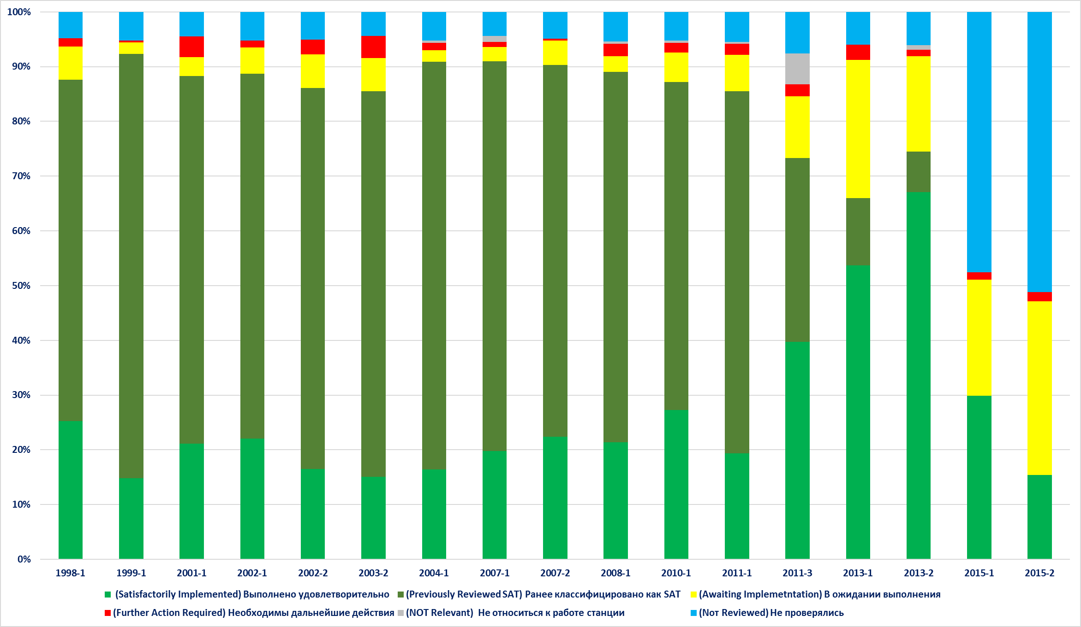

Following results of the year 2018, the following SOERs are characterized by the highest number of FAR status recommendations (further actions required) in MC:
- SOER 2001-1, Unplanned Radiation Exposure;
- SOER 2003-2, rev. 1, Reactor Pressure Vessel Head Degradation at Davis-Besse Nuclear Power Station;
- SOER 2007-1, rev. 1, Reactivity Management;
- SOER 2008-1 Rigging, Lifting, and Material Handling;
- SOER 2013-2, rev. 1, Post-Fukushima Daiichi Nuclear Accident Lessons Learned.

Main results:

– In 2018, SOER recommendations were reviewed during the peer reviews at six MC affiliated sites. At different sites the SOER recommendations are at different stages of implementation. For example, Leningrad and Smolensk show the highest percentage of implemented recommendations among the MC plants, i.e. 97 % and 95 %, accordingly. The implementation indicator for Kozloduy, Paks, Kola, Rovno, Balakovo and Atomflot is 90-95 %.

– A new unit, Novovoronezh 7, has the lowest indicator for implementation of the recommendations, 20 % of the recommendations are of FAR status (further actions required). Kudankulam has 18 % of recommendations of FAR status. In addition, Kudankulam is the only MC site where SOER recommendations were not fully reviewed. According to the 2011 PR results, the plant implemented just 29 % of the SOER recommendations. The plant is characterized by the highest percentage of recommendations not reviewed, i.e. 46 %. The next PR at Kudankulam is planned for January – February 2019.

– In 2018, in MC a portion of the recommendations not reviewed was reduced on the average to 4 %. At eight sites a share of these recommendations makes 5-6 %; it mainly concerns recommendations of SOER 2013-1,2 and SOER 2015-1,2 published in 2015. Provided that in 2019 the implementation of SOER recommendations will be reviewed at eight MC sites, it is expected that at the end of the year 2019 there will be no MC sites with SOER recommendations not reviewed.

– The WANO governance documents specify those SOER recommendations that are subject to mandatory review during the pre-startup peer reviews at the new units. In 2018, implementation of the SOER recommendations was checked at two new units (Tianwan 4 and Novovoronezh 7). For the year 2019 it is planned to conduct the pre-startup peer reviews at four new units (Mochovce 3, 4 and Belarusian 1, 2).

– After each MC peer review, all information on status of SOER recommendations implementation was uploaded to the WANO global SITS database for the purpose of monitoring of the SOER recommendations.
According to assessment of the SOER recommendations implementation at five (5) pre-startup peer reviews (PSUR) conducted by MC within the past 2 years, on the average for the new units 60 % of the recommendations are implemented satisfactorily (SAT). Nevertheless, 34 % are of awaiting implementation (AI) status and about 6 % - of further actions required (FAR) status.
However, in comparing the results of peer reviews with the results of the plant self-assessments, gaps are evident. The plant self-assessments show that on the average 97 % of the recommendations are implemented satisfactorily, 3 % are awaiting implementation (AI), and there are no recommendations that require further actions (FAR). Such gap indicates that:
• the plants shall scrutiny the SOER recommendations and the existing on-site problems, and
• corrective actions for implementing SOERs need more focus of the leads, in order to develop a clear actions plan including deadlines, performers, expected results and tasks.
Furthermore, a process of SOER recommendations implementation is inefficient at the new units from the point of view of the actions implemented, and this resulted in the fact that a number of recommendations were not still implemented appropriately. In particular, it concerns the recommendations for safety system status monitoring, reactivity management, safety provision in shutdown modes and risk management. In addition, shortcomings were identified as to operator fundamentals (monitoring, control, conservatism, team work, knowledge). A failure to implement the SOER recommendations could result in repeated events and industrial problems.
Below are shortcomings in implementation of the SOER recommendations that are characteristic for the new units and require more focus:
- SOER 1998-1 Safety System Status Control: shortcomings are identified in control of the actual physical conditions of the safety systems and operational documentation in terms of requirements to verification of the safety system operability;
- SOER 2007-1, Reactivity Management: it was identified that there were cases when reactivity was changed without use of procedures, no error prevention tools were used, and there were cases when conservative decisions were not made in unforeseen situations of managing the reactivity. There were cases of inappropriate communications between the team of physicists and the team of operators in the area of reactivity management, in particular, in cases of unforeseen situations;
- SOER 2010-1, Shutdown Safety: expectation and methods of providing information to the plant personnel and contracted workers on the status of «protected» components are not identified or recognized. There was no training for the maintenance control team, plant management and MCR crews in managing the shutdown risks and providing the defence-in-depth;
- SOER 2013-1, Operator Fundamentals Weaknesses: there are shortcomings in the operator fundamentals associated with unclear performance of the actions and prescribed functions, and shortcomings in effective support to the team work for plant monitoring and control;
- SOER 2015-2, Risk Management: there were shortcomings in observance of the principles and requirements in the area of risk identification, assessment and minimization during operations, making operational decisions, support to the equipment reliability and implementation of the temporary modifications.
Below are potential causes of poor implementation of the SOER recommendations at the new units:
- The new units eliminated just some part of the shortcomings, and the plants did not develop any approach or efficient methodology for implementing the SOER recommendations and the result assessment.
The new units have no efficient process for implementing the SOER recommendations with clearly stated expectations as to the type of support provided, the communication and verification of the assessment results and finally the identification and tracking of the corrective actions.
- No periodic assessment of the SOER recommendations is done. Moreover, the self-assessment is not done deeply and is insufficiently documented.
- Due to frequent changes in the on-site SOER ownership, new persons being responsible for the recommendations implementation are not always aware of contents and purposes of the recommendations.

Accounting for the operator fundamentals improvement-related steps taken at the industry level, the MC Secretariat applied to all the plants with a suggestion for the self-assessment of the operator training programmes and the practical application of the operator fundamentals, as per SOER 2013-1 recommendations.

As of the end of 2018, MC has the following results as to implementation of the SOER 2013-1 recommendations:
- 66 % of recommendations – implemented (including 12 % of recommendations earlier classified as satisfactorily implemented (PRS));
- 25 % of recommendations – awaiting implementation (AI);
- 06 % of recommendations – not reviewed (NRV);
- 03 % of recommendations – further actions required (FAR).
The SOER 2013-1 recommendations are completely implemented only at the following three sites: Balakovo, Kalinin and Leningrad. Implementation of the recommendations at Kudankulam was not reviewed.

Status of SOER 2011-3, Rev.1 Recommendations Implementation in MC
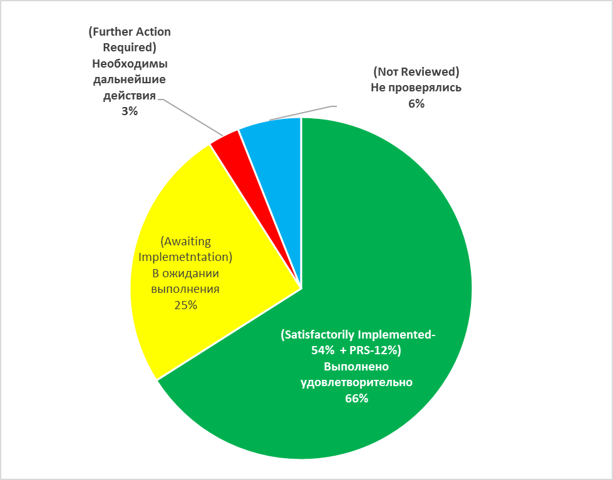

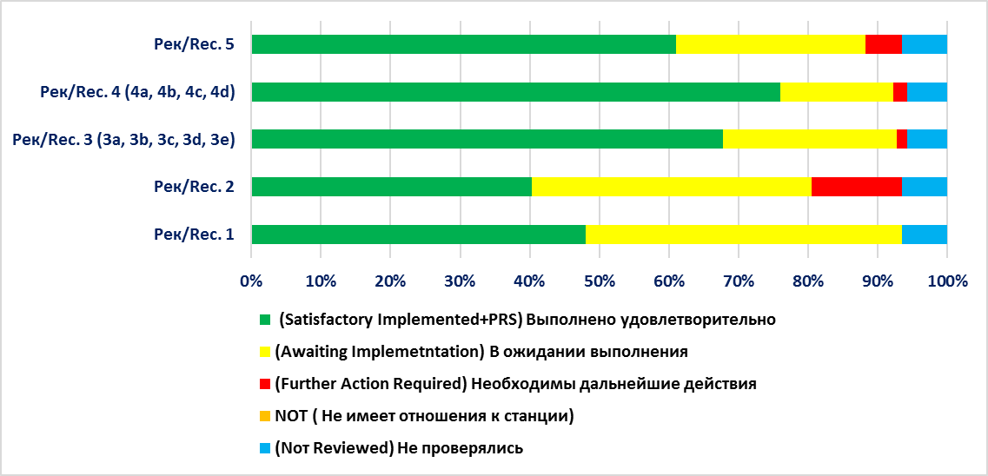

In MC, the recommendations 2 and 1 show the lowest percentage of implementation. For example, the recommendation 2 is not implemented at 16 sites, and at 5 sites its status is FAR. As concerns the recommendation 1, it is not implemented at 13 sites. The review results showed that implementation of the recommendations 4 was not difficult for the plants, and these recommendations show the highest percentage of implementation, i.e. more than 75 %. The recommendations 3 and 5 are not implemented at 18 and 9 sites, accordingly.
For February 2019 it is planned to conduct a workshop to discuss results of the SOER 2013-1 self-assessments, with participation of the plant training department leads/trainers. Proposals will be developed in order to improve the operator training.

Below is a detailed description of the SOER 2011-3 Rev. 1 status: improvement of the plant capability for responding to the cooling loss- and spent fuel storage pool makeup-related events is extremely important.
During the plant peer reviews, status of implementation of all seven SOER 2011-3 recommendations was reviewed.
As of the end of 2018, in MC there are the following results of implementation of the SOER 2011-3 recommendations, i.e. Fukushima Daiichi Nuclear Station Spent Fuel Pool/Pond Loss of Cooling and Makeup:
- 73 % of recommendations – implemented (40 % of SAT and 33 % - of PRS);
- 11 % of recommendations – awaiting implementation (AI);
- 08 % of recommendations – not reviewed (NRV);
- 02 % of recommendations – further actions required (FAR).
In addition, according to the peer review results, 6 % of the recommendations were not applicable to the plants. This mainly concerns the recommendation 6 in terms of the dry-storage casks being used on site.
Status of SOER 2011-3, Rev.1 Recommendations Implementation in MC
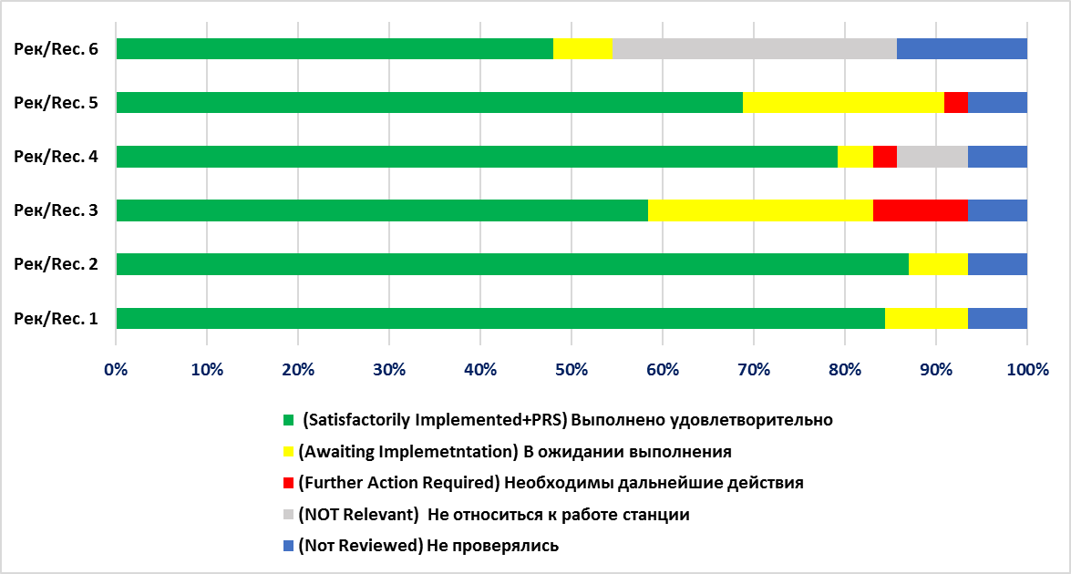
Main results:
– Kudankulam is the only MC site where implementation of the SOER 2011-3 recommendations was not reviewed.
– Three SOER 2011-3 recommendations at Loviisa, one recommendation at Novovoronezh and one recommendation at Rovno are of FAR status (further actions are needed).
– All SOER 2011-3 recommendations are completely implemented only at ten sites. According to the review results, there were no particular difficulties in implementing the SOER 2011-3 recommendations 1, 2 and 4 at the plants.
Issues:

– 13 sites face difficulties with implementation of the following two recommendations as per SOER 2011-3:
- Recommendation 3: Confirm completeness of emergency operational procedures and abnormality procedures in terms of responses to loss of cooling and spent fuel pool water level. This recommendation is not implemented at 11 plants.
- Recommendation 5: Check emergency operational procedures and abnormality procedures for deviations in terms of actions in case of storms, earthquakes, loss of MCR controls, floodings and/or similar situations in regard to incorporation of written warnings, spent fuel pool level and temperature monitoring provisions under these conditions. This recommendation is not implemented at 9 plants.

Potential improvement actions:
– We shall provide a possibility for the plants to extensively exchange the technical experience and knowledge regarding further improvements in the areas specified in the SOER 2011-3, rev. 1, SOER 2013-1, rev. 1, SOER 2015-1, rev. 1 and SOER 2015-2 recommendations.

– We shall provide a targeted support to the plants with the largest number of recommendations rated as FAR (further actions required) by means of the exchange of experience and dissemination of good practices form the plants of similar design, where these recommendations have been successfully implemented. Kudankulam, Armenian, Loviisa and Atomflot should be included into a list of plants that need the high-priority assistance.

– We shall use the capabilities of the SITS database to provide the MC affiliated plants with useful information for searching the best solutions during implementation of the individual SOER recommendations.

– We shall communicate the information on a new approach towards SOER optimization to all the plants during the peer reviews and pre-visits. We shall provide a SOER optimization presentation to the MC interface officers and site representatives in order to organize familiarization of the plant personnel with this information.
CHAPTER 6. OE PROGRAMME INDICATORS

In 2015, the London Office and the regional centres developed a group of 9 performance indicators for the OE Programme assessment both in the regional centres and in the industry globally. The system of indicators allows compare the OE programmes of different regional centres and assess the individual regional centre against the industry indicators.
The comparative analysis of the MC OE Programme 2018 indicators against the similar indicators of the other regional centres shows that MC has the best regional values of the following two indicators:
- timeliness of the event report (average duration of the report issue in MC is 102 days instead of the expected 140 days);
- significant events (significant + noteworthy) not reported (there were no events in MC that would be communicated via other information channels and not reported in the WANO OE database).
One MC OE Programme indicator is yellow (many improvements required), thus requiring additional actions to improve the situation. It is:
- quality of the event reports (such quality factors as event causes, event consequences and event comprehensibility are below the expected target of 3.8).
In 2018, all the MC sites submitted periodically the event reports (WER) to the MC Secretariat for uploading to the WANO OE database. The main shortcomings of the received WERs were deviations from the required WANO WER format as specified in MN 01, and the language of the reports provided.
As concerns the WER format, only 49 % of the event reports (175) submitted to the MC Secretariat met the WANO WER format. Some MC members provided the WER in a format different from that recommended, which required the OE team to additionally process the information in order to prepare the WER in the required format before being published.
As concerns the language of the WERs provided, only 46 % of WERs (164) were submitted to the MC Secretariat in the language of publication (English). 193 WERs were submitted in Russian and were translated by the MC Secretariat into English before being published.
Main Weaknesses in Quality of WERs Submitted to MC in 2018

WANO Member | WER /  (Significant) | Format |  | Language |  | WER modification by MC before publication
WANO Member | WER /  (Significant) | In compliance with WER format | Different from WER format | English | Russian | WER modification by MC before publication
Armenian | 6/0 |  | + |  | + | Abbreviations, textual comprehensibility, coding
Atomflot | 19/0 | + |  |  | + | Report to be fully re-organized as per WANO format
CEZ | 50/0 | + |  | + |  | Small corrections
Energoatom | 49/0 |  | + |  | + | Report to be fully re-organized as per WANO format
Fortum | 5/0 | + |  | + |  | Small corrections
Tianwan | 52/0 | + |  | + |  | Abbreviations, textual comprehensibility, coding
Kozloduy | 5/0 | + |  |  | + | Abbreviations, textual comprehensibility, coding
Kudankulam | 4/0 | + |  | + |  | Abbreviations, textual comprehensibility, coding
Bushehr | 6/0 | + |  |  | + | Report to be fully re-organized as per WANO format
Paks | 25/0 | + |  | + |  | Small corrections
Rosenergoatom | 108/2 |  | + |  | + | Abbreviations, textual comprehensibility, coding
Slovenske Elektrarne а.с. | 28/0 | + |  | + |  | Small corrections
Total | 357/2 | 194 | 163 | 164 | 193
All plants of Czech Republic, Slovakia, Hungary, Finland, China and India submitted the event reports (WER) in the required format in English; minor corrections relating mainly to the text understandability, were made prior to the WER uploading to the WANO OE database.
Potential improvement actions:
Below are actions implemented in the year 2018; however they are still important for implementation in the year 2019, too.

– The nuclear power plants and companies responsible for the event reporting shall provide the needed quality of information to be submitted in the WANO WER event report format according to the established criteria and requirements (MN 01). Such WER quality factors as event causes, event consequences and report comprehensibility need to be considered for the purpose of improvement.
– The nuclear power plants and companies responsible for the event reporting shall significantly reduce the number of preliminary event reports not updated within 140 days. Primarily, all significant and noteworthy reports must be updated in due time.

APPENDIX 1

WANO-MC WERs IN 2018

Report Number | Unit Reference | Event Date | Title
WER MOW 18-0001 | Kalinin 2 | 02.01.2018 | Generator's Internals Damage led to Unit 2 disconnection from the grid
WER MOW 18-0002 | Khmelnitsky 2 | 03.01.2018 | Unit 2 Was Disconnected From The Grid For Urgent Repairing
WER MOW 18-0003 | Dukovany 4 | 22.08.2017 | Foreign material found in valve 4XL10S09 of the Containment Pressure Suppression system
WER MOW 18-0004 | Dukovany 2 | 28.12.2017 | Diesel Generator 2QX of Unit 2 failed after the load sequence test.
WER MOW 18-0005 | Mochovce 1 | 19.12.2017 | Spurious actuation of safety system signal "Suction from hermetic zone"
WER MOW 18-0006 | South Ukraine 3 | 11.01.2018 | The Unit was down powered due to loss of the reactor coolant pump (RCP)
WER MOW 18-0007 | Leningrad 4 | 15.01.2018 | Steamed leakage from the pipe of blowdown and cooldown system led to the Unit shut down
WER MOW 18-0008 | Dukovany 4 | 20.09.2017 | Smoke in the room caused by pump sealing during test run
WER MOW 18-0009 | Rovno 2 | 19.01.2018 | Unit 2 disconnected from the grid
WER MOW 18-0010 | Rovno 2 | 15.12.2017 | Pressure seal leak of the Motor Driven Feedwater Pump (2MD FWP-5)
WER MOW 18-0011 | Rostov 1 | 25.08.2017 | Electrical Load Reduction to Repair a Through-Wall Defect on the Vent Valve Line Associated with the Separate Discharge Pump Piping
WER MOW 18-0012 | Rostov 1 | 31.01.2018 | The main generator disconnected from the grid by protection actuation
WER MOW 18-0013 | Zaporozhye 6 | 30.01.2018 | Electrical Load Reduction from the Loss of Turbine Driven Feedwater Pump No.1
WER MOW 18-0014 | Dukovany 1 | 16.09.2017 | Exchange of hoses on the cooling water lines to the exchanger
WER MOW 18-0015 | Dukovany 3 | 06.10.2017 | Foreign material found near valve
WER MOW 18-0016 | Dukovany 3 | 26.09.2017 | Plastic sleeve found in reactor pit
WER MOW 18-0017 | Armenia 2 | 31.01.2018 | Dropwise Oil Leaks Observed from the Bearing No.1 Sealing Cap on Emergency Charge Pump No.2
WER MOW 18-0018 | Mochovce 1 | 05.02.2018 | Low pressure emergency injection pump discharge valve unavailability
WER MOW 18-0019 | South Ukraine 1 | 08.02.2018 | High Pressure Heaters HPH 6A and HPH6B removed from service for unplanned repairing
WER MOW 18-0020 | Tianwan 3 | 28.11.2017 | Outdoors fire-fighting pipelines broken resulted in a large ejection of fire-fighting water
WER MOW 18-0021 | Tianwan 1 | 06.12.2017 | An alarm for temperature being higher than 180ºC appeared for the measuring point at the discharge pipeline for the main steam isolation valve
WER MOW 18-0022 | Tianwan 3 | 12.12.2017 | A scaffold was found not removed after opening the manhole gate of train B seawater inlet chamber of Unit 3 # 1 condenser.
WER MOW 18-0023 | Kalinin 3 | 14.02.2018 | Two main circulation pumps (MCP) trip followed by Unit 3 down powered
WER MOW 18-0024 | Kursk 4 | 18.02.2018 | Unit 4 disconnected from the grid
WER MOW 18-0025 | Paks 3 | 04.12.2017 | Safety system inoperability caused by cell damage of safety system battery due to the load sequencing program function being disabled
WER MOW 18-0026 | Kalinin 1 | 18.02.2018 | Unit 1 disconnected from the grid for a leak repairing
WER MOW 18-0027 | Mochovce 2 | 15.02.2018 | Superemergency feed water pump recirculation valve unavailability
WER MOW 18-0028 | Paks 2 | 11.12.2017 | Circumstances of 21SD02W001 condenser perforation
WER MOW 18-0029 | Kalinin 2 | 23.02.2018 | Condenser level controller stem decoupling followed by the turbogenerator (TG-2) trip
WER MOW 18-0030 | Smolensk 2 | 27.02.2018 | Oil leak on the turbine automatic сontrol and protection system pipeline led to the manual trip of turbogenerator 4
WER MOW 18-0031 | Kursk 3 | 02.03.2018 | Abruption of a current lead wire on the phase A 750 kV disconnector led to an unplanned repairing of unit 3
WER MOW 18-0032 | Leningrad 2 | 03.03.2018 | The second 330 kV bus system switched off by the bus differential protection actuation
WER MOW 18-0033 | Leningrad 1 | 05.03.2018 | Spontaneous throttling control valve closing followed by the unit fast controlled power reduction
WER MOW 18-0034 | Dukovany 1 | 29.10.2017 | Severe weather – clogging of suction strainers of Circulating Cooling Water pumps
WER MOW 18-0035 | Dukovany 3 | 24.10.2017 | Inoperability of the Isolation Valve due to the effects of thermal pressurization
WER MOW 18-0036 | Temelin 1 | 28.12.2017 | Foreign material found in the shaft of the transport container
WER MOW 18-0037 | Temelin 1 | 28.12.2017 | Foreign material found in the technology
WER MOW 18-0038 | Temelin 1 | 28.12.2017 | Foreign material found in the shaft of the transport container
WER MOW 18-0039 | Rostov 4 | 07.03.2018 | Unit 4 disconnected from the grid
WER MOW 18-0040 | Tianwan 2 | 27.12.2017 | High leak rate of hydrogen from Unit 2 generator and rapid decrease of hydrogen purity led to large increase of hydrogen supplementation and exchange amount
WER MOW 18-0041 | Tianwan 2 | 28.12.2017 | Reactive power fluctuated largely during power increase of 2XKA40 emergency diesel generator
WER MOW 18-0042 | Tianwan 1 | 15.12.2017 | Steam leaked from the thermal insulation at outlet position of Unit 1 feed-water byroad valve 1LAB40AA113
WER MOW 18-0043 | Leningrad 2 | 13.03.2018 | Unit power reduction due to feed water pump (2FWP-5) urgent repairing
WER MOW 18-0044 | Kalinin 3 | 21.11.2017 | A Level Controller Failure at the First Stage Condensate Pump Discharge Due to Slide Valve Deformation
WER MOW 18-0045 | Kalinin 1 | 18.11.2017 | Increased Vibration and Temperature on a Turbine Generator Bearing from Foreign Material Intrusion
WER MOW 18-0046 | Smolensk 3 | 09.09.2017 | An Evaporator Safety Valve Will Not Move When Tested with a Control Switch
WER MOW 18-0047 | Balakovo 3 | 25.10.2017 | Unit 3 thermal power reduction due to a failed weld on the drain nozzle in a non-isolatable part of the Auxiliary Steam Header
WER MOW 18-0048 | Beloyarsk 4 | 21.08.2017 | Failure of a channel in the Ex-Core Neutron Flux Monitoring System caused by a software error
WER MOW 18-0049 | Leningrad 1 | 11.11.2017 | Inadvertent reactor protection group control rod insertion into the core due to broken conductors on the drive mechanism magnetic coupler power cable
WER MOW 18-0050 | Tianwan 4 | 15.12.2017 | Improper material of supporting flange of fire-fighting system filter of part of buildings in Unit 4 Nuclear Island was used
WER MOW 18-0051 | Tianwan 4 | 16.12.2017 | The pipeline leaked behind the manual valve of fire-fighting water
WER MOW 18-0052 | Leningrad-2 1 | 25.03.2018 | Unit 1 Leningrad NPP-2 turbogenerator disconnected from the grid
WER MOW 18-0053 | Armenia 2 | 26.03.2018 | Unit 2 was shut down and disconnected from the grid for urgent repairing
WER MOW 18-0054 | Leningrad-2 1 | 26.03.2018 | Unit 1 Leningrad NPP-2 Main Circulation Pump tripped
WER MOW 18-0055 | Beloyarsk 3 | 21.10.2017 | Loss of Power to Category 3 0.4 kV Standby Power Buses After a Cutout Shorted
WER MOW 18-0056 | Temelin 1 | 21.12.2017 | Fuel Leakage During Campaign
WER MOW 18-0057 | Rostov 1 | 28.03.2018 | Personnel Error during scheduled work at switchyard led to the unit disconnection from the grid
WER MOW 18-0058 | Leningrad 2 | 16.10.2017 | Electrical Load Reduction from Condenser Vacuum Degradation Due to a Closed Position of the Steam-Gas Mixture Suction Header Drain Valve
WER MOW 18-0059 | Leningrad-2 1 | 09.01.2018 | A Through-Wall Crack in the Steam Generator Main Safety Valve Body-Seat Weld Attachment
WER MOW 18-0060 | Tianwan 1 | 10.01.2018 | NO.2 low pressure regulating valve of Unit 1 turbine jammed
WER MOW 18-0061 | Tianwan 1 | 21.11.2017 | Higher horizontal vibration happened to motor bearing of No.1 circulation pump 1PAC22AP001 of Unit 1
WER MOW 18-0062 | Tianwan 3 | 27.12.2017 | The linear leakage at the cooling water inlet line nozzle of No.3 Primary Coolant Pump starting electromagnet cooling water system
WER MOW 18-0063 | Khmelnitsky 1 | 03.04.2018 | A ground fault of the generator stator winding followed by the unit disconnection from the grid
WER MOW 18-0064 | Temelin 1 | 11.01.2018 | Foreign material in cold header of steam generator
WER MOW 18-0065 | Balakovo 1 | 11.08.2017 | Traces of a Water Leak into the Diesel Generator Oil
WER MOW 18-0066 | Smolensk 3 | 26.01.2018 | A Turbine Generator was tripped off line due to excitation circuit insulation resistance dropping
WER MOW 18-0067 | Zaporozhye 6 | 08.04.2018 | Unit 6 reactor automatically scrammed by protection actuation
WER MOW 18-0068 | Balakovo 3 | 05.01.2018 | A Limit Switch Failure to Actuate Resulted in Containment Bridge Crane Load Trolley Damage
WER MOW 18-0069 | Dukovany 3 | 28.11.2017 | Leak from Essential Service Water (ESW) pipeline due to corrosion his venting pipe
WER MOW 18-0070 | Dukovany 3 | 04.12.2017 | Broken venting pipe on Essential Service Water (ESW) due to his corrosion
WER MOW 18-0071 | Kola 3 | 02.02.2018 | Generator’s brushgear sparking due to eroded surface of the “+” rocker
WER MOW 18-0072 | Dukovany 4 | 12.04.2018 | Planned Shutdown of Unit 4 to Carry out Check of Emergency Feedwater Pipeline Heterogeneous Welds
WER MOW 18-0073 | Tianwan 3 | 21.01.2018 | The blade of cooling fan 30BAT13AN012 of main transformer ruptured
WER MOW 18-0074 | Tianwan 3 | 13.01.2018 | Lubricant leaked from the cracked electric actuator of atmospheric release valve 30LBU10AA201
WER MOW 18-0075 | Tianwan 2 | 16.01.2018 | Most positive terminal posts of the accumulator battery 2BTD53 of Unit 2 are badly corroded
WER MOW 18-0076 | Tianwan 3 | 31.10.2017 | Low level of Unit 3 pressurizer triggered a shutdown protection signal
WER MOW 18-0078 | Dukovany 3 | 22.04.2018 | Unit 3 of Dukovany NPP was conservatively shutdown to check heterogeneous welds
WER MOW 18-0079 | Smolensk 2 | 22.04.2018 | Unit 2 was manually shutdown for an unplanned maintenance
WER MOW 18-0080 | Kola 1 | 17.01.2018 | Incorrect Low Pressure Heater Level Meter Indications Due to Cold Air Ingress into the Turbine Hall
WER MOW 18-0081 | Tianwan 2 | 20.01.2018 | The bypass valve of Unit 2 turbine was not removed from the closure limit during the activity test
WER MOW 18-0082 | Tianwan 2 | 23.01.2018 | Air release pre-isolating valve of turbine in Unit 2 is unable to reseat after opening
WER MOW 18-0083 | Zaporozhye 2 | 07.03.2018 | Safety System Train Actuation on the Loss of Power to a 6 kV Vital Bus During Refueling
WER MOW 18-0084 | Kola 4 | 12.03.2018 | Through wall crack of the drainage valve of the second extraction steam separator led to manual trip of TG-7
WER MOW 18-0085 | Smolensk 2 | 27.04.2018 | Leak of the feed water pressure header followed by unit 2 an unplanned repairing
WER MOW 18-0086 | Mochovce 1 | 25.04.2018 | A foreign material was found in the absorber part of the control rod
WER MOW 18-0087 | Rostov 4 | 01.05.2018 | Unit 4 was manually tripped upon an urgent application
WER MOW 18-0088 | Tianwan 3 | 01.02.2018 | Electric protection actions caused by 6 kV power distribution equipment led to bus cable loss of power and fire alarms in involved electric rooms
WER MOW 18-0089 | Tianwan 3 | 28.02.2018 | Unit 3 steam generator level dropping triggered the reactor automatically shutdown
WER MOW 18-0090 | Tianwan 3 | 29.03.2018 | Low level of the steam generator of Unit 3 caused by the failure of I&C system network switch triggered automatically shutdown of the reactor
WER MOW 18-0091 | Paks 3 | 22.01.2018 | Reactor scram at Unit 3 operating at rated power during on-line maintenance of safety system train “X”
WER MOW 18-0092 | Leningrad-2 1 | 08.05.2018 | Unit 1 Leningrad NPP-2 turbogenerator disconnected from the grid
WER MOW 18-0093 | Temelin 1 | 11.01.2018 | Plug jammed in primary hot collector of Steam Generator while seating it for inspection of heat transfer tubes at high level of the primary coolant
WER MOW 18-0094 | Smolensk 1 | 10.05.2018 | A Fatal Contractor Accident
WER MOW 18-0095 | Paks 4 | 08.11.2017 | Simultaneous unavailability of emergency power supply of two vital power supply systems due to failed start of unit 4 Y diesel generator with the unit in refuelling outage
WER MOW 18-0096 | Paks 4 | 22.11.2017 | Foreign object induced leakage of a relief valve providing cold overpressure protection to the reactor vessel in pressurized cold condition of unit 4
WER MOW 18-0097 | Paks 4 | 27.11.2017 | Inoperability of unit 4 X safety system during implementation of load sequencing program of the X safety system due the load sequencing function being disabled
WER MOW 18-0098 | Paks 4 | 27.11.2017 | Inoperability of unit 4 Y safety system due to failure of the makeup water booster pump during unit heatup
WER MOW 18-0099 | Leningrad-2 1 | 12.05.2018 | Main Condenser’s low level led to Unit 1 power decreasing
WER MOW 18-0100 | Temelin 1 | 16.02.2018 | Contamination of Contractor Personnel
WER MOW 18-0101 | Temelin 1 | 23.01.2018 | Graphite found in cold header of steam generator
WER MOW 18-0102 | Dukovany 1 | 27.02.2018 | Foreign Material found in Cold Supply Plant Pipe
WER MOW 18-0103 | Rostov 3 | 15.05.2018 | Steaming leakage found on the feedwater header to steam generators led to the unit setback and disconnection from the grid
WER MOW 18-0104 | Temelin 1 | 07.02.2018 | Foreign materials found in the core
WER MOW 18-0105 | Icebreaker Fleet 1 | 06.01.2018 | A Leak from the Steam Generator Internal Component Tubing
WER MOW 18-0106 | Icebreaker Fleet 1 | 20.03.2018 | A Leak from the Steam Generator Internal Component Tubing
WER MOW 18-0107 | Rostov 4 | 22.05.2018 | Hydrogen leak from the main generator
WER MOW 18-0108 | Leningrad 4 | 27.05.2018 | A Leak from the Supply Waterway-Turbine Condenser Attachment
WER MOW 18-0109 | Icebreaker Fleet 1 | 12.12.2017 | A Leak from the Steam Generator Internal Component Tubing
WER MOW 18-0110 | Kursk 1 | 27.05.2018 | Kursk unit 1 shutdown per work application to allow troubleshooting into high activity and humidity inside the box of Main Circulation Pump 11
WER MOW 18-0111 | Paks 4 | 20.01.2018 | Inoperability of ’W’ (Y;X;W) safety system due to replacement of the manual actuating assembly of unit 4 essential service water, in consequence of disabling the diesel generator
WER MOW 18-0112 | Zaporozhye 2 | 23.05.2018 | The unit was disconnected from the grid for finding aerosols sources inside of containment premises.
WER MOW 18-0113 | Armenia 2 | 09.11.2017 | Deficient Pre-Installation Gasket Assembly Caused a Leak from the Valve Cover-Body Flanged Connection
WER MOW 18-0114 | Bohunice 3 | 30.05.2018 | Essential water system pump was damaged
WER MOW 18-0115 | Leningrad 3 | 01.06.2018 | Transformer 3TR tripped followed by diesel generators of unit 3 started up.
WER MOW 18-0116 | Armenia 2 | 29.11.2017 | Turbine Generator No.4 Had to Be Tripped Off Line Due to Steam Generator Water Chemistry Degradation
WER MOW 18-0117 | Khmelnitsky 1 | 03.06.2018 | Reactor Downpower from a Turbine Driven Feedwater Pump Trip
WER MOW 18-0118 | Icebreaker Fleet 1 | 09.08.2017 | A Leak from the Steam Generator Internal Tubing
WER MOW 18-0119 | Beloyarsk 4 | 06.06.2018 | Turbo Generator of unit 4 disconnected from the grid.
WER MOW 18-0120 | Icebreaker Fleet 1 | 11.06.2017 | Steam Generator internal Tubing of Icebreaker Vaygach was found leaked.
WER MOW 18-0121 | Icebreaker Fleet 1 | 25.11.2017 | Steam Generator Internal Component Tubing was found leaked.
WER MOW 18-0122 | Khmelnitsky 2 | 08.06.2018 | Turbo generator 2 tripped from the grid.
WER MOW 18-0123 | Tianwan 3 | 01.03.2018 | Protective shutdown of unit 3 main feed-water pump No. 2
WER MOW 18-0124 | Tianwan 1 | 01.03.2018 | Linear leakage on process hole of upper part of the radial thrust bearing casing of Main CoolantPump No. 1 of Unit1.
WER MOW 18-0125 | Tianwan 2 | 10.03.2018 | Electric leakage occurred to the wire of temporary pump in the ground pit 2GMC70BB001 and smoke came out of it.
WER MOW 18-0126 | Kalinin 1 | 12.06.2018 | A Fatality at the Kalinin NPP
WER MOW 18-0127 | South Ukraine 2 | 14.06.2018 | Unit 2 disconnected from the grid due to high temperature of the turbine generator bearing.
WER MOW 18-0128 | Kalinin 3 | 16.06.2018 | Unit 3 disconnected from the grid due to a primary circuit leak
WER MOW 18-0129 | Leningrad 1 | 16.06.2018 | A leak of a drain pipe of the emergency core coolant system followed by the unit disconnection from the grid
WER MOW 18-0130 | Kursk 1 | 29.03.2018 | Mast Rupture During CRDM Transportation
WER MOW 18-0131 | Bilibino 4 | 20.03.2018 | Pump NOS 4A Associated with the Control and Protection System Cooling Circuit Undergoes Unplanned Repairs Due to Bearing Degradation
WER MOW 18-0132 | Novovoronezh-2 1 | 17.03.2018 | Steam Generator Emergency Cooldown Heat Exchanger Tube Leaks into the Secondary System Identified During Planned Outage
WER MOW 18-0133 | Tianwan 1 | 19.03.2018 | Breakage of the Weld between the Connecting Pipe and the Main Pipe of the Primary Valve of Water Pressure Gauge
WER MOW 18-0134 | Tianwan 1 | 15.04.2018 | Leakage of Heat Exchanger for Generator Stator Cooling Water
WER MOW 18-0135 | Icebreaker Fleet 1 | 20.05.2018 | 50 Years of Victory Icebreaker - a Leak from the Steam Generator Internal Component Tubing
WER MOW 18-0136 | Bohunice 4 | 26.03.2018 | Inadequacies found during transport of main cooling pump (MCP) diffusers.
WER MOW 18-0137 | Mochovce 2 | 04.02.2018 | Shutdown one turbine generator due to leakage on the steam bleed
WER MOW 18-0138 | Mochovce 3 | 07.09.2017 | Damage of valves, internal impurities of valves and pipelines
WER MOW 18-0139 | Loviisa 2 | 03.01.2018 | Fire on the roof of LO2 auxiliary building
WER MOW 18-0140 | Loviisa 2 | 14.03.2018 | Seal tightness of refueling pool gate was lost
WER MOW 18-0141 | Zaporozhye 5 | 15.08.2017 | An Essential Service Water Pump Removed from Service to Allow Repairs
WER MOW 18-0142 | Bohunice 4 | 18.10.2017 | Not starting the essential service water pump No. 7 during a load sequencing test
WER MOW 18-0143 | Kozloduy 5 | 30.01.2018 | In-Situ Dump Valve Changeover to Control Mode During New Cable Laying Per Work Permit
WER MOW 18-0144 | Bohunice 4 | 25.06.2018 | The 400kV line trip led to unit 4 transient
WER MOW 18-0145 | Kozloduy 6 | 28.06.2018 | A breaker failed to switch on during the automatic load sequencing test.
WER MOW 18-0146 | Kudankulam 2 | 19.02.2018 | Planned shut down of unit in due to hydrogen leak from generator
WER MOW 18-0147 | Temelin 1 | 03.07.2018 | The Essential Service Water pump was not able to provide sufficient flow rate.
WER MOW 18-0148 | Dukovany 4 | 04.07.2018 | Internal sealing leakage of a Main Circulation Pump
WER MOW 18-0149 | Balakovo 1 | 16.12.2017 | Electrical Load Had to Be Reduced Due to Steaming from a Pulse Line for Measuring Steam Pressure Downstream of Turbine Stop and Control Valves
WER MOW 18-0150 | Bohunice 4 | 02.03.2018 | Reduction of under-pressure on the RCP room
WER MOW 18-0151 | Temelin 2 | 24.04.2018 | Work injury when working on an not tag-out device
WER MOW 18-0152 | Kozloduy 6 | 22.01.2018 | A primary water balance deviation.
WER MOW 18-0153 | Kozloduy 5 | 26.01.2018 | Water leak from the service water pipe located on the trestle bridge.
WER MOW 18-0154 | Rovno 2 | 16.07.2018 | Turbo generator 4 disconnected from the grid by protection actuation.
WER MOW 18-0155 | Beloyarsk 4 | 06.07.2018 | Reactor Coolant Pump Trip due to the drive controller frequency converter electronic card malfunction.
WER MOW 18-0156 | Bushehr 1 | 12.02.2018 | Unexpected actuation of reactor emergency protection at the time of reactor power decrease.
WER MOW 18-0157 | Tianwan 1 | 02.05.2018 | Valve Failed to Close Normally Due to Insufficient Motor Output
WER MOW 18-0158 | Tianwan 3 | 26.04.2018 | Closing of Fire Valve by Mistake Caused Abnormal Negative Pressure in Containment Annulus
WER MOW 18-0159 | Tianwan 3 | 17.03.2018 | Lifting Pipe and Pump Shaft of Backwash Pump Broke
WER MOW 18-0160 | Tianwan 1 | 05.04.2018 | Large Vibration Occurred in Upper Bearing of Motor of Circulating Cooling Water Pump
WER MOW 18-0161 | Paks 1 | 06.06.2018 | Generator 2 tripped on ‘loss of generator excitation’ protection signal due to ring fire on exciter commutator of of Unit 1
WER MOW 18-0162 | Beloyarsk 3 | 26.03.2018 | Recurrent repairings of a booster feed water pump.
WER MOW 18-0163 | Kola 2 | 13.04.2018 | Turbine 3 high pressure reheaters were swithced off by protection actuation on the first limit of hi-hi level
WER MOW 18-0164 | Khmelnitsky 2 | 27.07.2018 | Flow controller valve malfunction led to one of three trains of safety system unavailability
WER MOW 18-0165 | Rovno 4 | 11.04.2018 | Water conductivity incresing downstream of steam generators blowdown water cleanup system
WER MOW 18-0166 | Rovno 4 | 16.04.2018 | Bearing #1 temperature increase on a condensate pump of the second stage
WER MOW 18-0167 | Kursk 2 | 26.07.2018 | Fuel channel integrity monitoring system detected gas temperature increasing
WER MOW 18-0168 | Dukovany 2 | 25.03.2018 | Contamination of contractor´s worker detected on border monitor of controlled area
WER MOW 18-0169 | Dukovany 1 | 26.03.2018 | Use of different type of seal on flange joint for safety classification devices
WER MOW 18-0170 | Kursk 3 | 27.07.2018 | One of two generators was disconnected from the grid due to a short circuit in the rotor’s current lead.
WER MOW 18-0171 | Loviisa 2 | 23.02.2018 | Turbine power reduction due to control valve positioner failure
WER MOW 18-0172 | Rovno 4 | 28.04.2018 | Abnormal leaks on the shaft seal of a separator-steam superheater moisture drain pump
WER MOW 18-0173 | Rovno 2 | 02.05.2018 | High temperature of a sealing water supplying and draining hoses of a feed water pump bearing
WER MOW 18-0174 | Rovno 1 | 22.06.2018 | A main circulation pump tripped followed by the unit powered down.
WER MOW 18-0175 | Rovno 4 | 07.05.2018 | Turbine rotor relative expansion of low pressure cylinders measuring and vibration rate measuring of turbine bearing pedestals chennels malfunction
WER MOW 18-0176 | Balakovo 3 | 12.04.2018 | An oil pump of a main circulation pump unplanned repairing
WER MOW 18-0177 | Kalinin 3 | 16.05.2018 | Steam jet air ejectors failure followed by the unit shutdown on vacuum degradation
WER MOW 18-0178 | Balakovo 1 | 25.05.2018 | A high pressure heater had to be removed from service to allow repairs on leaked planar-spiral tubes
WER MOW 18-0179 | Kursk 2 | 02.08.2018 | Oil leak from the hatch of turbine automatic control and protection system followed by reactor automatic scram.
WER MOW 18-0180 | Kursk 2 | 02.08.2018 | Main Transformer 2TR protection actuation followed by diesel generators start-up
WER MOW 18-0181 | Leningrad 2 | 02.08.2018 | Hydrogen leak followed by turbogenerator disconnection from the grid
WER MOW 18-0182 | Mochovce 1 | 23.04.2018 | Interruption of refuelling after locking the control rod assembly catcher without catching the assembly
WER MOW 18-0183 | Paks 2 | 26.02.2018 | Simultaneous inoperability of two vital power supply systems due to a ‘fails to start’ signal on the ‘W’ (out of three Y,X,W) diesel generator
WER MOW 18-0184 | Armenia 2 | 01.08.2018 | A leaking pipe of the sealing water on the hydrocyclone draine line of main circulation pump followed by unit two manual shut down.
WER MOW 18-0185 | Loviisa 2 | 30.01.2018 | Unregistered pressure device use after operation permit expiration
WER MOW 18-0186 | Zaporozhye 1 | 01.12.2017 | Steaming out from the bleeder trip valve flange of the turbine bleeding pipe to the high pressure heater.
WER MOW 18-0187 | Zaporozhye 3 | 13.01.2018 | Melted Sensing Clamp Control Cable Insulation Observed in the Negative Sequence Overcurrent Protection Circuits
WER MOW 18-0188 | Zaporozhye 1 | 17.01.2018 | A Debris-Filled Flow from an Operating Condenser into a Low Point Drain Tank Caused Off-Spec Secondary Water Chemistry
WER MOW 18-0189 | Zaporozhye 4 | 20.04.2018 | A Pulse Line and a Root Valve Collided with the Metal Liner in Pipeline Penetration
WER MOW 18-0190 | Zaporozhye 6 | 18.04.2017 | A 750 kV Zaporozhye NPP-Dnepropetrovsk Substation Overhead Power Line Tripped off
WER MOW 18-0191 | Mochovce 2 | 17.05.2018 | Loss of electrical power supply of two valves of the emergency spraying system during the test
WER MOW 18-0192 | Dukovany 1 | 10.05.2018 | A relay failure caused the start of Automatic Standby System and a controlled reactor output reduction by the operation of Electrical Protections
WER MOW 18-0193 | Dukovany 1 | 22.05.2018 | Worker’s exposure to radiation during incorrect handling of the radiating source
WER MOW 18-0194 | Dukovany 1 | 05.06.2018 | Foreign Material in the inter-tube area of the Steam Generator secondary part
WER MOW 18-0195 | Tianwan 2 | 04.05.2018 | Quality of Blowdown Water from the Steam Generator Deteriorated
WER MOW 18-0196 | Tianwan 3 | 04.05.2018 | Insulation at the Bottom of Main Feedwater Pump Caught Fire
WER MOW 18-0197 | Kursk 4 | 19.08.2018 | Reactor Protection System Actuation During Main Safety Valve Spring System Adjustment
WER MOW 18-0198 | Armenia 2 | 14.08.2018 | Essential Service Water Pump Repairs
WER MOW 18-0199 | Dukovany 4 | 30.04.2018 | Main Circulation Pump Shutdown due to Insufficiently Secured Steam Generator Measuring Circuit
WER MOW 18-0200 | Paks 2 | 03.04.2018 | Inoperability of unit 2 Y safety system due to deenergization of 0.4 kV essential switchboard caused by breaker failure of the Y safety system’s make-up water oil pump 1
WER MOW 18-0201 | Temelin 1 | 20.04.2018 | Unauthorized work in Very High Voltage Conduction Safety Zone
WER MOW 18-0202 | Loviisa 1 | 12.04.2018 | Delay of the material lock preventive maintenance
WER MOW 18-0203 | Smolensk 1 | 04.09.2018 | The unit was shutdown per an urgent application to find out a steaming sources inside the room of the blowdown and cooldown system and allow repairs.
WER MOW 18-0204 | Bohunice 4 | 11.06.2018 | Leakage in the pressurizer safety valve at 2.5 MPa leak test of the primary circuit
WER MOW 18-0205 | Kalinin 2 | 06.09.2018 | A diesel generator switched off by protection actuation during the test
WER MOW 18-0206 | Tianwan 2 | 06.05.2018 | Frequent Action of the Main Feedwater Control Valve
WER MOW 18-0207 | Tianwan 4 | 26.04.2018 | Smoldering of Insulation Happened at the Main Steam Valve Station
WER MOW 18-0208 | Tianwan 2 | 14.06.2018 | Tripping of the Charging Pump Caused by Rupture of the Plunger Assembly Adapter
WER MOW 18-0209 | Temelin 1 | 07.09.2018 | A leakage occurred in the Auxiliary Service Building for Primary Systems
WER MOW 18-0210 | Tianwan 1 | 06.06.2018 | Abnormal Acetylene Content of Main TransformerCaused Unit to be Shutdown for Maintenance
WER MOW 18-0211 | Tianwan 2 | 23.06.2018 | An Alarm Was Triggered for Unit Due to Short Circuit of Instrument and Control Cable
WER MOW 18-0212 | Tianwan 1 | 19.06.2018 | Broken Compressor Belt Triggered an Alarm in Main Control Room
WER MOW 18-0213 | Tianwan 1 | 17.06.2018 | Failed Seal Caused Internal Leakage of Stator Cooling Water Heat Exchanger
WER MOW 18-0214 | Tianwan 2 | 09.06.2018 | Fire on Rectifier Transformer Caused Partial Unavailability of Chlorination System
WER MOW 18-0215 | Tianwan 2 | 16.06.2018 | Loose Cover of Methyl Iodide Generator Caused Leakage of Radioactive Gas
WER MOW 18-0216 | Paks 3 | 03.05.2018 | Actuation of cold overpressure protection during shutdown of unit 3 for outage,due to imbalance of make-up water feed and bleed
WER MOW 18-0217 | Bilibino 3 | 14.03.2018 | A Lo-Lo Cooling Water Level Observed in the Mobile Diesel Generator Cooling System
WER MOW 18-0218 | Kola 3 | 12.04.2018 | Maintenance of CRDM Electrical Components Reveals Failure of CRDM 21-40
WER MOW 18-0219 | Khmelnitsky 2 | 17.09.2018 | Diesel generators switched on due to operators’ mistake.
WER MOW 18-0220 | Kalinin 4 | 29.06.2018 | Circulating Water Pump 4VC10D04 Removed from Service Due to Bearing Separator Failure on Planetary Gear Reducer PVA80
WER MOW 18-0221 | South Ukraine 3 | 14.09.2018 | A Loss of the Reactor Coolant Pump
WER MOW 18-0222 | Novovoronezh-2 1 | 23.04.2018 | Unit Restart Delayed Due to Disengaged Mast-Absorber Rods Due to Poor Quality of Control Operations
WER MOW 18-0223 | Novovoronezh-2 1 | 18.05.2018 | Loss of Active Steel Integrity in the Generator Stator
WER MOW 18-0224 | Temelin 2 | 12.07.2018 | Discovery of foreign items in the reactor
WER MOW 18-0225 | Novovoronezh-2 1 | 17.09.2018 | Novovoronezh NPP 2-1 Had to Be Tripped after Liquid was Found in the Main Generator.
WER MOW 18-0226 | Kalinin 1 | 20.06.2018 | Reactor Power Reduction to Allow Unplanned Repairs on Turbine Driven Pump No.1 Due to Increased Axial Shift of the Shaft.
WER MOW 18-0227 | Zaporozhye 2 | 22.09.2018 | The unit was disconnected from the grid for a leak repairing
WER MOW 18-0228 | Kursk 3 | 10.06.2018 | A Leak from the Isolable Section of the Drain Line Associated with the Main Feedwater Leg
WER MOW 18-0229 | Balakovo 2 | 24.09.2018 | Reactor scrammed automatically on a reactor protection actuation.
WER MOW 18-0230 | Paks 4 | 18.02.2018 | Failure of the unit 4 Reactor Protection System temperature measurements in cold leg of loop 5
WER MOW 18-0231 | Beloyarsk 3 | 15.05.2018 | A Feedwater Pump Had to Undergo Unplanned Maintenance Due to End Sealing Contact Ring Degradation
WER MOW 18-0232 | Paks 1 | 26.02.2018 | Power decrease of turbine 2 to 100 MW due to actuation of low level protection of moisture separator reheater 2nd stage
WER MOW 18-0233 | Balakovo 2 | 02.04.2018 | Charging Pump Undergoes Unplanned Repairs Due to Radial Wobbling of Bearing Axle
WER MOW 18-0234 | Kola 4 | 03.08.2018 | Spurious Alarms During Switchover Operations Triggered Unnecessary Service Water Pump Actuations
WER MOW 18-0235 | Icebreaker Fleet 1 | 15.06.2018 | A Leak from the Steam Generator Internal Tubing
WER MOW 18-0236 | Icebreaker Fleet 1 | 25.06.2018 | A Leak from the Steam Generator Internal Tubing
WER MOW 18-0237 | Tianwan 2 | 10.07.2018 | The valve 2KAA44AA142 of Unit 2 intermediate cooling water system for important consumers had water ingress to its electric actuator.
WER MOW 18-0238 | Tianwan 4 | 01.08.2018 | The hoistway door was opened suddenly during operation of Unit 4 Turbine Building elevator.
WER MOW 18-0239 | Kudankulam 2 | 02.08.2018 | PLANNED SHUT DOWN OF UNIT-2 DUE TO HIGH HYDROGEN CONCENTRATION IN GENERATOR STATOR WATER SYSTEM
WER MOW 18-0240 | Temelin 2 | 06.08.2018 | Foreign Materials Found in the Reactor
WER MOW 18-0241 | Paks 3 | 12.03.2018 | Turbine trip on unit 3 due to actuation of vibration protection
WER MOW 18-0242 | Leningrad-2 1 | 05.10.2018 | A Steam Generator Pilot Operated Safety Valve Main Valve Failed to Open During Testing at the Shutdown Unit
WER MOW 18-0243 | Bushehr 1 | 25.10.2017 | Reactor power decrease due to drop one of control rods
WER MOW 18-0244 | Bushehr 1 | 12.02.2018 | Automatic unplanned shutdown of a main reactor cooling pump due to increase of water level of the related steam generator
WER MOW 18-0245 | Kudankulam 1 | 25.06.2018 | PLANNED SHUT DOWN OF TDFP-2 OF UNIT1 DUE TO HIGH VIBRATION AND ABNORMAL SOUND
WER MOW 18-0246 | Rovno 1 | 08.10.2018 | Reactor Thermal Power Reduction Due to Circulating Water Pump Malfunction
WER MOW 18-0247 | Rovno 2 | 19.07.2018 | Loss of Turbine Generator TG No. 3 Load.
WER MOW 18-0248 | Rovno 4 | 02.07.2018 | A Leak from High Pressure Heater Tubing
WER MOW 18-0249 | Novovoronezh 5 | 18.07.2018 | Hydraulic leak testing revealed a leak from a steam generator blowdown pipeline during a statutory outage.
WER MOW 18-0250 | Novovoronezh 4 | 31.07.2018 | Autotransfomer Tripped Due to Deliberate Mechanical Damage to Control Cable
WER MOW 18-0251 | Temelin 1 | 28.05.2018 | Making the 6 kV Breaker on a Short Circuit
WER MOW 18-0252 | Rovno 3 | 12.07.2018 | High Bearing Shoe Temperature on Circulating Water Pump No.1
WER MOW 18-0253 | Rovno 1 | 20.08.2018 | Recirculation Valves Associated with Motor Driven Feedwater Pump No.1 Failed to Open Due to KP-140 Type Secondary Instrument Inoperability.
WER MOW 18-0254 | Rovno 3 | 28.08.2018 | Additional Noise near Bearing No.4 on the Generator Shaft Sealing System Pump
WER MOW 18-0255 | Rovno 2 | 04.09.2018 | Mechanical Stem Damage on a Hydrogen Supply Valve Associated with Turbine Generator No. 3
WER MOW 18-0256 | Tianwan 4 | 26.07.2018 | Leakage in Spent Fuel Pool Liner Leakage Monitoring System Due to Improper Welding
WER MOW 18-0257 | Rovno 3 | 04.09.2018 | Fire Alarm Mechanism Inoperable
WER MOW 18-0258 | Rostov 1 | 11.10.2018 | #PRELIMINARY# Maintenance Personnel Received Injuries During Generator Gas System Testing
WER MOW 18-0259 | Rostov 2 | 14.10.2018 | Unit 2 power reduction to allow circulation pump 2CN-1 repairing.
WER MOW 18-0260 | Kola 3 | 17.04.2018 | Kola Unit 3 Shutdown To Allow Unplanned Repairs on the Non-Isolable Section of the Reactor Coolant Pump Pressure Difference Minus Sensing Line
WER MOW 18-0261 | Leningrad-2 1 | 11.10.2018 | Leningrad Unit 2-1 Tripped Off Line to Inspect a Hydraulic Actuator Flange on the Check Valve Associated with Turbine Extraction 1
WER MOW 18-0262 | Bohunice 3 | 28.06.2018 | Start-up of a high pressure make-up pump with closed electric valve
WER MOW 18-0263 | Leningrad-2 1 | 16.10.2018 | A Leak from the Steam Generator Main Safety Valve Plug at the Shutdown Unit
WER MOW 18-0264 | Rostov 2 | 15.10.2018 | Rostov Unit 2 Tripped Off Line Per Urgent Work Permit
WER MOW 18-0265 | Mochovce 2 | 25.06.2018 | Damaged impeller of the pump of water cooling of the spent fuel pool
WER MOW 18-0266 | Paks 3 | 01.06.2018 | Simultaneous unavailability of two essential electrical power supply systems
WER MOW 18-0267 | Paks 3 | 05.06.2018 | Complete loss of off-site power (LOOP) due to the deenergization of the backup busses 30BL, BM in G1 operating condition of unit 3 under maintenance
WER MOW 18-0268 | Kursk 3 | 16.10.2018 | An Alternate Reactor Pressure Tube Cooling Equipment Failure During Unit Restart
WER MOW 18-0269 | South Ukraine 3 | 17.10.2018 | Unit 3 disconnected from the grid
WER MOW 18-0270 | Kola 4 | 18.10.2018 | Diesel generator 4QW failed to start during the test
WER MOW 18-0271 | Zaporozhye 4 | 18.10.2018 | Spurious Reactor Protection System Actuation with Zaporozhye Unit 4 Getting Back On Line After a Planned Outage.
WER MOW 18-0272 | Leningrad-2 1 | 21.10.2018 | #PRELIMINARY# A Leak Observed from the Valve Gland Seal on the Steam Supply System Associated with Non-Vital Loads
WER MOW 18-0273 | Zaporozhye 4 | 23.10.2018 | A diesel generator switched off during the test.
WER MOW 18-0274 | Paks 1 | 11.06.2018 | Level 3 reactor protection actuation due to trip of the Perkáta-Martonvásár transmission line
WER MOW 18-0275 | Paks 2 | 12.06.2018 | Level 3 reactor protection actuation during energization of the Perkáta-Martonvásár transmission line
WER MOW 18-0276 | Zaporozhye 1 | 22.10.2018 | #PRELIMINARY# A Worker Injured on the Job
WER MOW 18-0277 | Icebreaker Fleet 1 | 02.07.2018 | Icebreaker “50 Years of Victory”: A Leak from the Steam Generator Internal Component Tubing
WER MOW 18-0278 | Icebreaker Fleet 1 | 06.07.2018 | SEVMORPUT Nuclear Lighter-Aboard Ship: Automatic Reactor Protection System Actuation on a ‘Stop. Fast Rotation Speed’ Input (Lo-Lo Feedwater Flow Rate)
WER MOW 18-0279 | Paks 3 | 20.06.2018 | Unavailability of safety system due to de-energisation of safety distributors at Unit 3 as a consequence of failure of a sprinkler system pump breaker.
WER MOW 18-0280 | Leningrad-2 1 | 27.10.2018 | Leningrad-2-1 Unit reactor scram.
WER MOW 18-0281 | Kudankulam 1 | 08.03.2018 | HOT SHUT DOWN OF UNIT-1 FOR ATTENDING STEAM LEAK IN LCS SYSTEM
WER MOW 18-0282 | Paks 3 | 23.06.2018 | A „Small” leak in unit 3 due to operation and subsequent leakage of the safety valve on the reactor coolant pump’s (RCP) seal leakoff system
WER MOW 18-0283 | Smolensk 2 | 31.10.2018 | A main circulation pump trip followed by reactor power setback
WER MOW 18-0284 | Dukovany 4 | 11.07.2018 | Mechanical defect in a Rod Control System connector discovered during power ascending of the Unit
WER MOW 18-0285 | Dukovany 3 | 03.09.2018 | Control Rod Position Loss due to Defective Control System Card
WER MOW 18-0286 | Kursk 3 | 01.11.2018 | #PRELIMINARY# Reactor of unit 3 was manually scrammed from minimum controlled power.
WER MOW 18-0287 | Dukovany 1 | 19.06.2018 | Foreign Material found in Spent Fuel Pool
WER MOW 18-0288 | Bushehr 1 | 20.02.2018 | Damage to the surfaces of Graphite Segments and components of Axial-Radial Bearing of the reactor cooling pump (RCP) No.3.
WER MOW 18-0289 | Bushehr 1 | 19.05.2018 | Reactor power reduction to 82% of nominal power during work regime change of working oil pump of turbine control system to the backup pump.
WER MOW 18-0290 | Temelin 2 | 12.07.2018 | Fuel dehermetization in the core during the U2C15 campaign
WER MOW 18-0291 | Leningrad 4 | 04.11.2018 | Turbogenerator 8 of unit 4 trip on protection actuation.
WER MOW 18-0292 | Mochovce 1 | 18.07.2018 | Leaking spraying pump seal on its outer side
WER MOW 18-0293 | Kursk 2 | 06.11.2018 | Turbogenerator 4 of unit 2 disconnected from the grid by protection actuation
WER MOW 18-0294 | Dukovany 4 | 04.11.2018 | Steam Generator Primary-To-Secondary Leakage
WER MOW 18-0295 | Tianwan 1 | 26.08.2018 | Failure of Drive Chip of Variable Frequency Drive Caused Tripping of the Charging Pump
WER MOW 18-0296 | Tianwan 3 | 11.10.2018 | Loose Terminal of Sensor Inductive Coil Caused Unreliability of Control Rod Position
WER MOW 18-0297 | Tianwan 1 | 01.10.2018 | Loose Wiring Caused Short-term Position Fluctuation of Secondary Condensate Regulating Valve
WER MOW 18-0298 | Tianwan 2 | 17.09.2018 | Significant Fluctuation in Reactive Power of Standby Diesel Generator Led to Failure of Periodic Test
WER MOW 18-0299 | Tianwan 2 | 11.10.2018 | Transmitter Failure Caused Loss of Display of Reactor Coolant Pump Current and Power Signals in Main Control Room
WER MOW 18-0300 | Icebreaker Fleet 1 | 07.08.2018 | 50 Years of Victory Icebreaker: A Leak from the Steam Generator Internal Tubing
WER MOW 18-0301 | Icebreaker Fleet 1 | 18.07.2018 | 50 Years of Victory Icebreaker: A Leak from the Steam Generator Internal Tubing
WER MOW 18-0302 | Icebreaker Fleet 1 | 19.08.2018 | Taymyr Nuclear Icebreaker: A Leak from the Steam Generator Internal Tubing
WER MOW 18-0303 | Icebreaker Fleet 1 | 21.08.2018 | Taymyr Nuclear Icebreaker: A Leak from the Steam Generator Internal Tubing
WER MOW 18-0304 | Icebreaker Fleet 1 | 08.10.2018 | Vaygach Icebreaker: A Leak from the Steam Generator Internal Tubing
WER MOW 18-0305 | Kola 2 | 10.07.2018 | Loss of Information Transmission to In-Core Monitoring System Monitors Due to a Software Fault
WER MOW 18-0306 | Kozloduy 5 | 10.05.2018 | A Control System Operator Received Burns When Performing Work Per Work Order
WER MOW 18-0307 | Kursk 3 | 30.08.2018 | Electrical Load Reduction from Protection System Actuation to Trip Turbine Generator No.5 on Hi-Hi Pressure at the High Pressure Turbine Exhaust
WER MOW 18-0308 | Zaporozhye 3 | 09.08.2018 | A Control Valve Position Indicator Fault on a Feedwater Supply Valve Upstream of Steam Generator No.4
WER MOW 18-0309 | Temelin 2 | 06.11.2018 | Leakage of the through containment penetration pipeline
WER MOW 18-0310 | Leningrad-2 1 | 20.11.2018 | Leningrad–2 Unit 1 reactor scram
WER MOW 18-0311 | Khmelnitsky 2 | 19.11.2018 | Reactor Power Reduction During Air Removal from a Discharge Circulating Waterway
WER MOW 18-0312 | Mochovce 1 | 20.11.2018 | #PRELIMINARY# Spurious actuation of safety system second train
WER MOW 18-0313 | Bohunice 4 | 14.06.2018 | Starting of the reactor protection system and subsequent opening of the relief valve to atmosphere during the preparation of the equipment for steam generator pressure test
WER MOW 18-0314 | Rostov 1 | 23.11.2018 | Turbine Generator No.1 Tripped Due to Low Hydrogen Pressure in the Generator
WER MOW 18-0315 | Khmelnitsky 1 | 25.11.2018 | #PRELIMINARY# Transient During Removal of Khmelnitsky Unit 1 from Service
WER MOW 18-0316 | Dukovany 4 | 23.07.2018 | Camera stuck in spent fuel pool
WER MOW 18-0317 | Tianwan 1 | 27.09.2018 | Breakage of Driving Pawl Led to Regulation Function Loss of Primary Control valve of Condensate System
WER MOW 18-0318 | Tianwan 3 | 18.09.2018 | Failure of Power Supply Module C Caused Unavailability of Channel F of Reactor Emergency Protection System
WER MOW 18-0319 | Tianwan 3 | 30.10.2018 | Failure of Contractor Personnel to Confirm Conformity of Equipment Tag Led to Incorrect Tag Installation
WER MOW 18-0320 | Zaporozhye 1 | 09.10.2018 | A turbine control valve stem threading broke
WER MOW 18-0321 | Mochovce 1 | 18.07.2018 | Collision of a crane light with a temporary bracket and its fall on the floor of the reactor hall
WER MOW 18-0322 | Mochovce 3 | 20.08.2018 | Damaged control valve spindle
WER MOW 18-0323 | Bohunice 3 | 28.06.2018 | Foreign material in the fuel assembly found out during the core inspection
WER MOW 18-0324 | Balakovo 4 | 12.10.2018 | A High Pressure Heater Removed from Service to Repair Planar Spiral Tube Erosion Damage
WER MOW 18-0325 | Kola 1 | 05.10.2018 | 330 kV breakers tripped by main transformer differential protection actuation due to damaged control cable in the generator voltage circuit.
WER MOW 18-0326 | Paks 2 | 19.07.2018 | Increase of tritium activity concentration of the reactor coolant system of unit 2 beyond the Technical Specification (TS) limit of 1000 Bq/dm3
WER MOW 18-0327 | Icebreaker Fleet 1 | 05.11.2018 | 50 YEARS OF VICTORY ICEBREAKER: A LEAK FROM THE STEAM GENERATOR INTERNAL TUBING
WER MOW 18-0328 | Bohunice 4 | 15.09.2018 | Identification of 2 damaged sealings to be set on the SG secondary header
WER MOW 18-0329 | Zaporozhye 5 | 05.08.2018 | An Uncontrollable Cooling Water System Valve Downstream of the Turbine Oil Cooler
WER MOW 18-0330 | Novovoronezh 5 | 04.12.2018 | #PRELIMINARY# Unit Power Reduction Due to Control and Diagnostic System Module Failures
WER MOW 18-0331 | Temelin 1 | 14.08.2018 | Activation of partial trip during the trip test
WER MOW 18-0332 | Paks 3 | 14.08.2018 | Power reduction down to cold operating mode specified in the Technical Specification due to unavailability of a containment spray pump over 24 hours
WER MOW 18-0333 | Mochovce 2 | 16.09.2018 | Non-functional remote control of valves from the main control room due to leakage into control cables
WER MOW 18-0334 | Mochovce 3 | 15.08.2018 | Exceeded value of the set signalling of the dose rate during X-ray works
WER MOW 18-0335 | Temelin 1 | 30.07.2018 | Damage to Turbine Blades During Transport
WER MOW 18-0336 | Leningrad-2 1 | 07.12.2018 | #PRELIMINARY# Leningrad Unit 1 (Phase 2) Tripped to Repair an Air Valve Leak on the Main Steam Line
WER MOW 18-0337 | Dukovany 3 | 27.09.2018 | An error in the control unit module caused loss of information about the position of the control rod
WER MOW 18-0338 | Dukovany 1 | 25.11.2018 | #PRELIMINARY# Leakage in a Steam Generator Flange on a Blowdown Drainage Sleeve
WER MOW 18-0339 | Dukovany 4 | 06.10.2018 | Foreign Material Found in the Reactor
WER MOW 18-0340 | Dukovany 1 | 09.08.2018 | Defectoscopy Source Jamming
WER MOW 18-0341 | Bohunice 3 | 24.07.2018 | Activation of the Reactor Trip System (RTS) caused by signal “4 loops disconnected” during hot standby.
WER MOW 18-0342 | Khmelnitsky 2 | 13.12.2018 | #PRELIMINARY# Unit 2 disconnected from the grid due to the generator excitation system failure
WER MOW 18-0343 | Leningrad 4 | 11.12.2018 | #PRELIMINARY# Unit Power Reduction to Address High Condenser Chloride Levels
WER MOW 18-0344 | Leningrad 2 | 12.12.2018 | #PRELIMINARY# Diesel generator tripped during a regular test.
WER MOW 18-0345 | Mochovce 2 | 05.10.2018 | Foreign material on the pressuriser bottom and in its sprays
WER MOW 18-0346 | Bilibino 3 | 20.09.2018 | A Longitudinal Weld Crack was Observed at the Design Basis Accident Prevention Piping
WER MOW 18-0347 | Temelin 2 | 03.08.2018 | MCA imitator got stuck in the cluster housing
WER MOW 18-0348 | Icebreaker Fleet 1 | 19.12.2018 | Taymyr Icebreaker: Reactor Protection System Actuation on a ‘Stop. Feedwater’ Input
WER MOW 18-0349 | Rostov 1 | 31.05.2018 | Containment Wire Rope Failure from Wire Degradation
WER MOW 18-0350 | Bohunice 3 | 26.09.2018 | Occupational injury - injury of an employee by 1000 V during manipulation with testing equipment
WER MOW 18-0351 | Rovno 1 | 22.12.2018 | #PRELIMINARY# Unit 1 reactor automatic scram.
WER MOW 18-0352 | Bushehr 1 | 21.07.2018 | A manual srcam of the reactor by operator because of losing all the main feed water pumps by actuation of the protection “ decrese of the outlet pressure of the pumps of intermediate cooling system(VH)”
WER MOW 18-0353 | Balakovo 1 | 25.10.2018 | Diesel Generators Started after Safety System Vital Buses Lost Power
WER MOW 18-0354 | Beloyarsk 4 | 13.10.2018 | A Main Transformer Tripped on Remote Turbine Generator Protection Actuation Due to Loss of Integrity of Protection Cabinet Voltage Circuits.
WER MOW 18-0355 | Icebreaker Fleet 1 | 26.11.2018 | Vaigach ice breaker: A Special Drying System Air Lift ‘D’ Failure
WER MOW 18-0356 | Paks 4 | 11.10.2018 | Foreign object (M16 bolt head) presumably got into the discharge leg of a makeup water pump
WER MOW 18-0357 | Paks 2 | 19.10.2018 | Diesel generator unavailability over 24 hours due to leak in the internal cooling water system
WER MOW 18-0358 | Tianwan 4 | 28.09.2018 | Failure of the Isolation Valve to Open Resulted in Unavailability of the Accumulator in the Emergency Core Cooling System

APPENDIX 2

WANO SIGNIFICANT OPERATING EXPERIENCE REPORTS (SOERs)

Active SOERs

SOER 2015-2 Risk Management Weaknesses
SOER 2015-1, Rev.1 Safety Challenges from Open Phase Events
SOER 2013-2, Rev.1 Post-Fukushima Daiichi Nuclear Accident Lessons Learned
SOER 2013-1 Operator Fundamentals Weaknesses
SOER 2011-3 Fukushima Daiichi Nuclear Station Spent Fuel Pool/Pond Loss of Cooling and Makeup
SOER 2011-1, Rev.1 Large Power Transformer Reliability
SOER 2010-1 Shutdown Safety
SOER 2008-1 Rigging, Lifting, and Material Handling
SOER 2007-2 Intake Cooling Water Blockage
SOER 2007-1 Reactivity Management
SOER 2004-1 Managing Core Design Changes
SOER 2003-2 Reactor Pressure Vessel Head Degradation at Davis-Besse Nuclear Power Station
SOER 2002-2 Emergency Power Reliability
SOER 2002-1, Rev.1 Severe Weather
SOER 2001-1 Unplanned Radiation Exposures
SOER 1999-1 Loss of Grid and the 2004 Addendum
SOER 1998-1 Safety System Status Control

Archived (inactive) SOERs

SOER 2002-1 Severe Weather (replaced by SOER 2002-1, Rev.1)
SOER 2003-1 Large Power Transformer Reliability (replaced by SOER 2011-1)
SOER 2007-1 Reactivity Management (replaced by SOER 2007-1, Rev.1)
SOER 2011-1 Large Power Transformer Reliability (replaced by SOER 2011-1, Rev.1)
SOER 2011-2 Fuel Damage Caused by Earthquake and Tsunami (replaced by SOER 2013-2, Rev.1)
SOER 2011-4 Near-Term Actions to Address an Extended Loss of All AC Power (replaced by SOER 2013-2, Rev.1)
SOER 2013-2 «Post-Fukushima Daiichi Nuclear Accident Lessons Learned (replaced by SOER 2013-2, Rev.1)

APPENDIX 3

WANO SIGNIFICANT EVENT REPORTS (SERs)
SER 2016-2 Unplanned Reactor Shutdown and Equipment Malfunctions Caused by Water Intrusion
SER 2016-1 Failure to Establish and Maintain Required Reactivity Shutdown Margin Following a Reactor Scram
SER 2015-1 Weaknesses in Steam Generator Foreign Material Control
SER 2014-3 Reactor Scram and Safety Injection Caused by Human Errors during Maintenance Activities
SER 2014-2 Common Mode Failure of Emergency Power due to Internal Flooding
SER 2014-1 Temporary Lift Assembly Failure Results in a Fatality, Loss of Offsite Power, Scram and Extensive Equipment Damage
SER 2013-1 Inadvertent Loss of Reactor Coolant Inventory – Affecting Shutdown Cooling
SER 2012-3 Station Blackout and Loss of Shutdown Cooling Event Resulting from Inadequate Risk Assessment
SER 2012-2 Delayed Automatic Actuation of Safety Equipment on Loss of Offsite Power due to Design Vulnerability
SER 2012-1 Personnel Overexposure during In-Core Thimble Withdrawal
SER 2011-2 Reactor Pressure Vessel Upper Internals Damage
SER 2011-1 Primary Coolant Leak Caused by Swelling and Mechanical Failure of Pressuriser Heaters
SER 2009-3 Human Error during Scram Response Results in Inadvertent Safety Injection
SER 2009-2 Unrecognised Reactor Pressure Vessel Head Flange Leak
SER 2009-1 Failure of Control Rods to Insert on Demand
SER 2007-1 Loss of Grid and Subsequent Failure of Two Safety-Related Electrical Trains
SER 2006-2 Degradation of Essential Service Water Piping
SER 2006-1 Flow-Accelerated Corrosion
SER 2005-3 Errors in the Preparation and Implementation of Modifications
SER 2005-2 Weaknesses in Operator Fundamentals
SER 2005-1 Gas Intrusion in Safety Systems
SER 2004-2 Fuel Handling Events
SER 2004-1 Cooling Water System Debris Intrusion
SER 2003-7 Reactivity Events during Performance of an Infrequently Performed Evolution
SER 2003-6 Severe Damage to Fuel External to the Reactor due to a Loss of Decay Heat Removal
SER 2003-5 Operational Decision-Making
SER 2003-4 Condenser Tube Rupture Resulting in Chemical Excursion and Extended Plant Shutdown
SER 2003-3 Internal Contamination and Exit from Site of Contaminated Workers due to Deficiencies in Plant Radiation Protection Programme
SER 2003-2 Piping Ruptures Caused by Hydrogen Explosions
SER 2003-1 Lessons Learned from Power Up-Rates
SER 2002-4 Electrical Workers Severely Injured while Performing Maintenance on Medium-Voltage Switchgear
SER 2002-3 Reactor Pressure Vessel Head Corrosion at Davis-Besse
SER 2002-2 Inadvertent Draining from the Reactor Vessel while at Mid-Loop Conditions
SER 2002-1 4-kV Breaker Failure Resulting in a Switchgear Fire and Damage to the Main Turbine Generator
SER 2001-3 Intake Structure Blockage Results in Multi-Unit Transients and Loss of Heat Sink
SER 2001-2 Highly Radioactive Particles Associated with Fuel Pool Work
SER 2001-1 Cultural Contributors to a Premature Criticality
SER 2000-4 Isolation of All Low Pressure Feedwater Heaters Results in Complicated Plant Transient
SER 2000-3 Severe Storm Results in Scram of Three Units and Loss of Safety System Functions due to Partial Plant Flooding
SER 2000-2 BWR Core Power Oscillations
SER 2000-1 Reactor Scram and Partial Loss of Essential AC and DC Power During Recovery
SER 1999-4 Criticality Accident at a Uranium Processing Plant
SER 1999-3 Significant Reactor Coolant System Leak Resulting from Residual Heat Removal Piping Failure
SER 1999-2 Spurious Containment Spray Resulting in a Severe Plant Transient
SER 1999-1 Main Steam Safety and Relief Valves Unavailable during a Plant Transient
APPENDIX 4

Requests from Organizations & NPPs

Requests from Organizations in 2018

№ п/п | Organization | Number
1 | WANO-MC | 57
2 | WANO Lo | 39
3 | Rosenergoatom | 17
4 | VNIIAES | 6
5 | IAEA | 1
6 | Rosatom | 3
7 | NNEC Energoatom | 1
8 | RASU | 2
9 | EDF | 2
10 | MVM Group | 1
11 | EC Joint Research Centre | 1
12 | INPO | 2
13 | Crisis Centre | 1
14 | Lenenergoremont | 1
15 | NPO TSCTI | 1
16 | RAOS Prject | 2
17 | CEZ | 1
18 | Fennovoima | 2
 | Total | 140

Requests from NPPs in 2018

№ п/п | NPP | Request
1 | Rovno NPP | 31
2 | Zaporozhye NPP | 21
3 | South-Ukraine NPP | 16
4 | Tianwan NPP | 15
5 | Kalinin NPP | 13
6 | Paks NPP | 13
7 | Armenian NPP | 11
8 | Kola NPP | 10
9 | Smolensk NPP | 9
10 | Bohunice NPP | 8
11 | Bushehr NPP | 7
12 | Rostov NPP | 6
13 | Balakovo NPP | 5
14 | Kudankulam NPP | 5
15 | Kozloduy NPP | 5
16 | Dukovany NPP | 3
17 | Leningrad NPP | 3
18 | Loviisa NPP | 3
19 | Mochovce NPP | 3
20 | Belarusian NPP | 2
21 | Bruce NPP | 2
22 | Khmelnitski NPP | 2
23 | Borssele NPP | 1
24 | Ignalina NPP | 1
25 | Kursk NPP | 1
26 | Novovoronezh NPP | 1
27 | Pickering NPP | 1
28 | Temelin NPP | 1
29 | Forsmark NPP | 1
 | Total | 200

