

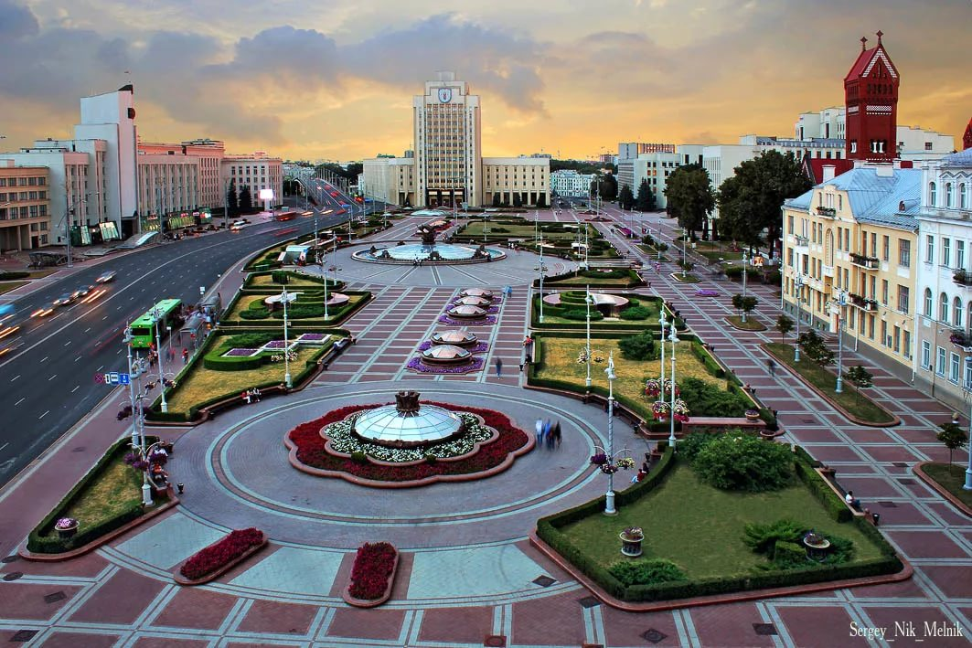

**WANO MC Directors’ Conference**

**Agenda**

Minsk

Belarus

14-15 May

2019

| **14 May** | | |
| --- | --- | --- |
| **Time** |  | **Responsible** |
| **09:00 18:00** | **WANO MC Directors Conference** |  |
| **09:00 09:05** | **Welcome Address** | **Host Company Representative** |
| **09:05**  **09:10** | **Opening Remarks** | **Vasily Aksenov**  WANO MC Director |
| **09:10**  **12:40** | **Session 1**  **30 Year WANO Anniversary** | **Moderator**  **Former WANO MC Chairman** |
| **09:10**  **09:30** | **WANO History** | **Anatoly Kirichenko** |
| **09:30**  **09:50** | **TBD** | **Peter Prozesky** |
| **09:50 10:20** | **TBD** | **Former WANO MC Chairman** |
| **10:20**  **10:40** | **Coffee Break** |  |
| **10:40 11:00** | **WANO MC: Facts and Figures** | **Sergey Frolov** |
| **11:00 11:30** | **Reserve Agenda Topic** |  |
| **11:30 12:00** | **Reserve Agenda Topic** |  |
| **12:00 12:30** | **Discussions** | **Moderator: Vasily Aksenov** |
| **12:30**  **13:30** | **Lunch** |  |
| **13:30**  **16:05** | **Session 2**  **WANO Today** | **Moderator**  **LO Representative** |
| **13:30**  **14:00** | **Changes in Nuclear Industry**  **WANO WANO’s Standpoint** | **Peter Prozesky** |
| **14:00**  **14:30** | **Performance Improvement**  **WANO’s Role in This Process. Escalation.** | **LO Representative**  **Anatoly Kirichenko** |
| **14:10**  **14:30** | **WANO MC Presentation** | **Vasily Aksenov** |
| **14:30**  **14:50** | **TBD** |  |
| **14:50**  **15:10** | **TBD** |  |
| **15:10**  **15:40** | **Discussions** | **Moderator** |
| **15:40**  **16:10** | **Coffee Break** |  |
| **16:10**  **18:00** | **Session 3**  **Involving ‘New’ Operating Companies into WANO Business** | **Moderator**  **Vasily Aksenov** |
| **15:50**  **16:05** | **WANO MC Presentation** |  |
| **16:05**  **16:20** | **WANO MC Presentation** | **Vasily Aksenov** |
| **16:20**  **16:40** | **TBD** |  |
| **16:40**  **17:00** | **TBD** |  |
| **17:00**  **17:20** | **TBD** |  |
| **17:00**  **17:20** | **TBD** |  |
| **17:20**  **17:40** | **TBD** |  |
| **17:40**  **18:00** | **Discussions** |  |

| **15 мая** | | |
| --- | --- | --- |
| **Time** | **Action** | **Responsible** |
| **09:00 12:10** | **WANO MC Directors Conference** |  |
| **09:00**  **12:10** | **Session 4: Summing up Plant Life extension Efforts** | **Moderator: Vadim Berkovich** |
| **09:00**  **09:20** | **Hydropress Experimental Design Bureau Presentation** |  |
| **09:20 09:40** | **NAEK Energoatom** |  |
| **09:40 10:00** | **TBD** |  |
| **10:00 10:20** | **TBD** |  |
| **10:20**  **10:40** | **Coffee Break** |  |
| **10:40 11:00** | **TBD** |  |
| **11:00**  **11:20** | **TBD** |  |
| **11:20 11:50** | **Summing Up Plant Life Extension Efforts Discussions** | **Moderator** |
| **11:50 12:00** | **Any Other Business** |  |
| **12:00 12:10** | **Data and Venue of the Next Conference** | **Vasily Aksenov**  WANO MC Director |