atomic energy organization of iran


Bushehr-2 npp
units 2, 3
Technical assignment for the BNPP-2
Appendix 8.
System for submission, review and approval of the Bushehr NPP-2
Design Documentation

01.BU2.0120.0.0.PM.DС0001
Revision В01

2015

state atomic energy corporation rosatom

joint stock company
atomstroyexport
(ao ase)


Bushehr-2 npp
units 2, 3
Technical assignment for the BNPP-2
Appendix 8.
System for submission, review and approval of the Bushehr NPP-2
Design Documentation

01.BU2.0120.0.0.PM.DС0001

Documentation package No.
Document number | Totally pages | Date | Revision number
01.BU2.0120.0.0.PM.DС0001 | 18 |  | В01
Inventory number | File: 01.BU2.0120.0.0.PM.DС0001_EN | Document control No.

Contract number | № NPP/4100/5500 – 2,3 от 11.11.2014 г

2015
state atomic energy corporation rosatom

joint stock company atomenergoproekt

Bushehr-2 npp
units 2, 3
Technical assignment for the BNPP-2
Appendix 8.
System for submission, review and approval of the Bushehr NPP-2
Design Documentation

01.BU2.0120.0.0.PM.DС0001
Revision В01

This document cannot be duplicated or transmitted to other organizations and persons without permission of JSC Atomenergoproekt | Director for BNPP-2 Designing  Director for Design Technologies  Project Chief Engineer |  | S.M. Takh  S.V. Ergopulo  S.L. Egorov

2015
SUMMARY
This document was developed in the framework of the implementation of the Bushehr nuclear power plant (Bushehr-2 NPP) construction contract No. NPP/4100/5500 - 2, 3 dated 11/11/2014.
TABLE OF CONTENT
1 Purpose 6
2 Scope of application 6
3 Terms, definitions and abbreviations 6
4 Responsibility 7
4.1 Responsibility of the contractor 7
4.2 Responsibility of the principal 7
5 The process of review and approval documentation «For Approval» 7
6 Document submission conditions 10
APPENDIX А Scheme of technical documents submission, review and approval in EDC system 12
APPENDIX B Comments submission form 14
APPENDIX C Form of List of Documentation 15
APPENDIX D Form of the marking sheet 16
APPENDIX E Form of the detailed packaging list 17
Revision Control Sheet 18

1 Purpose
1.1 The purpose of this document is to define requirements to the procedure of submission, review and approval by the Principal of the Technical Documentation on the “Bushehr-2" NPP, developed by the Contractor in the framework of implementation of works under Contract No. NPP/4100/5500 – 2, 3 of 11.11.2014.

2 Scope of application
2.1 This document is applicable for the process of submission, review and approval of the Technical Documentation, developed and transmitted within the framework of implementation of the Contract.
2.2 This document is applicable for the following categories of the documentation:
- «For Information»;
- «For Approval»;
- «For Submission by the Principal to the INRA»;
- «For Inclusion in the Unit Dossier».
2.3 This document is not applicable to the documentation for the Commissioning. In accordance with Appendix B to the Contract, the Contractor will develop and send to the Principal for approval the procedure for the elaboration, review and approval of the documents during the 12 (twelve) months prior to Commissioning
2.4 The requirements of the given document do not apply to the Documentation supplied with the Equipment of the Contractor.
2.5 This document was developed under the provisions of the Contract and Appendix B thereto.
2.6 If any provision of this document is contrary to the Contract or such contradiction is discovered at any time, this situation will be reviewed by the Parties for the adoption of a mutually agreed solution.
2.7 Review and approval of the documentation must be in electronic form in the system of electronic document circulation (EDC) (hereinafter EDC).
2.8 Adjustments to this document are regulated by the provisions of the Document: «Technical Assignment for BNPP-2". Annex 6. System of design documentation formatting. Guidance on the basic design technical documentation formatting. The format of text documents. 01.BU2.0120.0.0.PM.DС0001».

3 Terms, definitions and abbreviations
3.1 List of terms and definitions, abbreviations and names that are relevant to this document are given in the Contract text.
3.2. Terms, definitions and abbreviations, which are used only in the text of this document are given below:
Document | - fixed and structured amount of information intended for human perception, which can be controlled and which can be exchanged as a unit between users and systems (IEC 61355-1);
Technical Documentation | - collection of the documents relating to the subject (IEC 61355-1).
Type of document | - document belonging to a group of documents in accordance with the information content and form of presentation (IEC 61355-1).
Document identification | - identifier of a separate document in accordance with the object for which this Document is intended.
FSTEC of Russia | - Federal Service for Technical and Export Control of Russia.
EDC | - electronic document circulation.
NTD | - normative technical documentation.
- Responsibility

4.1 Responsibility of the contractor
    - The Contractor is responsible for:
- for the development and release of this document, as well as complying with its requirements to its personnel in the scope of their responsibility;
- for the delivery to the Principal of the documentation developed in the framework of its obligations under the Contract in accordance with the requirements of this document.

4.2 Responsibility of the principal
    - The Principal is responsible for:
- for the consideration and approval of this document and comply with its requirements of personnel in the scope of their responsibility;
- for timely acceptance, review and approval of the documentation of the Contractor within the frame of its obligations under the Contract, in accordance with the provisions of the present document.

5 The process of review and approval documentation «For Approval»
5.1 The documentation on the "Bushehr-2" NPP design is issued by the Contractor in accordance with the Contract requirements and the approved schedule of technical documentation development.
5.2 The list of sets of documents and the term of delivery at various stages of the contract implementation will be submitted by the Contractor in a separate document.
5.3 Review and approval of the documentation in electronic form is provided in the system EDC. The scheme of submission, review and approval of the documentation is given in Appendix A of this document.
5.4 The procedure of interaction of the Parties to the Contract at approval of the documentation in electronic form in the EDC system will be sent to the Principal after approval of this document.
5.5 To implement the submission of the Technical Documentation for review and approval of the Principal, the Contractor will identify the Technical Documentation on the subject of including the technologies described into export controller lists with obtaining of conclusions on the possibility of unlicensed export of scientific and technical products in the independent identification center, certified by the Russian FSTEC, and obtain permission of the State Corporation Rosatom on information exchange.
5.6 In case if the Technical Documentation, delivered to the Principle, requires to obtain a license of the FSTEC of Russia, then such submission is made in accordance with the requirements of the legislation of the Russian Federation in the field of export control.
This Technical Documentation is not to be placed in the EDC system and delivered to the Principal in accordance with the requirements of the legislation of the Russian Federation in the field of export control.
5.7 The Contractor places in the EDC system for consideration and approval by the Principal the developed Technical Documentation in PDF format and source formats, as well as a scanned version of the report on the possibility of unlicensed exportation and permit on the information exchange, and at the same time the Contractor will send the Principal a cover letter and the e-mail notification on the need to harmonize the documentation. Placed in the EDC system Technical Documentation must be assigned the status "For Approval by the Principal".
The Contractor in advance will send the Principal an information letter about the planned volume of the Technical Documentation placed in the EDC system.
Scheme of preparation, submission, review and approval of the Technical Documentation is given in Appendix A to this document.
5.8 The process of reviewing the Technical documentation by the Principal begins from the receipt of the covering letter of the Contractor on receipt of the Technical Documentation for consideration in the EDC information system.
5.9 The Principal, having received the cover letter on the necessity of consideration of the Technical Documentation within the period specified in Appendix B to the Contract, must perform the verification of the Technical Documentation.
If the volume of the Technical documentation does not allow the consideration within the specified time, the Parties shall agree a timetable for the consideration and approval of the documents for each case.
5.10 When considering the Technical documentation, the Principal checks each document for compliance with the Contract and the Technical Assignment for the BNPP-2 design, as well as for compliance with the requirements of normative and technical documentation (NTD).
5.11 As per the results of the Technical Documentation review, provided that each document meets the requirements, specified in para. 5.10 of this document, and the Technical Documentation has no comments, that lead to the amendments, the Principal in the EDC system approves the documentation with a simultaneous direction to the Contractor a letter on approval of the Technical Documentation.
The given Technical Documentation will be considered approved by the Principal.
5.12 In the presence of motivated comments, the Principal forms and places in the EDC system a complete list of comments to the document using the "Comments submission form" (Appendix B to this document). Each comment must be justified by reference to the exact para. of the Contract or item of the Technical Assignment on the BNPP-2 design either to a specific NTD item indicating the name of the standard.
The Principal in the EDC system declines the documentation and sends to the Contractor a letter with the comments issued in accordance with Appendix B to this document.
5.13 The Contractor after receipt of comments from the Principal by cover letter should submit his comments in respect of each observation, using the same form as directed by the Principal by filling in the column "Contractor reply".
If required the Contractor may request additional clarification on the comments.
When completing the form for submission of comments, the Contractor in the column “Contractor Reply” will indicate the revised parts of the text giving the page number and point number.
After filling in the form for submission of the comments, the Contractor shall sign it, post an electronic version on the EDC system and additionally send it to the Principal with a cover letter and e-mail.
5.14 All reasonable comments of the Principal regarding defects and/or deficiencies in the relevant Documents of the Contractor, which are subject to approval, will be rectified by the Contractor within 21 (twenty one) working days or, as an exception, in additional agreed time.
5.15 After receipt from the Contractor of a cover letter with comments on remarks, the Principal must notify the Contractor that the responses agreed or not agreed by the Principal.
In case of approval of Contractor comments, the Principal feels in and signs the form of comments submission. The column "Agreed solution" is feeled in, that means that Contractor comments are accepted.
The signed form the Principal places in the EDC system and simultaneously directs the Customer a cover letter and the notice by e-mail.
If the Principal does not agree with the comments directed by the Contractor, the matter is submitted for consideration of the Topical meeting, on what the Principal notifies the Contractor by a letter.
5.16 In the case of dispute resolution by means of correspondence and exchange of forms, the Contractor corrects the documentation in accordance with the terms specified in paragraph 5.14 and places it in the EDC system for reconsideration at the same time notifying the Principal by a letter and e-mail.
The Correction of the Technical Documentation as per the comments of the Principal is performed by the Contractor at his own expense.
5.17 The Principal within 7 (seven) working days reviews and approves in the EDC system the revised Technical Documentation of the Contractor.
This documentation is considered approved, about which the Customer shall notify the Contractor by a cover letter and e-mail.
5.18 In case if the Parties did not reach a decision on any observation by means of correspondence and exchange of forms (Appendix B to this document), they must take all necessary joint measures to resolve the existing differences.
5.19 If the parties have not come to an agreement by means of correspondence, they organize a Topical meeting.
If disagreements were not resolved at the Topical meeting, they may refer the matter to the periodical monthly Coordination meeting.
According to the results of Topical or Coordination meetings, Minutes of Meeting shall be compiled with the decisions made and the respective column "Agreed solution" of the form of comments submission is filled in and signed by the Principal and Contractor.
Based on the decisions taken at the meeting, the Contractor corrects the Technical Documentation within the period specified in para. 5.14 of this document and places it in the EDC system for re-agreement.
5.20 The Principal within 7 (seven) working days will review and approve in the EDC system the corrected documents of the Contractor.
This documentation is considered approved, about which the Principal shall notify the Contractor by a letter and e-mail.
5.21 Technical Documentation approved by the Principal is submitted to the Contractor archive, in accordance with the internal rules of the Contractor, where each document is assigned an archive number.
5.22 The Contractor places in the EDC system the documentation approved by the Customer and submitted to the Contractor archive in PDF format (which is obtained by scanning approved paper copies of the documents).
5.23 Review and approval of the Working Documents is performed by authorized representatives of the Principal in the EDC system on the Contractor territory in the Russian Federation.
5.24 Technical Documentation in respect of which the Contract does not provide for the obtaining of the approval of the Principal, is placed in the EDC system similar to the process described in paras. 5.1 – 5.7.
Contractor in the EDC system assigns for this Technical Documentation status "For Information".

6 Document submission conditions
6.1 In accordance with the terms of the Contract, the Contractor shall submit to the Customer documentation:
- in paper form - in three (3) copies in English and 2 (two) copies in Russian;
- in electronic form in PDF format (which is obtained by scanning paper copies of the approved copies of documents) and the original source format in Russian and English languages.
6.2 Delivered documentation shall include:
- documentation package number;
- list of delivered documentation.
The list of documentation shall contain:
- The document code by KKS, document title, number of pages, date of issue and the revision number, the structure of the documents submitted on electronic media;
- reference to the time schedule of the project (Appendix G to the Contract). After approval of detailed time schedule of the 3-rd level on the development of Technical Documentation, all references should be based on this time schedule;
- number and date of covering letter;
- type of works as per the documentation;
- plant construction stage.
Form of a list of documentation is given in Appendix C to this document.
6.3 One week before sending the documents on electronic media, the Contractor shall notify the Principal by letter and e-mail about the preliminary list of the cargo and the expected date of shipment.
6.4 Each package of documents will have the following marking in English language, inscribed by the Contractor:
1. Contract number, letter of credit number.
2. Destination, consignee.
3. Place of origin, shipper.
4. Document package number.
5. Weight (kg).
6. Sizes (length, width, height in mm).
The marking sheet is to be inserted in a transparent file, pasted on the box.
The shape of the marking sheet is given in Appendix D to this document.
6.5 Documentation provided by the Contractor to the Principal, needs to be put into separate boxes. Boxes must withstand multiple handling, avoid soaking and damage of documentation.
In each box detailed packing list in two copies is inserted. Each copy is filled in Russian and English languages.
The form of the detailed packing sheet is given in Appendix E to this document.
6.6 Packing list must contain:
- archives document numbers;
- codes documents;
- names of the documents;
- number of sheets of documents.
The package of documents shall be accompanied by a list of documents for each shipment (in accordance with para. 6.2).
6.7 Within 24 (twenty-four) hours after each shipment of documents package the Contractor shall inform the Principal via e-mail the following information in English:
1. Air shipment invoice number.
2. Flight number.
3. Total weight of packages.
4. Expected date of arrival to the city of delivery.
5. One copy of the document list.
6. Bill for the amount of supply.
6.8 The supplied documentation shall be checked for formal completeness by the Principal.
6.9 In case of incompleteness of the documentation received, the Principal within 5 (five) working days from the date of receipt, notify the Contractor in writing, indicating the missing items.
6.10 Within five (5) working days since notification the Contractor shall deliver the missing documentation to the Principal or, as an exception, in additionally agreed time.
6.11 The procedure of filing a detailed packing list for billing for submitted documents:
- detailed packing list is filed by the Contractor in accordance with the terms of the Contract and schedule of payments for the development of documentation and forwarded to the Principal;
- together with a detailed packing list the Contractor shall submit to the Principal a list of submitted documents agreed by the Parties;
- detailed packing list shall be certified by the authorized representative of the Principal and submitted to the Contractor.
6.12 Billing of technical documentation will be carried out in accordance with the schedule of payments for the handover of documentation based on detailed packing list and bill of lading marked "freight paid" with stamped flight.
6.13 Payments to the Contractor will be made by means of letters of credit opened for benefit of the Contractor under the Contract, as the Contractor submits the packages of documents developed under the Contract.

APPENDIX А
Scheme of technical documents submission, review and approval in EDC system
Stage 1 – Review and Approval of Technical Documentation by Principal in EDC system
Этап 2

Principal:
- approves Technical documentation.

Contractor:
- places the Technical documentation and supporting documents in the EDC system;
- sends a letter and an email notification to the Principal on the need to harmonize Technical documentation.
Principal:
- performs review and approval of Technical documentation.

Principal:

- rejects;
- forms and places in the EDC system «Comments submission form»;
- sends comments to the Contractor by letter.

п. 5.13 Подрядчик

- проанализирует замечания Заказчика;
- представит свои комментарии в отношении каждого замечания в «Форме представления замечаний комментариев» заполнив графу «Ответ Подрядчика»;
- разместит свои комментарии в системе ЭДО и дополнительно направит Заказчику сопроводительным письмом.
Contractor:

- corrects Technical Documentation according to agreed solutions.

Contractor:

- corrects the Technical documentation in case of resolving differences through the exchange of forms;
- if the Principal comments have not been removed through correspondence, the parties can arrange a meeting.
Principal, Contractor:
- Topical meeting;
- Coordination meeting;
- signing of the Protocol on the results of the meeting with the decisions on the documentation correction.

Stage 2 – Submission of Technical Documentation to Principal

Principal:

- receives TD.
- makes payment in accordance with paras. of the schedule of payments.

Stage 2
Contractor:

- approved TD is submitted to the Contractor archive, where each document is assigned an archive number;
- TD submitted to archive and permitting documentation is placed in the EDC system;
- TD, after going through the procedures of customs clearance is given to a Principal.

Principal:

Checks the TD for completeness.

Principal:

In case of incompleteness of the received documentation, the Principal will notify the Contractor.

Contractor:

- Contractor must deliver the missing documentation to the Principal.

APPENDIX B
Comments submission form
Bushehr-2 NPP Project/  ПРОЕКТ АЭС „БУШЕР-2”  Technical Design / Технический проект  Date/Дата  Rev/Ред. №  Contractor Covering Letter No. And Date/№ и дата сопроводительного письма Подрядчика | Title / Заглавие:
Document Number/ № документа | Section/Раздел:  Volume/Том........., Book/Книга ...............
Reviewer’s Name/ Имя рецензента:
№ | File/Файл  Subsection/Подраздел  Page/Стр | The Principal’s Comment/Комментарий | References or Reasoning  / Основание | Contractor/ Contractor reply | Agreed decision/Согласованное решение
1 | 2 | 3 | 4 | 5 | 6
1.
2.
3.
4.

APPENDIX C
Form of List of Documentation

Serial No | No. of Documentation Package as per the schedule of payments | Item No. As per the time schedule (Appendix G to the Contract Контракту) | Document designation | Document name | Revision No | Issue date | Number of discs | File name at the disc |  | No. and date of cover letter | Works type as per the documentation | Plant construction stage | No. of hard copies, RU/ENG | Disc No
1 | 2 | 3 | 4 | 5 | 6 | 7 | 8 | 9 |  | 10 | 11 | 12 | 13 | 14

APPENDIX D
Form of the marking sheet
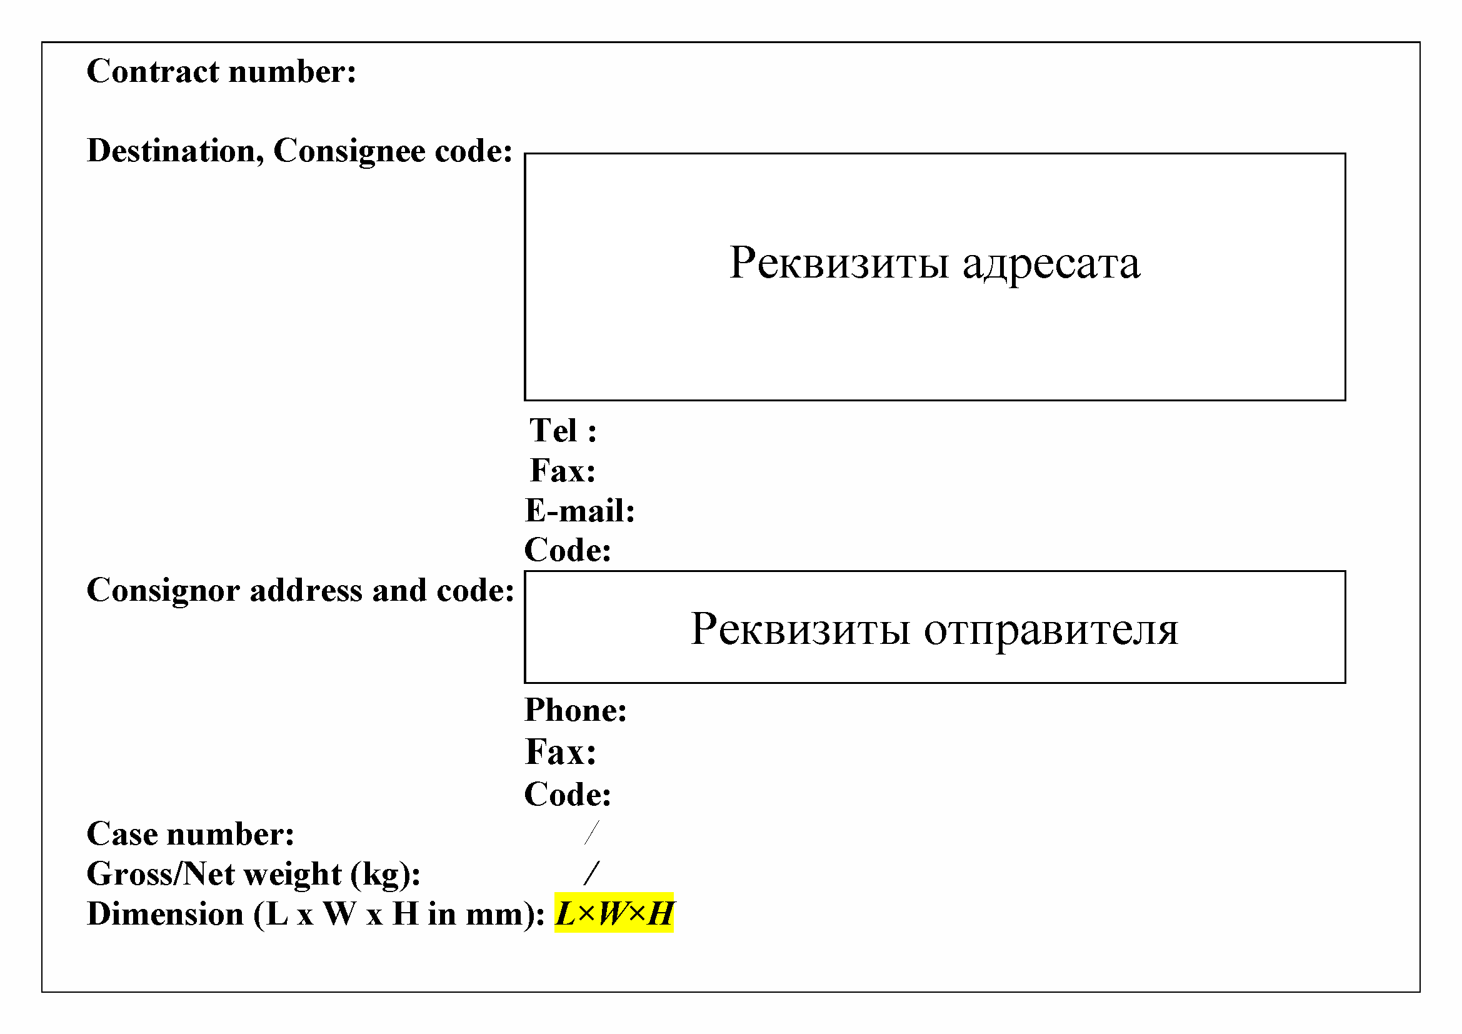

APPENDIX E
Form of the detailed packaging list
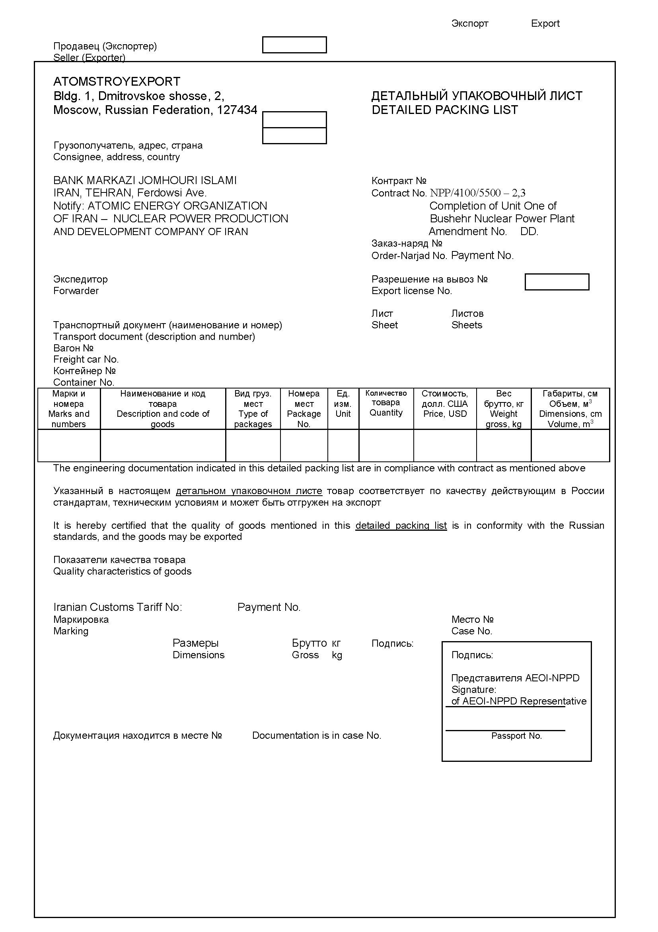

Revision Control Sheet
Rev. | Numbers of sheets (pages) |  |  |  | Description and Reason of Changes | Total of sheets (pages) in the document | Document No. | Signature | Date
Rev. | changed | replaced | new | cancelled

