TECHNICAL SPECIFICATION

for shutoff devices for *ПГВ-1000М (В)*-series steam generators

These shutoff devices are designed to shutoff steam generator primary circuit headers from main coolant pipelines during PPMs.

They enable simultaneous refueling and steam generator repair regardless of the primary circuit coolant level:

* Inspection of the metal of heat-exchange tubes and header crossover legs
* Inspection of sealing surfaces and reactor flange joint fasteners
* Defect remediation, including draining of defective heat-exchange tubes (the process of draining-machining-welding-inspection)

Allows for remote installation and dismantling.

Shutoff Device Components

|  |  |
| --- | --- |
| Header plug, pcs | 4* |

* – the stated number of plugs is for 2 (two) steam generators.

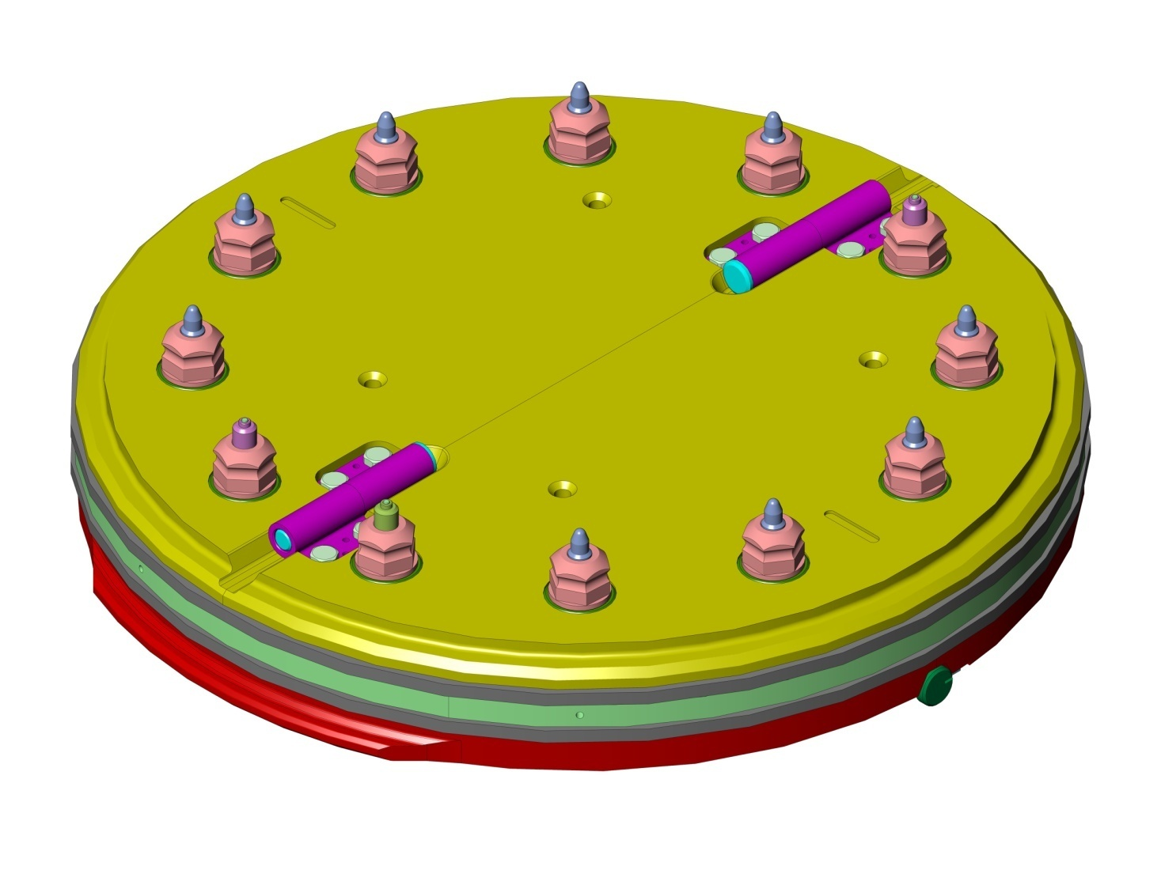

|  |  |
| --- | --- |
| Device for gas blowdown and integrity testing, pce | 1 |

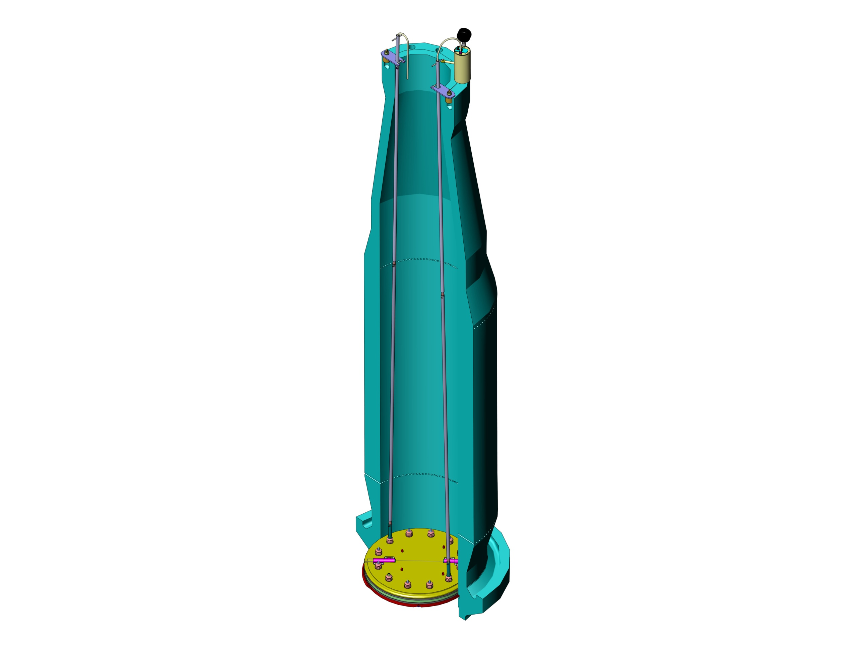



|  |  |
| --- | --- |
| Set of tools and accessories, pce | 1 |

|  |  |
| --- | --- |
| Packaging set, pce | 1 |
| Spare parts set, pce | 1 |

Technical Specifications

|  |  |
| --- | --- |
| Header plug design pressure, MPa | 0,29 |
| Header plug working pressure, MPa | 0,1 |
| Medium working temperature when using header plugs, оС | No more than 70 |
| Processing medium | Boric acid solution (concentration = 16-28 gram/liter) |
| Overall dimensions (when assembled) Length * Height, mm | 863х195 |
| Plug mass, kilos | 368 |
| Permissible leak under working pressure, liter/hour | No more than 1 |