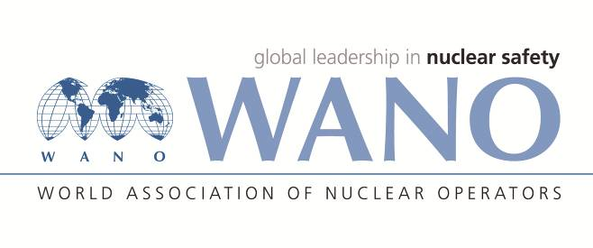 | World Association of Nuclear Operators  Moscow Centre  WANO – MC  25 Ferganskaya, Moscow, 109507, Russia  Phone. +7 495 376 15 87  Fax: +7 495 376 08 97  info@wanomc.ru

REQUEST
to provide technical and organizational information via WANO

- NPP/Organization: Dukovany NPP
- The topic of information request: The role of First-line Supervisor in MA activities
- The goal of information request: Gain information and experience in performing the role of First-line Supervisor in planned work within unit outages as well as on-line work and possibly also within modification activities (investments, equipment reconfiguration)
- Problem description: At the nuclear power plants Dukovany and Temelín we have contractor maintenance, where the required maintenance activities and nominal (investment) actions are carried out by selected contractors providing the required works. As part of these activities, we have a requirement under our legislation that each contractor's workgroup is managed by a worker with the necessary prescribed experience and training as a First-line Supervisor (Work Squad Leader). A given worker in the role of First-line Supervisor will ensure and carry out the full range of required activities from taking over the site, checking that equipment is secured for the work, marking out the site, briefing the members of the work group, managing the actual work task, to the final clean-up of the site and signing off the completion of the work in electronic and written form. Recently we have been receiving feedback from works contractors that we are continually increasing the requirements and duties for the role of First-line Supervisor, which in practice are disproportionately burdening them and costing them a large proportion of their allocated time for the actual work on the equipment. Maintenance and capital works contractors are also addressing our requirements for First-line Supervisors by continually increasing their numbers, but in doing so they are burdening the training and education centre with their new requirements for induction and refresher training. Our current endeavour is to analyse the current situation in all aspects concerned and then optimise the role of the First-line Supervisor.

- Specific questions:
- Do you have a similar role of First-line Supervisor in place for planned maintenance and modification activities as we have at Dukovany and Temelín?
- Is the role of First-line Supervisor performed by an employee of the contractor, or is this role performed by employees of your plant from a designated department (and from which department)?
- What are the basic duties and responsibilities prescribed for the role of First-line Supervisor?
- What is the minimum length of professional experience required before a person can become a First-line Supervisor?
- How do you check the fulfilment of professional requirements and the prescribed experience of staff who perform the role of First-line Supervisor?
- Do you have special blocks of training for First-line Supervisor?
- How do you verify the knowledge gained from the prescribed training?
- At what intervals do you repeat the training for First-line Supervisor?
- Do you have a system in place to check the performance of the First-line Supervisor directly at the workplace and who carries out the checks (from which department, managers' checking rounds, etc.)?
- Are workers in First-line Supervisor positions financially advantaged compared to workers who do not perform this role?
- Do staff in First-line Supervisor positions perform this activity with a sense of professional pride?
- Proposed organizations for sending this request:
All WANO MC and PC plants
- Department – request initiator:
Asset management strategy dpt.
- Contact details of the requester:
Position: Asset management strategy dpt. manager
Name: Vladimír Zika
Phone: +420 602 431 773
e-mail: vladimir.zika@cez.cz

- Date of request: 22.01.2022

The request created by:
On-site WANO MC Rep
Mr. Tomáš Kouba
Cell: +420 725 258 854
e-mail: tomas.kouba01@cez.cz

