TECHNICAL SPECIFICATION

for heat-exchange tube draining devices for *ПГВ-1000М (В)*-series steam generators

These steam generator heat-exchange tube draining devices (SG HET DDs) are designed for forced individual blowdown of all HETs.

It allows you to use 3 (three) working heads simultaneously for draining and blowing down at a set speed.

Unique features:

* Reduces SG HET draining time
* Ensures high quality of SG HET draining
* Reduces personnel collective exposure by means of using less compressed air for draining
* No need for polar cranes

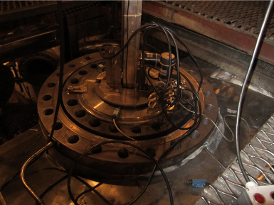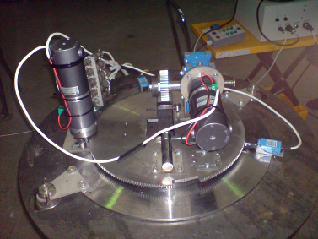 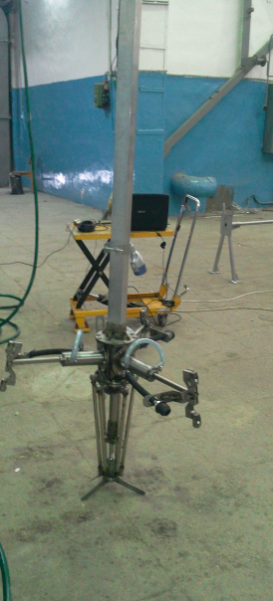

HET DD Components

|  |  |
| --- | --- |
| Top mast, pce | 1 |
| Horizontal movement assembly, pce | 1 |
| Large gearwheel, pce | 1 |
| Vertical movement assembly, pce | 1 |
| Large flange, pce | 1 |
| Bottom mast, pce | 1 |
| Support stand, pce | 1 |
| Compressed air preparation system, pce | 1 |
| Compressor, pce | 1 |
| Boric solution and moisture removal system, pce | 1 |
| Dummy ring, pce | 2 |
| TV equipment set, pce | 1 |
| PC with software, pce | 1 |
| Compressed air feed module, pce | 1 |
| Adjustment bench with a sample similar to a portion of SG header with HETs, pce | 1 |
| Container-type control room, pce | 1 |

Main Technical Specifications

|  |  |
| --- | --- |
| Header compressor neck, mm | 500 |
| Header working diameter, mm | 834 |
| Angle of rotation during the device horizontal movement, о | 120 |
| Direction of the device horizontal movement | Reciprocating |
| Time it takes to blowdown one HET, sec | 2.5 - 5 |
| Time it takes to blowdown all SG HETs, sec | 4.24 - 6.42 |
| Air working pressure, atm | 5 |
| Number of rotations of outlet shaft, RPM | 3.1 |
| Worm gearbox gear ratio | 25 |
| Mass without accessories, kg | 65 |
| Overall dimensions (when assembled) Length * Width * Height, mm | 4650х540х740 |

Horizontal Movement Engine Specifications

|  |  |
| --- | --- |
| Power supply, V | 24 |
| Nominal torque, gr⋅cm | 125 |
| Nominal speed, RPM | 3.1 |
| Nominal electrical current, MA | 3800 |

Vertical Movement Engine Specifications

|  |  |
| --- | --- |
| Power supply, V | 24 |
| Nominal torque, g⋅cm | 28 |
| Nominal speed, RPM | 112 |
| Nominal electrical current, MA | 7800 |

Spent Air Filtering Device Specifications

|  |  |  |
| --- | --- | --- |
| Capacity, m3\h | | 600 |
| Power consumption, kW | | 0.144 |
| Power supply, V\Hz | | 220-230/50-60 |
| Overall dimensions Length * Width * Height, mm | | 876х650х285 |
| Mass, kg | | 25 |
| Protection rating | | IP 44 |
| Mounting type | | Inner/exterior (casing is not heat-insulated) |
| Air purification efficiency | Dust filter | EU7 |
| Adsorption filter | Activated granular carbon |
| Mode of operation | | Continuous |
| Operating conditions | Intake air temperature, оС | -26/+50 |
| Filter aerodynamic resistance, Pa | | 95 |

Boric Acid Removal System Specifications

|  |  |
| --- | --- |
| Submersible vibration pump |  |
| Power, W | 240 |
| Maximum capacity, m3\h | 1.5 |
| Pressure, m | 40 |
| ГОСТ 18698-79 pressure hose with textile frame |  |
| Length, m | 100 |
| Inner diameter, mm | 18 |

Compressor Set Specifications

|  |  |
| --- | --- |
| Model | К-3М |
| Nominal capacity, m3\h | 2.2 |
| Maximum working pressure, MPa | 1.0 |
| Receiver tank volume, m3 | 0.5 |
| Capacity, kW | 22 (11х2) |
| Power supply, V | 380 |
| Overall dimensions, mm | 2300х700х1500 |
| Mass without lubricants, kg | 730 |
| Oil consumption, gr/h | No more than 5 (five) (for one compressor set) |