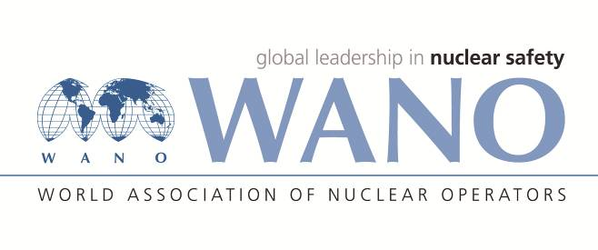 | World Association of Nuclear Operators  Moscow Centre  WANO – MC  25 Ferganskaya, Moscow, 109507, Russia  Phone. +7 495 376 15 87  Fax: +7 495 376 08 97  info@wanomc.ru

REQUEST
to provide technical and organizational information via WANO

- NPP/Organization: Smolensk NPP/ SC “Concern Rosenergoatom”.

- The topic of information request: floating boom defense.
- The goal of information request: getting information of the existing experience in the use of floating boom defense.
- Problem description: review possibilities to apply advanced boom defense methods.
- Specific questions:
- Type and manufacturer of boom defenses.
- Methods of boom defense installation.
- Maintenance and repair of boom defense.
- Life-time.
- Handling and disposal.
- Proposed organizations for sending this request:
WANO-MC NPPs.
- Department – request initiator: Support systems shop, Operating experience use & events investigations department.
- Contact details of the requester:
Chukanov Anton, Head of Operating experience use & events investigations department.
Tel. +7(48153)30432. е-mail: ChukanovAV@saes.ru
- Date of request: 01.03.2018

WANO representative at Smolensk NPP Dmitry Bazarev

