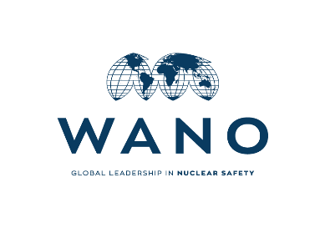

# 

# Agenda

# WANO MC

# General Meeting

# 09 October

# 2022

| 9 October 2022 | | |
| --- | --- | --- |
| **Time** | Activity | Responsible person |
| **8:00**  **8:40** | **WANO MC General Meeting** |  |
| **8:00**  **8:05** | **Opening** | **Vasily Aksenov**  **WANO MC Director** |
| **8:05**  **8:10** | **GM Chairman and Secretary** | **Vasily Aksenov**  **WANO MC Director** |
| **8:10**  **8:15** | **Agenda Approval** | **General Meeting Chairman** |
| **8:15**  **8:20** | **Update on WANO MC General Meeting decisions** | **General Meeting Secretary** |
| **8:20**  **8:30** | **Changes in WANO MC membership**   * Remove CNEA company from the MC membership. * Update on Energoatom’s membership in MC. Update on status of Energoatom’s fee agreement. | **General Meeting Chairman** |
| **8:30**  **8:35** | **Dates of next WANO MC General Meeting** | **General Meeting Chairman** |
| **8:35**  **8:40** | **Other Business** | **General Meeting Chairman** |