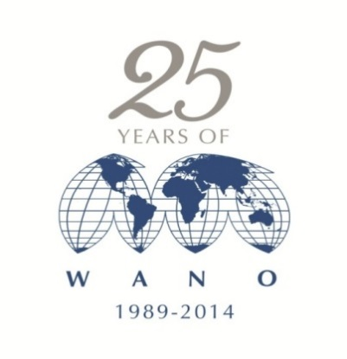

M o s c o w C e n t r e

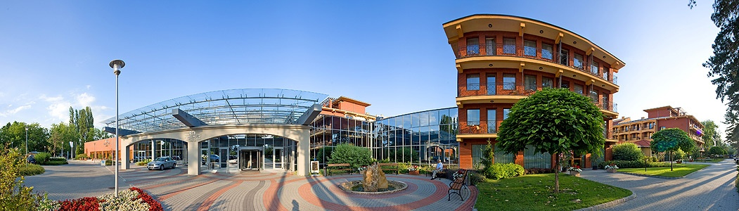

WANO-MC

GENERAL MEETING

Agenda

Siofok

April

2014

| **Time** |  | **Speaker** |
| --- | --- | --- |
| **13:00**  **13:30** | **WANO-MC General Meeting** |  |
| **13:00**  **13:05** | **Opening Remarks** | **Ladislav Stepanek**  **WANO- MC Vice Chairman** |
| **13:05**  **13:10** | **Election of the General Meeting Chairman and Secretary** | **Vasily Aksenov** |
| **13:10**  **13:15** | **Agenda Approval** | **General Meeting Chairman** |
| **13:15**  **13:20** | **Admission to WANO-MC membership** | **General Meeting Chairman** |
| **13:20**  **13:25** | **Election of members to the WANO-MC Governing Board** | **General Meeting Chairman** |
| **13:25**  **13:30** | **The next General Meeting** | **General Meeting Chairman** |