|  |  |
| --- | --- |
|  | **World Association of Nuclear Operators**  **Moscow Centre**  **WANO – MC**  25 Ferganskaya, Moscow, 109507, Russia  Phone. +7 495 376 15 87  Fax: +7 495 376 08 97  [info@wanomc.ru](mailto:info@wanomc.ru) |

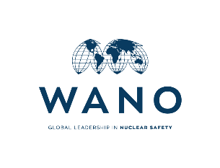

**REQUEST**

**to provide technical and organizational information via WANO**

Belarusian NPP is asking to share the experience in performing work on determining and maintaining the qualification of NPP equipment.

Detailed questions: (in two languages)

|  |
| --- |
| 1. **NPP/Organization:** Belarusian NPP |
| 1. **The topic of information request:** Work on determining and maintaining the qualification of NPP equipment. |
| 1. **The goal of information request**: Getting relevant information from other VVER-1000 Units/plants regarding the experience in performing work on determining and maintaining the qualification of NPP equipment. |
| 1. **Problem description:** fulfilment of IAEA and WANO requirements and recommendations based on the previous reviews. |
| 1. **Specific questions**:   Experience in the area of equipment qualification:  1- list of equipment to be qualified;  2- list of initial events;  3- programs, methods of work on equipment qualification;  4- programs to preserve the qualification of equipment;  5- methods for assessing the current state of qualification of NPP power unit’s equipment;  6- database (example of filling) on the qualification of equipment, the principle of construction and filling of data. |

**Russian:**

**З А П Р О С**

**на получение технической и организационной информации**

**по линии ВАО АЭС**

Белорусская АЭС просит поделиться опытом выполнения работ по определению и поддержанию квалификации оборудования АЭС.

Конкретные вопросы :

(на двух языках)

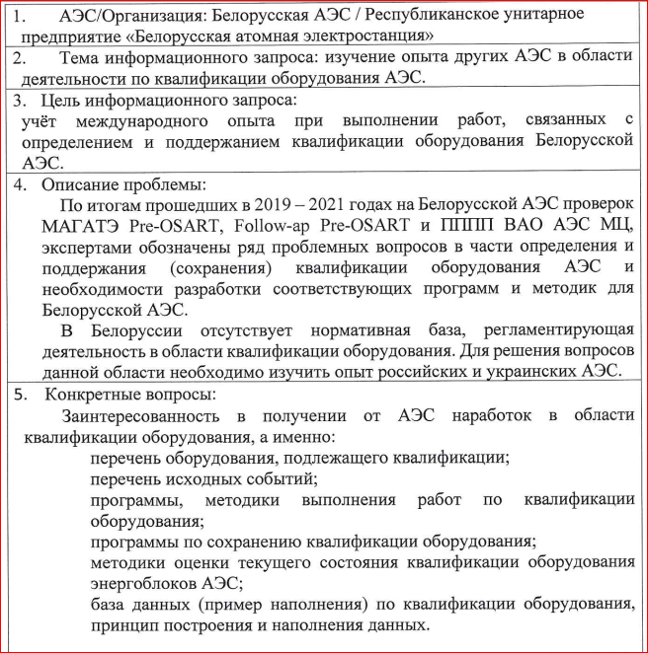

**Bushehr NPP Answers and Recommendations in this regard:**

**Ответы и рекомендации АЭС Бушер в этой связи:**

**1—**

**2—**

**3—**

**4—**

**5—**

**6—**

**\*\*- Specific descriptions, recommendations and comments:**

--

--

--