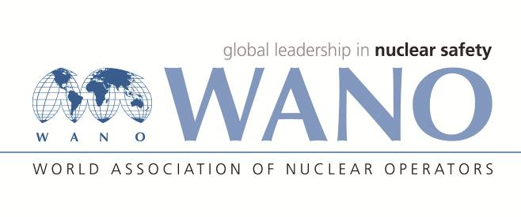 | Moscow Centre  World Association of Nuclear Operators  WANO MC  Russia, 109507, Moscow, 25 Ferganskaya Str.  Tel.: +7 495 376 15 87  Fax: +7 495 376 08 97  info@wanomc.ru
REQUEST
To provide technical and organizational information
via WANO
- NPP/Organization: Kozloduy NPP EAD
- Request subject:
Implementation of the risk-oriented methods in maintenance planning
- Request objective:
To obtain information from other plants where the risk-informed approach for maintenance planning and equipment inspection has already been applied
- Issue description:
Increase the effectiveness of maintenance planning activities at Kozloduy NPP in the long-term operation period
- Specific questions:
- What kind of equipment and systems is the risk-informed method applied to in maintenance planning and conduct of inspection?
- Has the critical equipment been identified and if yes, on the grounds of what data (criteria) and assessments?
- Has/have the risk/risks been taken into account for the stages of maintenance preparation and maintenance performance?
- Has the risk of maintenance activities and outage inspections overdue been taken into account?
- Are the risk assessments recorded (in an information system or other manner) during the maintenance preparatory stage of the maintenance performance stage?
- How do you evaluate the effects of the introducing risk-informed maintenance planning in terms of maintenance reliability, implementation time period and costs?
- Suggested organisations to receive this request:
All WANO members
- Administrative unit – request initiator: Kozloduy NPP
- Contact details of the request initiator:
Valentin Iliev, Head of Design and Lifetime Support Department +359 973 7 4136;
e-mail: VSIliev@npp.bg
- Date of request: 03.06.2021
Responsible person Veselin Nikolov WANO-MC contact person

Responsible person
Name, surname
Telephone

