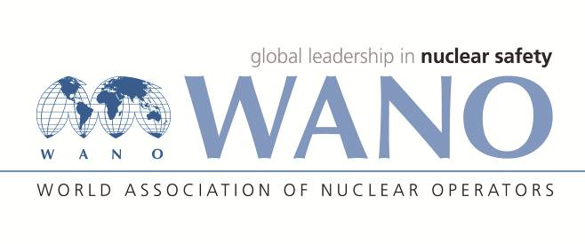 | World Association of Nuclear Operators  Moscow Centre  WANO – MC  25 Ferganskaya st, Moscow, 109507, Russia  Phone. +7 495 376 15 87  Fax: +7 495 376 08 97  info@wanomc.ru
REQUEST
to provide technical and organizational information
via WANO

- NPP/Organization: Zaporizhzhia NPP, SE “NNEGC “Energoatom”
- Information request topic: Detection of silver by the method of mass spectrometry with inductively coupled plasma
- Information request objective: Implementation of the method of silver mass concentration measurement by the method of mass spectrometry with high sensitivity.
- Problem description: At present, taking into account the matrix impact, we have caused the measurements of the mass fraction of silver in grade A boric acid to be done, during the acceptance test using the mass spectrometer with inductively coupled plasma, sensitivity: 2х10⁻⁶ %. The new normative document will regulate the silver standard rate in boric acid: -5x10⁻⁷ %. In order to perform control by this indicator, the sensitivity we have achieved is not enough.

- Specific questions:
1. How do you measure the mass fraction of silver in boric acid on a mass spectrometer with inductively coupled plasma, sensitivity: 5х10⁻⁹ %?
2. What is the sample preparation during this type of measurements (concentration, use of membranes, ion-exchange resins...)?
3. Experience and recommendations of the respective method use.
- Organizations proposed for distribution of this request:
All WANO centers
- Department – request initiator: Water Radiochemical Department
- Contact details of the requester:
Head of Water Radiochemical Department
Mrs. Iryna Dobrovolskaya
Tel.: +3 8 06139 565 88
E-mail: vrhl3048@mgw.npp.zp.ua
- Request date: 30/01/2020
Responsible individual Dobrovolskaya I.Yu.
Executed by
Yuzva O.N.., tel. +3 8 06139 572 44

