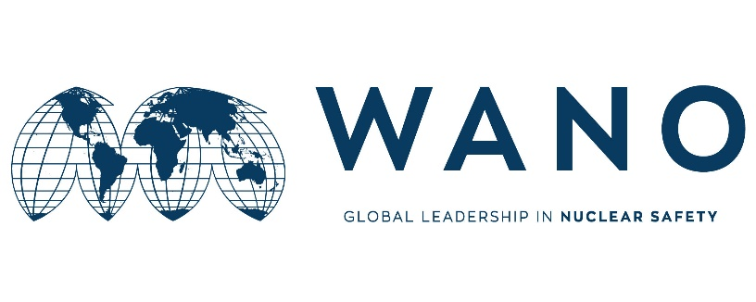 | Moscow Centre  WANO-MC  25 Ferganskaya, Moscow, 109507, Russia  Phone: +7 495 376 15 87  Fax: +7 495 376 08 97  info@wanomc.ru

WANO MOSCOW CENTRE

Final Benchmarking Report

Benchmarking visit of
Rosenergoatom COMPANY experts to
Nuclear Power Production & Development Company of Iran

Risk Management

3 - 5 December 2018

Nuclear Power Production & Development Company of Iran (NPPD)

Restricted Distribution
"CONFIDENTIALITY NOTICE: Copyright - 2018 World Association of Nuclear Operators (WANO). All rights reserved. Not for sale. This document is protected as an unpublished work under the copyright laws of all countries which are signatories to the Berne Convention and the Universal Copyright Convention. Unauthorized reproduction is a violation of applicable law. Translations are permitted. All copies of the report remain the exclusive property of WANO. This document and its contents are confidential and shall be treated in strictest confidence. In particular, without the permission of both the member and the applicable WANO Regional Governing Board, this document shall not be transferred or delivered to any third party* and its contents shall not be disclosed to any third party or made public, unless such information comes into the public domain otherwise than in consequence of a breach of these obligations. Furthermore, the circulation of this document must be restricted to those personnel within the WANO member organisations who have a need to be informed of the contents of this document.” *For the purposes of this policy, “third parties” are those persons or entities not directly involved in the implementation of the WANO processes. For clarification, a Governor of WANO or of a Regional Centre, the staff of the Coordinating Centre and the Regional Centres, and peer review team members are not “third parties.”

CONTENT

Стр.

1 Background and Purpose 3
2 Summary 4
2.1 Program of the BМ 4
2.2 Topics for discussion during BM 4
2.3 The special aspects in the area of XXX (on theme BM) on XXX NPP 4
3 Recommendations (suggestions) for implementation of BM results 5
Appendix 1: Contacts: 6

Plant area: Rosenergoatom COMPANY

Key words: Risk Management, Enterprise risk Management, Project Risk Management

- Background and Purpose

In accordance with the request of Nuclear Power Production & Development Company of Iran (NPPD) conducted a Benchmarking (BM) during the period of 3 till 5 December 2018 on topic: “Risk Management”.

The objectives of the BM were:
- The exchange of ideas, experiences and practices in the field of Risk Management
- Understanding Enterprise Risk Management Structure in Rosenergoatom Company
- Risk Breakdown Structure of Enterprise Risk Management in Rosenergoatom Company
- Enterprise risk management processes in Rosenergoatom Company
- Project Risk Management in Rosenergoatom Company
- Risk Breakdown Structure of Project Risk Management in Rosenergoatom Company
- Project risk management processes in Rosenergoatom Company
- Project Risk management relationship with time, cost and change management
Description of the problem: Describe the problem to be addressed. Indicate if it corresponds by an AFI identified during a Peer Review.
- Lack of proper planning
- Lack of access and view system documentation related to Enterprise risk management (Risk Breakdown Structure, Enterprise risk management process)
- Lack of access and view system documentation related to Project risk management
- Lack of coordination between the content presented with the questions raised
Lack of view Rosenergoatom's company structure in relation to risk management processes

Host interface representative:
Mr. Evgeny Kovalev

BM participants list:
- Mr. Hamid Barjesteh
- Mr. Mohmmad sbbagh

NPP team Composition:

- Mr. Sergey Schelglove (Rosenergoatom)
- Mr. Sergey Vasilyev (Rosenergoatom)
- Mr. sergey Kislinsky (Atomtechenergo)
The NPP BM team members, as well as their full contact data, are given in Attachment 1.

- Summary

Program of the BМ

The program for BM at Rosenergoatom company “Risk Management” on: «Risk Management» included the following activities: (briefly).
The first day at Rosenergoatom Company, at the beginning of the meeting after the introduction of the parties, a presentation was presented by Mr. Barjesteh about risk management at NPPD Company. Then it was discussed about Enterprise risk management. Due to the limitations in rosenergoatom co, did not provide any documentation system.
For the second and third days there was not proper planning. It would have been better if the program continued at Rosenergoatom Company.
On the second day, presentation was presented on enterprise risk management focused on Operation. This presentation was very suitable.
On the third day, discussions were about the deviations of time, cost, and changes throughout the life cycle of the project. Which did not relate to the process of risk management in the construction of power plants.

Topics for discussion during BM

During the BM, the following issues were discussed (in detail):
- • Enterprise risk management.
- • risk management in npp.

During the BM:
- Enterprise risk Management

- Recommendations (suggestions) for implementation of BM results

Recommended practices for use in Rosenergoatom Company

The visit was conducted in an open, direct and good atmosphere. The following main conclusions, suggestions can be mentioned:
- It was better to have all the presentations and discussions in Rosenergoatom's company, according to Benchmark.
- Relationships between questions and requested were better communicated with presentations.

Learning lessons
The Impact of Enterprise Risk Management Outcomes on Organization Goals, Mission, and Perspectives

Appendix 1: Contacts:

NAME | POSITION | ADDRESS | E-mail, TEL, FAX
Hamid Barjesteh | Expert Of Risk Management in NPPD |  | Barjesteh@nppd.co.ir

