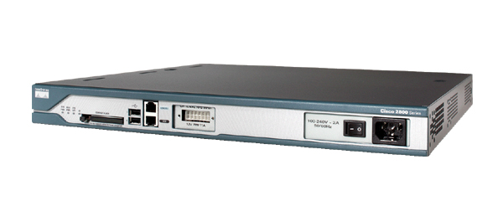

The Cisco 2811 Integrated Services Router is part of the Cisco 2800 Integrated Services Router Series which complements the Integrated Services Router Portfolio.
The Cisco 2811 Integrated Services Router provides the following support:
- Wire-speed performance for concurrent services such as security and voice , and advanced services to multiple T1/E1/xDSL WAN rates
- Enhanced investment protection through increased performance and modularity
- Increased density through High-Speed WAN Interface Card Slots (four)
- Enhanced Network Module Slot
- Support for over 90 existing and new modules
- Support for majority of existing AIMs, NMs, WICs, VWICs, and VICs
- Two Integrated 10/100 Fast Ethernet ports
- Optional Layer 2 switching support with Power over Ethernet (PoE) (as an option)
- Security
  - On-board encryption
  - Support of up to 1500 VPN tunnels with the AIM-EPII-PLUS Module
  - Antivirus defense support through Network Admission Control (NAC)
  - Intrusion Prevention as well as stateful Cisco IOS Firewall support and many more essential security features
- Voice
  - Analog and digital voice call support
  - Optional voice mail support
  - Optional support for Cisco CallManager Express (Cisco CME) for local call processing in stand alone business for up to36 IP Phones
  - Optional support for Survivable Remote Site Telephony support for local call processing in small enterprise branch offices for up to 36 IP phones

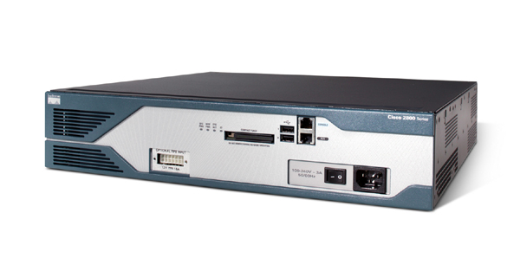

The Cisco 2821 Integrated Services Router is part of the Cisco 2800 Integrated Services Router Series which complements the Integrated Services Router Portfolio.

The Cisco 2821 Integrated Services Router provides the following support:
- Wire-speed performance for concurrent services such as security and voice , and advanced services to multiple T1/E1/xDSL WAN rates
- Enhanced investment protection through increased performance and modularity
- Enhanced investment protection through increased modularity
- Increased density through High-Speed WAN Interface Card Slots (four)
- Enhanced Network Module Slot
- Support for over 90 existing and new modules
- Support for majority of existing AIMs, NMs, WICs, VWICs, and VICs
- Two Integrated 10/100/1000 Ethernet ports
- Optional Layer 2 switching support with Power over Ethernet (PoE) (as an option)
- Security
  - On-board encryption
  - Support of up to 1500 VPN tunnels with the AIM-EPII-PLUS Module
  - Antivirus defense support through Network Admission Control (NAC)
  - Intrusion Prevention as well as stateful Cisco IOS Firewall support and many more essential security features
- Voice
  - Analog and digital voice call support
  - Dedicated Extension Voice Module slot
  - Optional voice mail support
  - Optional support for Cisco CallManager Express (Cisco CME) for local call processing in stand alone business for up to48 IP Phones
  - Optional support for Survivable Remote Site Telephony support for local call processing in small enterprise branch offices for up to 48 IP phones

Models Comparison

Model | Onboard  DSP Slots | Fixed  LAN Ports | Optional Power  over Ethernet | Slots for  Interface Cards | Slots for  Network  Modules | Size
2811 | 2 | 2 FE | 160W | 4 HWIC | 1 NME | 1 RU
2821 | 3 | 2 GE  (10/100/1000) | 240W | 4 HWIC | 1 NME or  NME-X | 2 RU

