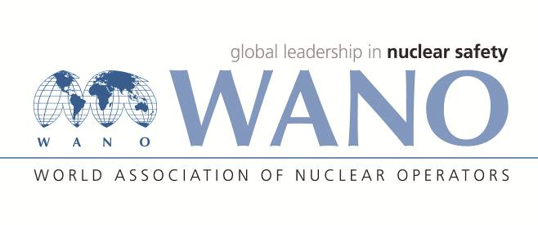 | World Association of Nuclear Operators  Moscow Centre  WANO – MC  25 Ferganskaya, Moscow, 109507, Russia  Phone. +7 495 376 15 87  Fax: +7 495 376 08 97  info@wanomc.ru

REQUEST
to provide technical and organizational information via WANO

- NPP/Organization: HAYKAKAN ATOMAYIN ELECTRAKAYAN CJSC (HAEK CJSC) Armenian Nuclear Power Plant CJSC
- The topic of information request: Ball cleaning system (BCS) of turbine condensers
- The goal of information request: Study of existing experience of condenser BCS with the purpose of its potential application at the ANPP
- The describing of problem: Recently water chemistry incidents have become more frequent at the ANPP due to failures (loss of integrity) of the condensers’ heat-exchanging tubes (HET). The method of HET periodic shooting applied at the ANPP is resulting in many cases in damage of tubes. During modernization process the ANPP condensers were replaced. As to the recommendation of the equipment manufacturer a ball cleaning system shall be used for cleaning of HET
- Questions:
1. Is a condenser BCS is applied at your plant?
2. If yes, name the manufacturer and what are the criteria for selection of that company?
3. Describe advantages and disadvantages for operation of the selected by you BCS
4. What kind of balls is used in your BCS (material, size, manufacturer, cost, replacement frequency)?
5. Which software is applied in your BCS?
6. Have any incidents with balling up in HET occurred, if yes, in what proportion?
7. If possible, provide, please, some technical-economic evaluation (for instance, annual ball consumption)
- Proposed organizations for sending this request: WANO MC NPPs
- Department – request initiator: Turbine Department (TD)
- Contact details of the requester: Daniel Danielyan, Deputy Head of TD
Теl.: +37493233278 e-mail: daniel1996@yandex.ru
- Date of request: 12.08.2021

