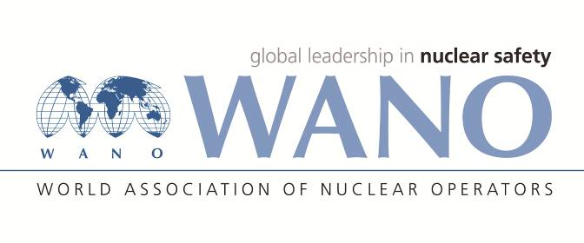 | Moscow Centre  WANO-MC  25 Ferganskaya, Moscow, 109507, Russia  Phone: +7 495 376 15 87  Fax: +7 495 376 08 97  info@wanomc.ru
№ MC-26/ 30 июля 2026 Pages 1+8
To: Mr. Mohammad Ahmadian, Managing Director of Nuclear Power Production and Development Company of Iran
From: Dr. Vasily Aksenov, Director of WANO Moscow Centre
Subject: WANO- MC Technical Support Mission
Dear Mr. Ahmadian,
In accordance with the request of the NPPD, WANO Moscow Centre plans to conduct a Technical Support Mission (TSM) at the NPPD on the topic of ‘Risk Management’. The TSM will be held
on 03 – 09 August 2017.
The following experts will take part in the TSM: Sergei Kislinsky (Atomtekhenergo, Russia);
Roussel Laurent (EDF, France); Vasilii Solovev (Leningrad NPP, Russia), Liadenko Halyna (Energoatom, Ukraine); Chichikin Dmitrii (WANO MC, Russia). The team leader will be Evgenii Kovalev (WANO MC, Russia).
The completed registration forms and the scanned copies of the experts’ passports will be sent to Mr. Rouhanifard Seyed Abolhassan.
Please find attached a draft TSM programme (Appendix 4).
The purpose of the TSM is to receive support in addressing the issue of ‘Risk Management’ area at the NPPD. The TSM will be conducted as a training mission.
The experts will arrive in Tehran on Friday, 04 August 2017 and depart on Wednesday,
09 August, 2017.
In this regard I would ask you to arrange the TSM in accordance with the list of activities, to develop the Advanced Information Package, to estimate the cost of TSM budget in accordance with the items specified in attachment and send them to the WANO-MC before 07 July, 2017 (Appendixes 1, 2, 3).
Could you prepare and send the letter of invitation for all the experts before 10 July, 2017.
If you have any questions related to the TSM, please, do not hesitate to contact a WANO-MC adviser Evgenii Kovalev at e-mail: evkovalev@wanomc.ru.

Looking forward to further cooperation.

Best regards,

Dr. Vasily Aksenov
Director
WANO Moscow Centre

