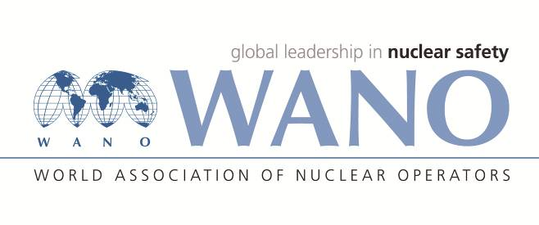 | Moscow Centre  WANO-MC  25 Ferganskaya, Moscow, 109507, Russia  Phone: +7 495 376 15 87  Fax: +7 495 376 08 97  info@wanomc.ru
IL&D Feedback Form
WANO Moscow Centre
Industrial learning & Development Programme
Date(s) of the activity: 23-26 November 2020
Activity topic: Workshop-Configuration Management
Date (of giving the feedback):30-11-2020
For each statement, put the (clear and readable) number after the questions that best describes your opinion using the following scale. Please provide comments at least for any attribute rated 3 or less. Please, return this form to the WANO-MC Coordinator.
5 = Strongly agree | 2 = Disagree
4 = Agree | 1 = Strongly disagree
3 = Neutral | NA = Not applicable
- Did the activity meet its objectives? |  | Grade
 |  | 4
Comments:

- Was the topic applicable to plants/organizations? |  | Grade
 |  | 5
Comments

- Did the activity meet your expectations? |  | Grade
 |  | 4
Comments:

- What is your overall rating for the activity? |  | Grade
 |  | 4
Comments:

Please provide any additional comments or suggestions to improve our activities.
Proposals are welcome how to improve IL&D process / WANO-MC team effectiveness.
All presented topics and discussions were of crucial interest for BNPP and for preparing to our future peer reviews. I hope, in the next workshops, more attention will be paid to training CM, CM indicators, software CM and full-scale CM.

Name, job, sign (if you wish): Mohammad Reza Abbasi , Bushehr NPP, Iran

