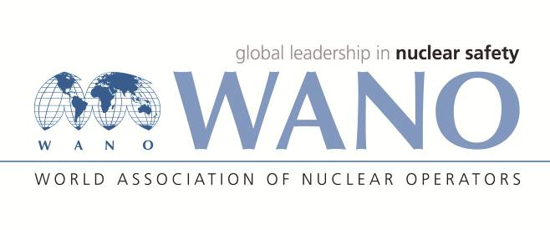 | Moscow Centre  World Association of Nuclear Operators  WANO– MC  Russia, 109507, Moscow, 25 Ferganskaya Str.  tel. +7 495 376 15 87  Fax: +7 495 376 08 97  info@wanomc.ru

REQUEST
to provide technical and organisational information
via WANO

- NPP/Organisation: Kozloduy NPP EAD
- Inquiry subject: Positive experience in ensuring the required climatic parameters of the rooms accommodating technological and electronic equipment while the supply ventilation systems are operated in summer conditions using the cooling water from the absorption refrigeration machine or another machine for preparation of cooling water
- Inquiry objective: Receive information on the topic from other plants.
- Issues: Reaching the expiration date of the absorption refrigeration machines; failure to maintain the temperature of the cooling water supplied to the air coolers of the supply ventilation systems while operated in summer conditions.
- Specific questions:
1. What machines according to the principle of operation (compressor, sorption, steam ejector, thermoelectric, etc.) do you use for preparation of cooling water?
2. What is the cold production capacity of the machines you use?
3. What is the temperature regime of the machines in operation at your plant?
4. Where are the machines in operation located - in the turbine hall rooms, or in separate buildings - external refrigeration centres for preparation of cooling water used by the air conditioning systems?
5. What types of maintenance and repairs are performed on the machines at your plant? What is the scope and periodicity of the different types of maintenance and repairs?
6. Which organisation - a separate unit within the maintenance structural unit of the plant or an external organisation (company) performs the maintenance and repairs of the machines for preparation of cooling water?
7. What types of controls are performed with respect to the corrosion processes occurring on the internal metal surfaces and elements of machines?
8. What types of chemical additives do you use to protect against corrosion of metal surfaces and the main elements of the machine?
- Suggested organisations to receive this inquiry:
WANO– MC
Administrative unit – inquiry initiator: Kozloduy NPP
- Inquiry initiator contact details: Mladen Nikolov, Head of Operation of HVAC Systems Section, telephone: +359973 7 3724

- Date of inquiry: September 27th, 2021

Accountable person Veselin Nikolov, WANO contact person
Responsible person
Surname, name, father’s name
Telephone:

