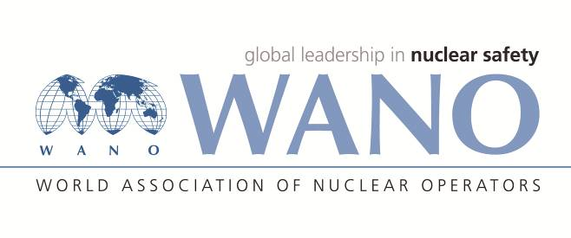 | World Association of Nuclear Operators  Moscow Centre  WANO – MC  25 Ferganskaya, Moscow, 109507, Russia  Phone. +7 495 376 15 87  Fax: +7 495 376 08 97  info@wanomc.ru

REQUEST
to provide technical and organizational information via WANO

1.NPP/Organization: Tianwan NPP

2.The topic of information request:
How to manage Beyond Design Basic Accident(BDBA) and Severe Accident(SA) at multi-units NPP.
3.The goal of information request:
Collecting information to improve response level of Beyond Design Basic Accident(BDBA) and Severe Accident(SA) at NPP with multiple units
4.Problem description:
There are 4 units operating at the Tianwan NPP and 2 units are under construction, another 2 units are planned to start construction this year. Documents on the management of BDBA and SA occurring on a separate unit were developed, and a document on the management of multi-unit accidents was also developed, which takes into account issues such as the response of non-emergency units to the emergency unit. The station intends to collect information from WANO members in order to improve response level to BDBA and SA.
Questions as follows:
(1) What anti-accident measures are applied by non-emergency units during BDBA or SA occurring on a particular station unit?
(2) Does your country or station have standards to guide responses to the BDBA and SA in the above case? you are appreciated to share with us your standards.
5.Proposed organizations for sending this request:
WANO-MC,PC,AC,TC.
6.Department – request initiator: Nuclear Safety Branch
7.Contact details of the requester:
Gao Haiyang, +86-518-82205808, gao@wanomc.ru
8.Date of request: 09.01.2020

