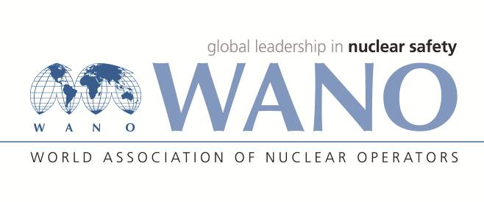 | World Association of Nuclear Operators  Moscow Centre  WANO – MC  25 Ferganskaya, Moscow, 109507, Russia  Phone. +7 495 376 15 87  Fax: +7 495 376 08 97  info@wanomc.ru

REQUEST
to provide technical and organizational information via WANO

- NPP/Organization:
Haykakan Atomayin Electrakayan CJSC (HAEK CJSC)
(Armenian Nuclear Power plant)
- The topic of information request: Intergranular corrosion of sensitization type due to the increased content of chloride ions.

- The goal of information request: Obtain information about the equipment used at other NPPs when performing inspection and remedial work in the steam generator.

- The describing of problem:
An increased content of chloride ions in the SG blowdown water was observed after outage. There is a suspicion that the reason could be the occurrence of a foreign object on the surface of the tubes - a piece of additional PPE of PVC compound (lab coats, protective sleeves, shoe covers) or plastic covering, which decompose with increasing temperature during Unit 2 heat-up after outage, torn off when performing maintenance activities inside the SG, stuck to the heat exchange tubes, which form chlorine when interacting with water.
- Questions:
What non-chlorine-containing materials are used for additional PPE and equipment to perform inspection and remedial work inside the steam generators?
- Proposed organizations for sending this request:
WANO Moscow Centre NPP

- Department – request initiator:
Maintenance Preparation and Implementation Department (MPID)

- Contact details of the requester:
Head of MPID - Oleg Gevorkyan, Tel. +374 94834582, e-mail: oleg.gevorkyan@anpp.am
- Date of request:
12 July, 2022

ANPP Director M. Vardanyan

WANO MC Representative at the ANPP S. Kenjetsyan

