
Moscow Centre
__________________________________

ATTENDANCE NOTIFICATION FORM
__________________________________

WANO MC General Meeting (Session)

10 October 2018

Our organization
(Organization Name)

◻ will be presented at the above General Meeting by:

Full Name:

Job Title:

Signature

Position in the Organization

Date

OR

◻ We authorize an alternate to vote on our behalf (Alternate Appointment Form is attached)

Signature

Position in the Organization

Date

Please submit this document to WANO MC before 10 August 2018.

Attachment
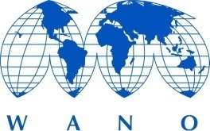
Moscow Centre
______________________________

AN ALTERNATE APPOINTMENT FORM
______________________________

WANO MC General Meeting (Session)

10 October 2018

We _______________________________________________________________
(Organization Name)

as a Member of the World Association of Nuclear Operators appoint

(Full Name)

(Position)
(WANO member, executive or employee)

as our alternate to attend, speak and vote on our behalf at the WANO MC General Meeting to be held on 10 October 2018, as well as at any other delayed meeting.

Signature: __________________________________________________________

Position in the Organization: ______________________________________________

Date: ______________

Please submit this document to WANO MC before 10 August 2018.

