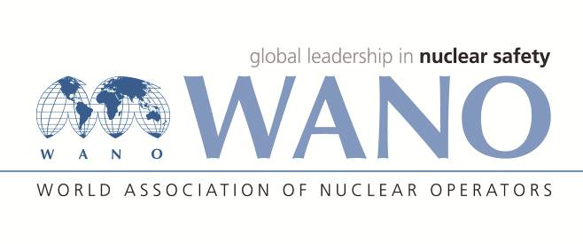 | World association of nuclear operators  Moscow Centre  WANO MC  25, Ferganskaya, Moscow 109507, Russia  Phone: +7 495 376 15 87  Fax: +7 495 376 08 97  info@wanomc.ru

REQUEST
Request to provide technical and/or organisational information via WANO
- NPP/Organization:
Bushehr NPP (IRAN) (Request Number BNPP2022.Rq02 eng)
- The topic of information request:
Strategy and Planning for Increasing Power (104%-107%) and Increasing the Duration of fuel cycle.
- The goal of information request:
To resolve the ambiguities and use the operating experiences of the WANO member NPPs related to increasing power (104%-107%) and increasing the duration of fuel cycle.
- The describing of problem:
In the Bushehr-1 nuclear power plant, there are some technical questions in regard to strategy and planning for transition to the 18-month fuel cycle and increasing power in the WWER reactors, which are as follows:
- Questions:
We ask you to share the experiments of your nuclear power plant:
- Provide us with experiences related to the list and type of modernizations implemented on the equipment and systems as a result of increasing power and increasing the duration of fuel cycle (list of these equipment and systems, timetable for their modernization, etc.)
For transition to the 104% power uprate of Units 5 and 6 at Kozloduy NPP EAD, the following modifications of SSCs defined by OKB GIDROPRESS, the designer, were planned and implemented:
- Steam generators - Modernization of the SG separation system to provide for the operation at 104% power uprate
The modernization of the SG separation system and justification of the compliance of its characteristics with the design requirements for steam production capacity and steam humidity is aimed at providing the design steam humidity of 0.2 % (at the SG outlet) during the turbine operation.
According to the design documentation developed for the modernization of ПГВ-1000М type turbine, the reconstruction was performed, as follows:
- Unit 5 SG separation system - The reconstruction of SG 2 and 3 was performed during the 2016 outage, and of SG 1 and 4 during the 2017 outage. In the frames of the Integrated programme for testing of the reactor facility of Unit 5 at Kozloduy NPP following the 2019 outage, SG separation tests were performed at 102% and 104% N_{nom.}
- Unit 6 SG separation system - The reconstruction of SG 1 and 4 was carried out during the 2015 outage, and of SG 2 and 3 during the 2016 outage. In the frames of the Integrated programme for testing of the reactor facility of Unit 6 at Kozloduy NPP following the 2017 outage, SG separation tests were performed at 102% and 104% N_{nom}.
- Instrumentation - a new primary coolant temperature monitoring system was installed.
In the scope of this substage, the primary coolant monitoring system - thermal converters, compensating devices, electric power supply, cable routes, cabling and providing the capability for separate adjustment of every thermal converter, was modernised.
One of the main points is the replacement of the coolant temperature measurement trains with more precise ones to improve the accuracy of measurement.
As a result, the sensitivity and reliability of the reactor control, regulating and protection instrumentation that uses the information from this system was increased.
The works for the modernisation of the primary coolant monitoring system at Units 5 and 6 were performed under the following modifications:
- The modification "Replacement of the reactor coolant temperature monitoring system – emergency/preventive protection, reactor power limiter, in-core monitoring system, normal operation system, safety control system software and hardware complex" was implemented at Unit 5 during the 2016 outage;
- The modification “Replacement of the reactor coolant temperature monitoring system – emergency/preventive protection, reactor power limiter, in-core monitoring system, normal operation systems, safety control system software and hardware complex”, which began in 2015, was completed at Unit 6 during the 2016 outage.
- Upgrade of the software and hardware of the in-core monitoring system for the needs of testing and operation at new levels of the increased neutron power;
Modernization of the software and hardware complex and the software of the in-core monitoring system is related to the increase of the accuracy of monitoring of the reactor core parameters, which allows precise monitoring of the local parameters of the reactor core and complies with the assumptions used in the analyses.
The purpose of the modernized software and hardware is to perform in full scope the functions of the in-core monitoring system in all design modes of reactor operation at power levels from 10% to 104% N_{nom}.
The measure was implemented in 2014 at Units 5 and 6 while implementing the modifications for the replacement of the equipment and software of the upper level of the in-core monitoring system.
- Reactor control and protection systems - commissioning of the software and hardware of the instrumentation for reactor scram, alarm protection, reactor power controller, reactor power limiter and nuclear flux monitoring system in order to improve the dynamic stability of the nuclear steam supply system.
The purpose is to improve the dynamic stability of the nuclear steam supply system by making the required changes in the logic of the reactor protection, regulation and control systems recommended by safety analyses taking into consideration the transition to operation at power uprate.
The works for modernization of the reactor protection and control systems in connection with the power uprate to 104% of Units 5 and 6 were as follows:
- While implementing the Integrated programme for the testing of the reactor at an increased thermal capacity of 3120 MW at Unit 6, following the 2017 outage, the activities for the final implementation of the modification "Change in the design algorithms for the operation of the instrumentation of the control and protection system in connection with the transition to the operation at the power uprate of N=104%N_{nom} at Unit 6" were completed.
- While implementing the Integrated programme for the testing of the reactor at an increased thermal capacity of 3120 MW at Unit 5, following the 2019 outage, the activities for the final implementation of the modification "Change in the design algorithms for the operation of the instrumentation of the control and protection system in connection with the transition to the operation at the power uprate of N=104%N_{nom} at Unit 5" were completed.
At the stage of Preparation for transition to the plant extended operation at power uprate (implementation of the modifications of the SSCs related to the modernization of the main equipment of the BOP equipment of the power unit: turbine flow through, electric generator and related installation works) and recommendations of OKB GIDROPRESS, the designer, the following works were completed:
- Reconstruction of the flow through high pressure side of TG 9 and TG 10 and low-pressure side rotors 1,2,3 of TG 10 in order to increase the output of the turbine generator and extension of the design lifetime of safe operation
By reconstruction, the flow through cross-section of the high-pressure side has been increased, and as a result, the conversion of a higher thermal drop corresponding to the increased thermal capacity is possible. This leads to the improvement of the efficiency of the thermal cycle and an increase in the electric capacity of the electric generator.
- Supply of a new stator, reconstruction of the rotor of the ТВВ-1000-4 УЗ type generator and reconstruction of the БВД-4600-1500 УЗ type excitator for providing the operation at 1100 MW
The stator of the electrical generator with a new one which has a higher electric generation capacity.
- Design and reconstruction of the auxiliary systems of ТВВ-1000-4УЗ type turbine generator 10 GQ for operation at 1100 MW
The generator auxiliary systems have been reconstructed so that their operation is compatible with the new stator.
- Purchase and installation of a 125/20 t crane and 335 t beam for the implementation of the installation works for the generator stator during the 2013 outage at Unit 6
The support equipment facilitating the dismantling, installation, relocation and transportation of heavy equipment within the turbine building for installation of the generator stator during the Unit 6 outage was supplied. The activities also included additional engineering, the manufacturing of crossbars for the installation of generator stators, as well as the development of a project for the installation of the crane during the plant operation and the related installation of the electric part.

Tentative schedule for following the performance of the activities at Unit 5

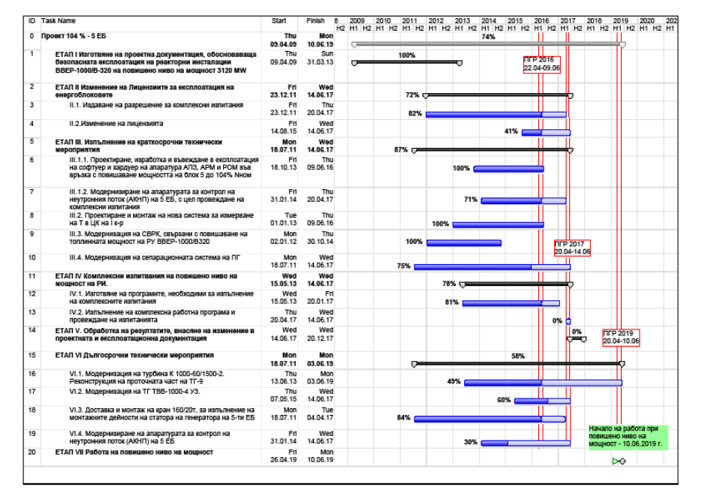
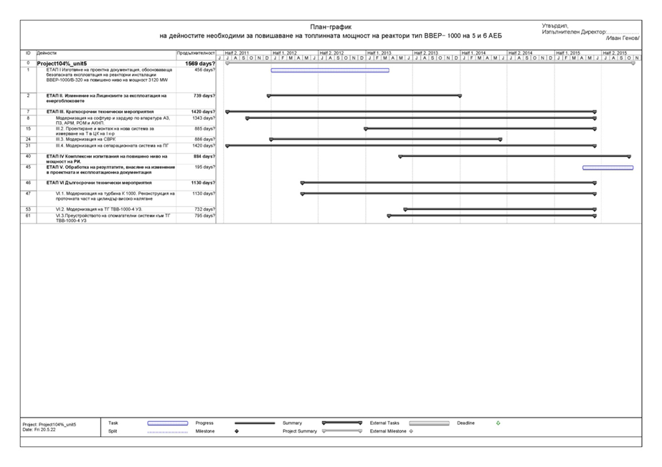
- Provide us with experiences related to the list of documents/reports developed in this regard and/or introduction of changes in safety documents and/or developing new safety documents as a result of increasing power and the duration of fuel cycle (list of changes in the safety documents and list of developed safety documents together with timetable for their development and presentation, etc.)
The activities of the integrated testing at power uprate of the nuclear steam supply system were preceded by the organizational measures related to the development and acceptance of the working programme.
The planned programmes were prepared and the Bulgarian Nuclear Regulatory Agency was consulted for the performance of the integrated testing for power uprate up to 104% of Units 5 and 6.
- Integrated working programme for performance of the main checks and tests while operating at power uprate of 104% Nnom;
- Programme for the testing of the instrumentation, protections, interlocks, regulators;
- Programme for neutron physics characteristics verification;
- Programme for thermal-hydraulic testing;
- Programme for reactor dynamic testing;
- Programme for SG separation testing;
- Programme for verification of the SG design characteristics during their operation;
- Programme for thermal balance testing of primary and secondary circuits;
- Programme for verification of the operability of the electrical equipment of Units 5 and 6 at Kozloduy NPP for operation at power uprate;
- Programme for frequent primary radiochemistry and physical chemical monitoring;
- Programme for vibration monitoring;
- Programme for water chemistry control.
After the processing of the results from the integrated tests, the changes should be introduced to:
- Plant Safety Analysis Report;
- Technical specifications for safe operations;
- Change in the operating and maintenance documentation based on the results obtained.
After the completion of the activities for processing of the results from the performed integrated tests, the relevant information is sent to OKB Gidropress, the designer, and the Bulgarian Nuclear Regulatory Agency, and Report for the implementation of the reactor integrated testing programme for Units 5 and 6 of Kozloduy NPP at increased thermal power of 3120 MW was prepared.
After the processing of the results from the integrated tests, the changes were introduced to:
- Units 5&6 Safety Analysis Report;
- Technical specifications for safe operation;
- The operating and maintenance documentation was changed based on the results obtained.

- Which Design Criteria (GDC) has changed at your plant as a result of increase of power and fuel cycle duration? Provide us with the necessary experiences in this regard.
Based on the thermal-hydraulic analyses performed by OKB Gidropress, the designer, changes were introduced to the Technical specifications for safe operation and operating documentation of Units 5 and 6 at Kozloduy NPP, as follows:
- Operational limits of the process parameters (maximum allowable reactor power, values of the reactor coolant maximum allowable heating up;
- Values of the setting for the reactor scram, preventive protection, reactor power limiter;
- Working area - reactor power controller dead band;
- Actuation signal of accelerated power reduction with the disconnection of one reactor coolant pump while four loops are in operation at the nominal mode of operation with four loops and reactor power above 100% N_{nom} was introduced
- Reactor scram actuation signal in the event of failure of the accelerated power reduction with disconnection of the reactor coolant pump and reactor power above 100% N_{nom} was introduced
- Limit values of the neutron physics characteristics of the reactor core (limit values of neutron physics characteristics for safety thermal-hydraulic calculations) and limitations by energy distribution factors in compliance with the new methodologies presented by the designer.

- Provide us with the requirements of national safety regulatory bodies (national nuclear safety department, etc.) in regard to increasing power and the duration of fuel cycle at your plant.
According to the regulations, the licensing process for transition to power uprate is launched applying to the BNRA for the change of the current plant operating licence.
Kozloduy NPP EAD submitted to the regulator the following documents:
- Application for the change in the licence;
- Justification of the required changes in the design of the SSCs;
- Evidence related to the required change (design documentation and Programme for the implementation of the activities related to the preparation and performance of testing during the transition to and operation at reactor power uprate).
According to regulatory requirements, separate permits were issued upon the implementation of the required technical modifications of the safety-related SSCs as well as upon introduction of changes to the current licensing basis documents.
The results of the testing programmes performed to validate the capabilities of the units for safe operation at power uprate are subject to approval by the regulator.
After completion of all testing activities and a detailed review of the testing results and conclusions by the regulator, the changes were introduced to the Plant safety analysis report and the following operating documentation was changed.
- Technical specifications for safe operation;
- Operating procedure;
- Procedure for preparation of reports for the neutron physics characteristics;
- Maintenance procedure, etc.
- Proposed organizations for sending this request:
Nuclear power plants that have already implemented (or are planning to) increase power (104%-107%) and increase fuel cycle up to 18 months including: Balakovo NPP, Rostov NPP and Tianwan NPP
- Department – request initiator:
Technical and engineering deputy of Bushehr NPP
- Contact details of the requester
Mr. Y. Shamani - Technical and engineering deputy of Bushehr NPP
- Date of request: 10 May. 2022

Hamid Azarbad
WANO-MC OSR at BUSHEHR NPP
Phone: +98 773 111 2156
Fax: +98 773 111 2157
Сell: +98 917 351 6368
E-mail: azarbad@wanomc.ru

