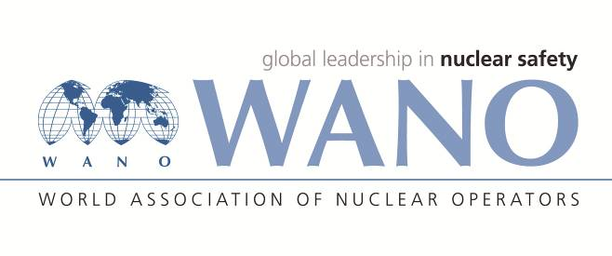 | World Association of Nuclear Operators  Moscow Centre  WANO – MC  25 Ferganskaya, Moscow, 109507, Russia  Phone. +7 495 376 15 87  Fax: +7 495 376 08 97  info@wanomc.ru
REQUEST
to provide technical and organizational information via WANO
- NPP/Organization: Kola NPP, “Concern Rosenergoatom”, Russia

- The topic of information request: Protection from single-phase earth faults in generator power circuits and/or from open phase short circuits in generator winding.
- The goal of information request: Gain data on protection specifications and operating modes.
- Problem description: Kola plant is going to optimize performance of protections from single-phase earth faults in generator power circuits and/or from single-phase short circuits in generator winding.
- Specific questions:
5.1. Do you have protections from single-phase earth faults in generator power circuits and/or from single-phase short circuits in generator winding?
5.2. What are specifications and operating modes of those protections from single-phase earth faults in generator power circuits and/or from single-phase short circuits in generator winding?
- Proposed organizations for sending this request:
All plants of WANO MC.
- Department – request initiator: Kola NPP, Electrical Department
- Contact details of the requester:
Sergei Seremak, Electrical Department Deputy Head, Tel. +78153242373; +78153242890
email: SeremakSV@kolnpp.rosenergoatom.ru
- Date of request: 29.11.2021

WANO MC on-site representative Kuzin Sergey

