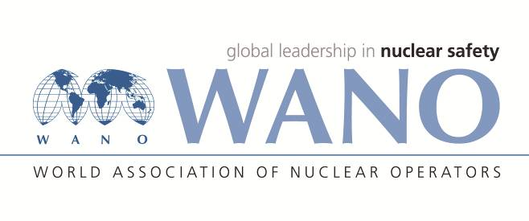 | World Association of Nuclear Operators  Moscow Centre  WANO – MC  25 Ferganskaya, Moscow, 109507, Russia  Phone. +7 495 376 15 87  Fax: +7 495 376 08 97  info@wanomc.ru
REQUEST
to provide technical and organisational information via WANO

- NPP/Organisation: Kudankulam NPP

- The topic of information request:
Radiation “Hot-spots” on trip devices (arresting devices) of impulse lines of main coolant pipeline.

- The goal of information request: Getting relevant information from other member plants
- Problem description:
Localised high radiation fields are observed in the trip devices of impulse lines in main coolant pipelines (MCP). These high radiation fields are pointed in nature and shows radiation field multiple times more than on other areas of MCP. These radiation “hot-spots” leads higher radiation dose to personnel involved in insulation ISI programs. Spectrometric analysis indicated that main constituents of these “hot-spots” constitute the radionuclides like Co-60 and Mn-54.

- Specific questions:
- Do these types of radiation “Hot Spots” are observed in other VVERs?
- If yes, what is the radiation field range?
- What is the action taken to remove these radiation “Hot Spots”?
- Are these radiation hot spots are shielded? If yes, what are the materials and arrangements for this?
- Are these trip devices of impulse lines are cut and removed? If yes, what are the alternate arrangements taken to meet the design intend of these devices?
- How is the performance of high temperature and low temperature purification systems of main coolant system to prevent the formation of these type of radiation “hot-spots.
6.Proposed organisations for sending this request:
WANO-MC
7.Department – request initiator: Health Physics dept. KKNPP
8.Contact details of the requester:
Sanjeev Bhardwaj , +91-9489080628, sbhardwaj@npcil.co.in
9.Date of request:20-08-2021

