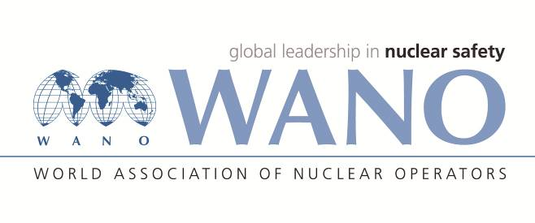 | Московский центр  Всемирная Ассоциация Организаций, эксплуатирующих Атомные Электростанции  ВАО АЭС – МЦ  Россия, 109507, Москва, Ферганская ул., 25  Тел. +7 495 376 15 87  Факс: +7 495 376 08 97  info@wanomc.ru

REQUEST
to provide technical and organizational information via WANO

- NPP/Organization:
Rivne NPP / SE NNEGC "Energoatom"
- The topic of information request:
Installation of the feedwater flow meters of ITABAR-probe type
- The goal of information request:
Familiarization with experiences with ITABAR-probes while measuring feedwater and other media flow. Reducing the losses at flow meter and improvement of the feedwater and steam flow measuring accuracy by replacement of orifice gages with ITABAR-probes.
- Description of the problem:
Restricted straight sections downstream orifice gages in the feedwater lines resulting in additional error during the feedwater flow measurement.
- Questions:
Is there any positive experience of ITABAR-probe application?

- Proposed organizations for sending this request:
Nuclear power plants in India, Slovakia, Germany, and other WANO-MC countries
- Department – request initiator:
Rivne NPP, I&C department
- Contact details of the requester:
Vitalyy Korolchuk, Head of the I&C department
KorVP@rnpp.atom.gov.ua
- Date of request:
30.01.2018.
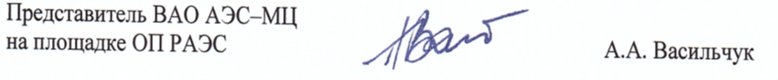
Anatolii Vasylchuk
WANO representative at Rivne NPP
+380 3636 61513
vasylchuk@wanomc.ru

