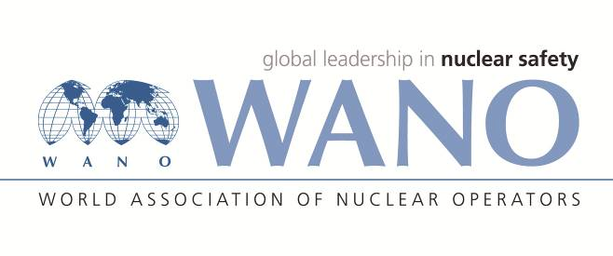 | Московский центр  Всемирная Ассоциация Организаций, эксплуатирующих Атомные Электростанции  ВАО АЭС – МЦ  Россия, 109507, Москва, Ферганская ул., 25  Тел. +7 495 376 15 87  Факс: +7 495 376 08 97  info@wanomc.ru
REQUEST
to provide technical and organizational information
via WANO
NPP/Organization: Zaporizhzhia NPP / SE “NNEGC “Energoatom”
- Information request topic:
Elimination of equipment leaks
- Information request objective:
Learning from international experience at other nuclear power plants near and far abroad.
- Problem description:
The works on the elimination of leakages, leaks on operating systems and equipment are being carried out at Zaporizhzhia NPP.
At present, ZNPP is testing the “Furmanite” compound for sealing during the elimination of leaks.
- Specific questions:
The information about the materials and methods for leaks elimination, as well as the experience of using materials at other nuclear power plants is required.
- Organizations proposed for distribution of this request:
Moscow, Atlanta, Paris, Tokyo WANO Centers
- Department – request initiator:
Maintenance Department Head
- Contact details of the requester:
Nikolay Aleksandrovich Babenko
- Request date: 26/02/2018

ZNPP WANO representative
Responsible person V.K. Bronnikov
Exec. A.A. Ryabukha
Tel.: 06139 5-62-65 E-mail: on31374@mgw.npp.zp.ua

