**Support in the Stress Tests Exercise**

IRN3.01/16 Lot 2

**MINUTES OF THE 4th PROGRESS MEETING**

8. 6. 2021, videoconference

Content:

1. Place and time 3

2. Attendance: 3

3. Introduction 4

4. Course of meeting 4

4.1. Project status presentation, comparison of plans and achievements 4

4.2. Latest development in Task 4 4

4.3. Latest development in Task 5 5

4.4. Latest development in Task 6 5

4.5. Future activities planning 6

5. Other issues 6

6. EC note 7

7. Follow-up project 7

8. Conclusions 7

Attachment 1 Agenda of Progress Meeting 8

Attachment 2 Presentations 9

# Place and time

The 4th progress meeting (PrM) of the Project INSC IRN3.01/16 Lot 2 “Support in the Stress Test Exercise” was organised as a videoconference on 8th of June 2021.

# Attendance:

The meeting was attended by representatives of EC (INTPA and JRC), by representatives of the End User, and by representatives of the Contractor. The particular interconnected conference room and the list of attendees were as follows:

* UJV, Prague, Czech Republic
* BNPP-1, Iran
* Tavana, Tehran, Iran
* EC, Brussels, Belgium

**European Commission:**

Mr. Pascal Daures, Head of Sector Nuclear Safeguards and Safety, INTPA

Mr. Xavier Pinsolle, EC Project manager, Nuclear Safeguards and Safety, INTPA

Mr. Ghislain Pascal, EC Project manager, Nuclear Safeguards and Safety, INTPA

Mr. Marc Noel, Expert, JRC, EURATOM Coordination Unit

**End User**

**NPP:**

Mr. Yadollah Shamani, Deputy Chief Engineer for Technical & Engineering

Mr. Hamid Valikhani, Management System and Supervision Manager

Mr. Seyed Fazel Ghazi Ardekani, Substitute of Manager of Technical & Engineering Division

**TAVANA (TSO to NPPD):**

Mr. Mohammad Hossein Raji, Head of Nuclear Engineering dpt.  
Mrs. Elham Tavakoli, Head of DSA section

Mr. Hedayat Abbaspour, Head of Tavana local office at BNPP

**Contractor (UJV):**

Mr. Jozef Misak, Key-expert, Project Manager

Mr. Jiri Sedlak, Senior-expert, Project coordinator

# Introduction

The meeting was conducted according to the adopted agenda, see Attachment 1.

The objectives of the progress meeting were to enable timely and effective oversight and monitoring of the project progress, both in terms of its quality and compliance with the project schedule and goals.

The special attention was payed to keeping the project on track in current complicated situation caused by worldwide SARS-CoV-2 pandemic.

Presentations delivered during the Progress Meeting are attached in a single file, see Attachment 2.

# Course of meeting

## Project status presentation, comparison of plans and achievements

Current project status was presented. It was stated that the project course is more delayed than anticipated within the previous progress meeting in December 2020. The main cause of the additional delay is that INRA needed more time to finalize its review of the self-assessment report than could be expected. Nevertheless, both the End-user and Contractor are working with the preliminary versions of the INRA review report.

The status of tasks fulfilment has not considerably changed since the last project meeting. Details concerning Task 4, Task 5, and Task 6 are presented in following paragraphs.

## Latest development in Task 4

Task 4 (support NPPD in the development of the final Self-Assessment Stress Test report) is aimed to resolve INRA's comments received as a result of INRA's regulatory review and prepare the final Self-Assessment Stress Test report.

The NPPD has received a preliminary version of the INRA review report and made it available to UJV in the beginning of April 2021. Both parties have started to evaluate this preliminary revision hoping to get the final version soon and without substantial changes. However, the final version has not been delivered to NPP up to date (i.e. June 8, 2021).

During the Progress Meeting, UJV presented its view of INRA comments resolution and results incorporation into the final STSA report (see details in presentation in Attachment 2). NPP declared that they are going to finalize their evaluation of the INRA comments within next two weeks and they will make it available to UJV. UJV will compare its own and NPP views on resolution of INRA comments and the harmonisation of the responses will be discussed within the next Technical meeting (see 4.5 for details).

NPP will insist on INRA to release the final version of the review report as soon as possible.

## Latest development in Task 5

Task 5 (support in addressing stress test recommendations and proposed safety improvement measures) is aimed to assist to NPPD in the implementation of safety improvement measures responding to stress test recommendation.

In the beginning of 2021, NPP sent to UJV a list of services wanted from UJV in support of implementation of specific measures selected from the STSA report recommendations. Based on this request, UJV has developed a detailed list of activities and sub-activities needed for fulfilment of corresponding tasks and sent it back to NPP for further evaluation. It needs to be stated that significant part of the (sub)activities extends the scope and deadline of the current project. Nevertheless, the list could serve as a good basis for the foreseen follow-up project. Once list of (sub)activities are agreed by NPP, UJV will develop their more detailed specification. UJV will also suggest responsibility matrix to each sub-activity to be further discussed with NPP and Tavana.

EC has suggested complementing of the list of (sub)activities in order to cover all measures recommended by the STSA report. UJV is going to do that and to turn the list into more appropriate format (MS Excel or Access) after that to serve as a basis for the corresponding implementation plan and for the National Action Plan (NAcP) development (responsibility of Lot-1). Nevertheless, it has to be noted that the list and all related details are subjects of changes based on the final INRA review of STSA report.

All above mentioned actions will be discussed within the next Technical meeting (see 4.5 for details). UJV and NPP/Tavana will select from the overall list those implementation activities which could be initiated soon.

## Latest development in Task 6

The Task 6 (assistance in the implementation of the OSART mission recommendations in synergy with the stress tests results) is aimed to assist to the NPPD in reviewing the final OSART recommendations and in assistance in the implementation of one or more corresponding measures in synergy with the stress tests results.

Mr. Misak summarized links between the OSART mission findings, suggestions, and recommendations in the areas relevant for the scope of the stress test. He concluded that there are no contradictions between the OSART findings and recommendations of STSA report and no major problems with integration of OSART findings with the stress test recommendations can be expected. Therefore, there is no need to differ between OSART and ST recommendations within the implementation process.

However, this conclusion is based on the preliminary information gathered during presence of Mr. Misak in the part of the ST relevant topics (i.e. emergency preparedness and response and accident management). NPP has been asked to provide UJV with the final version of the OSART recommendations relevant for the stress tests (OSART review areas EPP and AM) to confirm that.

## Future activities planning

The near futures activities were suggested and discussed during the meeting.

It was concluded that the Technical meeting 5 will be held in the last week of June 2021, i.e. from 28 to 30. The meeting will last 2 working days (limited by the time shift between EU and Iran).

The response to the INRA review report and modification of the STSA report (Task T4) will be discussed for one day and implementation tasks (T5, T6) will be subject of the other day. The meeting will be held as a videoconference using Polycom platform. UJV, NPP, Tavana, and EC will participate. UJV will check availability of its experts and will suggest the exact days for the meeting (not necessarily consecutive ones) asap. UJV will also prepare an agenda for the meeting. UJV and NPP will send materials (as mentioned above) for discussion preferably a week before the meeting. NPP will also send the final version of INRA comments providing it is available.

UJV also presented its intention to organize the joint meeting with all stakeholders including INRA and Lot-1 to discuss resolution of INRA comments to the STSA report (T4). Such a meeting would be held on-line as well, and it could be organized in summer season (based on INRA availability).

The other activities would be smaller topical meetings on STSA report modification and on STSA recommendations implementation organized ad hoc as needed.

# Other issues

NPP reminded their request to the Contractor with the drafting of tendering process for some spare parts (the list has been sent to UJV earlier) and other equipment. UJV in cooperation with the European Commission are examining possibilities for further support.

# EC note

EC representatives acknowledged the fact that experts of both parties are working in difficult conditions caused by pandemic. They encouraged all parties to intensify the work as much as possible and confirmed EC’s will to participate into the next Technical meeting.

UJV is requested to prepare the Progress Report covering the period December 2020 – June 2021 including all relied activities.

# Follow-up project

The worldwide SARS-CoV-2 pandemic caused serious complication in the Project execution. Besides, realised needs of NPP in the support of stress tests recommended measures implementation as well as in other safety related issues including ongoing Periodical Safety Review of BNPP-1 go behind the scope and the end-date of the current Project (March 2022). EC presented its intention to launch the follow-up project to enable continuation of works without any gap. EC plans to send draft of the Terms of Reference of the foreseen project to UJV in August 2021. The EC expressed the hope to organize next Progress Meeting on site if pandemic crisis is over.

# Conclusions

The 4thprogress meeting was concluded with an acceptance of the course of the project in current complicated conditions due to pandemic. The travelling limitations do not seem to allow travelling to and from the target region at least in the several next months. On-line meetings, especially when using rather obsolete platform, are not so effective as the face-to-face ones. On the other hand, since the inland limitations in both countries are being relieved, they could be organized more frequently.

1. Agenda of Progress Meeting

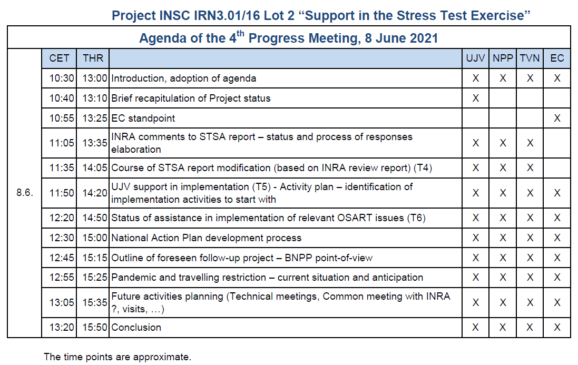

1. Presentations

