**Negative Points based on AIP.**

1. High Collective Dose last years – no positive trend in 10 years.

* High releases of I131 in 2014 and 2015
* Average Annual Individual Dose is rising for the last 4 years. Same level as 10 years ago (no positive trend).

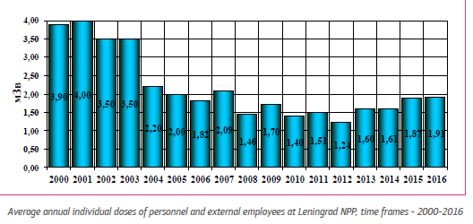

* General dose is rising since 2012. 2016: same level as 2005 for own personnel. Contractors: no better result since 2011.

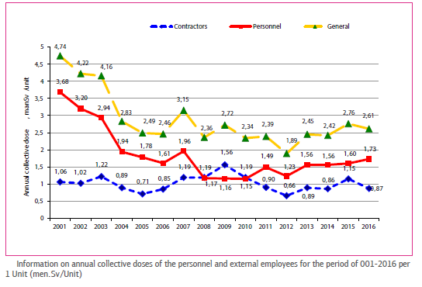

1. Twenty (20) power reductions on Unit 4 in 3 years caused by technical issues.

* 10 times power reduction caused by leaks
* 4 times complete shut down for repair
* 2 times shut down because of higher radiation (April 2015 and November 2015)
* Power reduction caused by technical issues: 2014: 10 – 2015: 4 – 2016: 6
* Mechanical events leading to reducing power. Examples:
  + 13/01/16: disconnection of Turbogenerator 7 due to static failure of an welded joint
  + 08/02/16: disconnection of Turbogenerator 8 due to through wall defect in steam line shell caused by corrosion-erosion
  + 09/11/16: power reduction caused by heat-exchange tube loss of tightness in the tubing part of low pressure turbine condenser (= repeated event of 17/06/16)
    - Same problem on unit 3: 28/02/16 – 11/11/16 – 25/11/16
    - Same problem on unit 2: 15/04/16

1. Key Performance Indicators TQ – flat lines last years: Showing real performance? Enough challenging to improve performance and continuous improvement?

KPI TQ for last 3 years (see table): the figures seem to be very good but is this reality? What is exactly behind the KPI? If all these goals are met: don’t they have to be adjust to be more challenging - to improve performance and continuous improvement?

* No violations caused by training deficiencies:
  1. Threshold to report an event to high (what is exactly in the KPI?) ?
  2. Really ZERO OE events (taking into account all the Low Level Events) where lack of knowledge is part of the rootcause?
* No license violations: Really all the licenses of the employees and contractors are OK (licenses for functions, roles (e.g. lifting & rigging,…) …) ?
* Number of successful exams: 100%? Is the threshold during the exam/test that has to be reached high enough?
* Training schedule 100%: Really no annulations? Did everybody follow the trainings on time without any remedial training and/or countervailing measures ?

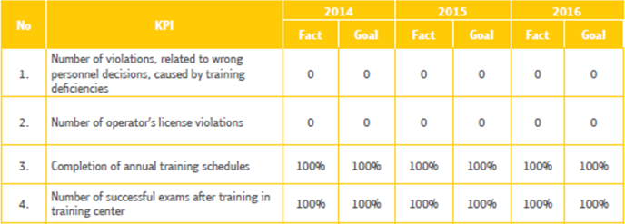

1. Key Performance Indicators MNT – flat lines last years: Showing real performance? Enough challenging to improve performance and continue improvement?

* Schedule: 100% completed. This means: no backlogs?

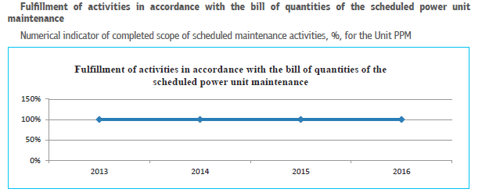

* No reworks last 4 year? OE events show that there are repeated events: no reworks?

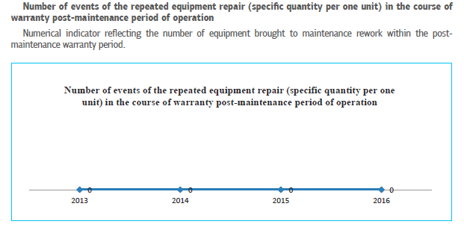

* No events resulting from shortcomings in equipment repair?

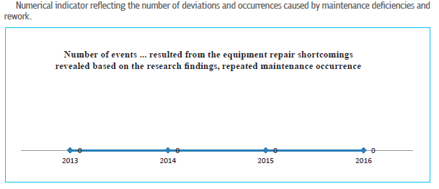

**Positive Points based on AIP.**

1. Impressive training facilities: simulators, mock ups,…
2. Good process of evaluation/assessment of training efficiency/effectiveness.

Assessment / evaluation of training on different levels:

* Level 1: feedback from trainees and their managers
* Level 2: check knowledge trainees at the end of the training warm
* Level 3: assessment of completed training effect on quality of a trainees’ activity in 3 to 6 month upon the training completion (heads of divisions)
* Level 4: effect of training on the NPP operation
* Yearly comprehensive assessment outcome document: Analytical Report produced by Training Centre. The report reflects strengths and weak points in the NPP training system, presents results of analysis and summary of inspections/checks outcomes as well as plans of corrective actions to dispose deficiencies and improve effectiveness of the NPP training system.

1. Good process and a lot of resources in the area of OE to report, investigate and follow up (corrective actions) events.

* Opportunity given to the plant personnel and visitors to report about any LLE by using electronic kiosks in the main building halls or information boards with boxes for reporting in paper format.
* OE resources: 8 persons trained in OE & experienced (at least 5 year in their area)
* An OE person in charge is designated in each division to hold responsibility for LLE reporting
* Number of reported LLE : More than doubled in 2016 comparing to 2015 and 2014
* Investigation and analysis: psycho-physiological lab involved to investigate significant events.
* Human factor expert involved in analysis if personnel actions were incorrect during the event.
* Training expert involved in analysis if it seems that personnel were inadequately trained.
* Corrective Actions: follow up of the actions implemented one year ago shall be conducted quarterly based on Order of the Chief Engineer.