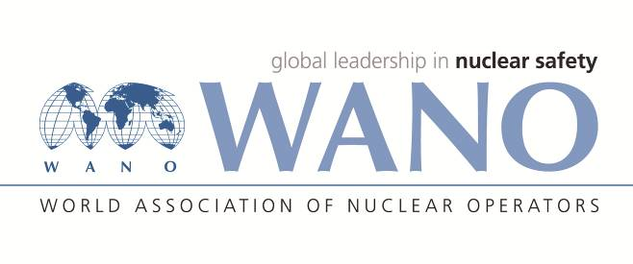 | World Association of Nuclear Operators  Moscow Centre  WANO – MC  25 Ferganskaya, Moscow, 109507, Russia  Phone. +7 495 376 15 87  Fax: +7 495 376 08 97  info@wanomc.ru

REQUEST
to provide technical and organizational information via WANO

- NPP/Organization: Dukovany NPP
- The topic of information request: Moister Separator reheater exchange
- The goal of information request: Collect experience from other members in this area

Problem description: The Dukovany NPP is preparing the exchange of moister separators reheaters between high and low pressure part of the turbines. The plant would like gain some experience from other members to prevent a problems when conducting this task.

- Specific questions:
      - Have you changed your separators reheaters? (whole vessels or only reheating part)
      - Was parameters change according the expectations as designed?
      - Have you experienced any difficulties which could be avoided in preparation phase?

- Proposed organizations for sending this request: WANO MC members
- Department – request initiator:
Dukovany NPP – System engineering dpt.
- Contact details of the requester:
Turbine system engineer
Mr. Robin Tretera
e-mail: robin.tretera@cez.cz

- Date of request: 01.09.2021

The request created by:
On-site WANO MC Rep
Mr. Tomáš Kouba
Cell: +420 725 258 854
e-mail: tomas.kouba01@cez.cz

