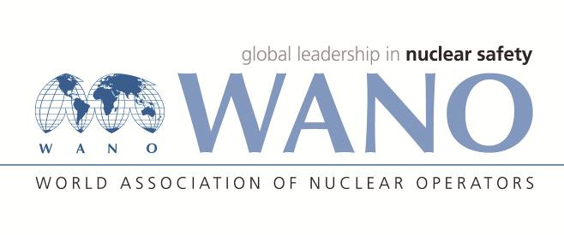 | Moscow Centre  WANO-MC  25 Ferganskaya, Moscow, 109507, Russia  Phone: +7 495 376 15 87  Fax: +7 495 376 08 97  info@wanomc.ru

REQUEST
of a Technical Support Mission

1. HOST PLANT/ORGANIZATION:NPPD/I.R.IRAN
TSM TOPIC:To support NPPD and BNPP-1 in the development of the strategy for continuous improvement of the BNPP Training Centre
2.TSM QUESTIONS:
- The aim of the Technical Support Missions to use the international experiences for developing BNPP Training System with emphasis on M&R training.
- It is necessary for visitors to be familiarized with all aspects of training system through benchmarking especially the following:
- Familiarization with the technical requirements and specifications of the plan and equipping the training centre;
- Familiarization with the training system of Maintenance and Repairs personnel;
- Familiarization with the technical requirements and specifications of training workshops of BNPP personnel (including instrumentation workshop, repair mechanical workshop, mechanical equipment (rotating and static) workshop, electrical workshop, measurement and control workshop, thermo hydraulic loop workshop and welding workshop);
- Familiarization with the technical requirements and specifications of Computer Based Training (CBT) and the manner of developing training multimedia software in the field of “Plant equipment and systems” and “training the activities of equipment maintenance and repair” and also the list and duties of divisions participated in developing software and manner of organizing the activities and work flow;
- Visiting the facilities of Demonstration Room (hall) of training centres and familiarization with the technical requirements and specifications of the Mock-ups, physical models of NPP main equipment in real or relative scales (such as control rods, fuel assembly, reactor vessel with inner equipment, primary circuit main coolant pump, turbine, steam generator, pressurizer, safety valves and etc.);
- Familiarization with software for Training Centre Management System and software package for supporting systematic approach to training;
- Familiarization with the technical requirements and specifications of the Recreation Center and Psycho-Physiological Facilities;
- Familiarization with the technical requirements and specifications of the Laboratory facilities including laboratories of industrial safety and fire fighting, radiation safety, I&C and chemistry;

3.DESCRIPTION OF THE PROBLEM:
M&R personnel initial training has been conducted by the Сontractor mainly abroad, at this moment mentioned training is being implemented in the work places of BNPP-1. NPPD management has decided for increasing effectiveness of practical training and empowering employees to perform M&R activity independently to establish of M&R training system in BNPP-1.

REASON FOR TSM:
□Safety issue
□Self-assessment

4.TYPE OF TSM:
- INFORMATION EXCHANGE (BENCHMARKING)

5.OBJECTIVES AND OUTCOMES OF THE TSM:.
- The aim of the TSM is to use the international experiences for developing BNPP Training System and to support BNPP-1 in the development of the strategy for continuous improvement of the BNPP Training Centre, hence, it is necessary for visitors to be familiarized with all aspects of training system through benchmarking especially for issues related to M&R training personnel.
6.PROPOSED DATES:
One week in the first quarter of 2017, preferably on February.

7.PROPOSED EXPERTS/PLANTS/COUNTRIES:
With this point that ‘Requirements and Specification for Bushehr NPP Training Centre, have been prepared within the framework of the IAEA Technical Co-operation by a Consortium of organizations comprising Tecnatom of Spain and VNIIAES of the Russian Federation. It is preferred that scientific visit is made from the training centres of nuclear power plants of reactor type VVER-1000 in the above-mentioned countries.

8.ADDITIONAL REMARKS: -

9.THE HOST INTERFACE REPRESENTATIVE FOR THIS TSM WILL BE:
Name: Sadeghi Farzad
Job Position:Administrative Reform&Development Manager
Phone: +9821 24882 460
e-mail: F.Sadeghi@nppd.co.ir

THE CONTACT PERSON FOR THIS TSM WILL BE:
Name: Rouhanifard Seyed Abolhassan
Job Position: Advisor to NPPD Managing Director
Phone: +982124882602
e-mail: Rohani@ nppd.co.ir

