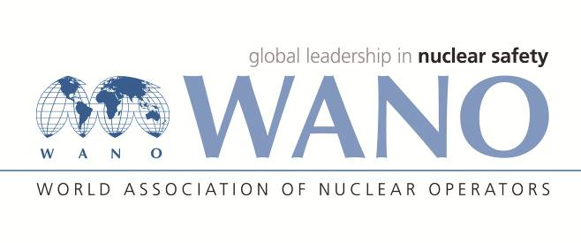 | World Association of Nuclear Operators  Moscow Centre  WANO – MC  25 Ferganskaya st, Moscow, 109507, Russia  Phone. +7 495 376 15 87  Fax: +7 495 376 08 97  info@wanomc.ru

REQUEST
to provide technical and organizational information
via WANO

- NPP/Organization: Mochovce NPP
- Information request topic:
Seal gasket design of the turbine vacuum part valves.
- Information request objective:
To collect information about the design solution of valve seal gasket on the turbine vacuum part.

Problem description:
The VVER 440 project has two turbines with a total output of approximately 440 MW, with corresponding extensive pipeline network with a number of connections and valves. 274 valves were identified on the vacuum part of the two turbines, with spindle sealed by an ordinary seals with graphite cords without the supply of a flooding medium. After unit commissioning, we have concerns of the air suction through the seals and the maximum permitted oxygen content in the feed water will be exceeded.

Specific questions:
1. How many turbines do you have in your project and what power?
2. Approximately how many valves on the vacuum part of the turbine do you have per turbine?
3. What kind of sealing do you use to seal the valves spindles on the turbine vacuum part?
4. Do you have installed valves with ordinary seals with graphite cords without flooding with external medium on the turbine vacuum part?
5. What is yours maximum allowed oxygen concetration in the feed water?
6. Do you have problems with the increased content of oxygen in the feed water, caused by the leaking valve seals on the turbine vacuum part?
7. Do you have problems with retention of vacuum caused by the leaking valve seals on the turbine vacuum part?

- Organizations proposed for distribution of this request:
All NPPs affiliated in WANO
- Department – request initiator: Maintenance Department of Mochovce 34 NPP
- Contact details of the requester:
Name: Ing. Pavol Dubovský
Position: MO34 Unit specialist at Mochovce NPP
Business telephone: +421910673068
e-mail: Pavol.Dubovsky@seas.sk
- Request date: 05/04/2022

