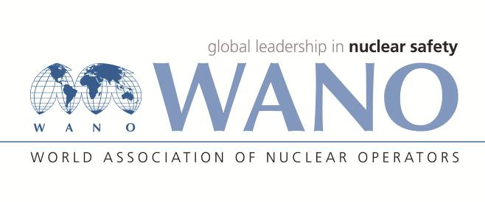 | World Association of Nuclear Operators  Moscow Centre  WANO – MC  25 Ferganskaya st, Moscow, 109507, Russia  Phone. +7 495 376 15 87  Fax: +7 495 376 08 97  info@wanomc.ru

REQUEST
to provide technical and organizational information
via WANO

- NPP/Organization: Mochovce NPP
- Information request topic: External base camp
- Information request objective: Obtaining information about external base camp implementation.
- Problem description:
The Mochovce nuclear power plant plans to ensure the organization of emergency response even during long-term multiunit emergency events using an external base camp. Base camp should ensure the basic functions of emergency response even when it is not possible to use in the full extent the emergency control centre located in the shelter on the plant territory or the backup emergency centre located approximately 20 km in the town of Levice.
- Specific questions:
- Do you have a strategy in place to arrange an external base camp outside the endangered zone with the necessary equipment to rotate personnel and store the material needed for interventions at the affected power plant (this question is not about backup emergency control centre near the NPP)?
- If you answer yes, how do you run the base camp?
a) Is a base camp set up on the territory of a neighbouring power plant (more than 50 km from the affected nuclear power plant)?
b) Does the base camp consist of mobile parts that are set up and put into operation at virtually any location?
c) Do you use a stable external emergency control centre?
d) Do you use a combination of the previous alternatives (please specify)?
e) Do you use another solution (please specify)?
- What is the goal and what is the function of the base camp?
- What is the basic equipment of the base camp?
- Under what conditions is the base camp put in operation?
- Who runs the base camp at the time of operation?
- Who and how maintains the base camp readiness?
- Organizations proposed for distribution of this request:
All NPPs affiliated in WANO.
- Department – request initiator: Emergency Planning Department of Mochovce NPP
- Contact details of the requester:
Name: Ing. Mariana Mančíková
Position: Head of Emergency Planning
Business telephone: +421910673150
e-mail: Mariana.Mancikova@seas.sk
- Request date: 28/03/2022

