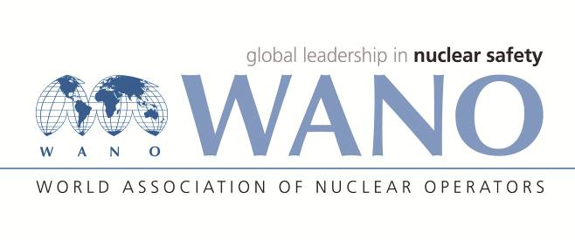 | Московский центр  Всемирная Ассоциация Организаций, эксплуатирующих Атомные Электростанции  ВАО АЭС – МЦ  Россия, 109507, Москва, Ферганская ул., 25  Тел. +7 495 376 15 87  Факс: +7 495 376 08 97  info@wanomc.ru

REQUEST
to provide technical and organizational information via WANO

- NPP/Organization: Khmelnytskyi NPP
- The topic of information request:
Experience in organizing stationary posts for decontamination of vehicles and decontamination of personnel on roads outside the industrial site of a nuclear power plant, including those intended for evacuating personnel from nuclear power plants to populated areas
- The goal of information request:
Obtain relevant information from other WANO NPPs
- Description of the problem:
There are no stationary posts for decontamination of transport and sanitization of personnel in the Khmelnitsky NPP, which can be used in the event of a radiation accident, due to the lack of uniform technical requirements, standards, standard projects for their construction and arrangement. In this regard, there is no possibility of decontamination of vehicles at stationary decontamination and sanitization posts moving from the NPP in the direction of the NPP satellite city (including during the evacuation of personnel). To date, the KhNPP SE foresees the possibility of organizing transport decontamination posts on unprepared terrain, by carrying out engineering and technical work in fact, which requires a significant investment of time and increases the time for carrying out evacuation measures.
- Questions:
- How does your NPP provide for the decontamination of transport and sanitization of personnel outside the industrial site of the NPP, in the event of a radiation accident, during the evacuation of personnel and in the future, during emergency recovery work?
- Are there unified state, industry norms or requirements for the construction and arrangement of stationary posts for the decontamination of vehicles and sanitization of personnel?

- Proposed organizations for sending this request: WANO - MС
- Department – request initiator: Emergency Preparedness and Response Department
- Contact details of the requester:
Pavlo Hvozdiar, +38-0673800699 hvozdiar.pavlo @khnpp.atom.gov.ua

