Instrument for Nuclear Safety Cooperation

Project INSC IRN3.01/16 Lot 2

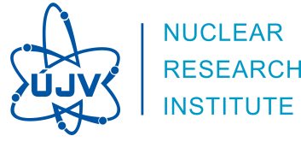**SUPPORT IN THE STRESS TEST EXERCISE**

**MEETING MINUTES**

**Technical Meeting (Task 2)**

15.-18. 6. 2019, Iran

List of contents

1. Place and time 3

2. Attendance 3

3. Course of the workshop 4

3.1. WG-1 (Hazards) 5

3.2. WG-2 5

3.3. WG-3 6

4. Presentations delivered during the workshop 6

5. Plan of future meetings 6

6. Attachments 7

Attachment 1 Agenda of the meeting 7

Attachment 2 **Chyba! Nenalezen zdroj odkazů.**List of participants 10

Attachment 3 Presentations 12

# Place and time

The Technical meeting organized within the framework of the Project INSC IRN3.01/16 Lot 2 “Support in the Stress Test Exercise” was held at the NPPD company headquarter in Tehran, Iran in the period from 15th to 18th June 2019. It followed up previous Topical meeting (February 2019) and Consultancy meeting (May 2019).

# Attendance

The Technical Meeting was attended by 11 experts of the Contractor and 8 specialists from Tavana and 3 from NPP. However, the number of local specialists and experts fluctuated within the course of the meeting according to their availability and usefulness for the issues discussed at the moment.

A list of experts and specialists involved within the whole Technical meeting can be seen below, Attendance sheet is attached.

**UJV:**

Mr. Jozef Misak, Key- expert, Project Manager

Mr. Jiri Sedlak, Senior expert

Mr. Jan Maly, Key-expert

Mr. Stanislav Hustak, Key-expert

Mr. Jozef Balaz, Senior expert

Mr. Ondrej Novotny, Senior expert

Mr. Vaclav Hakl, Senior expert

Mrs. Jelena Krhounkova, Senior expert

Mr. Jan Stanicek, Senior expert

Mr. Tomas Hroch, Junior expert

Mr. Jakub Vyvadil, Junior expert

**NPP:**

Mr. Ebrahim Deylami, NPP-1 Deputy Chief Engineer (part time)

Mr. Vahid MomeniNia

Mr. Hamid Valikhani

**Tavana:**

Mr. Mohammad Hossein Raji, Head of Nuclear Engineering dpt.  
Mrs. Elham Tavakoli, Head of DSA section

Mr. Mohamad Razaee

Mr. Ali Akbar Najafi

Mr. Ahmad Ramezani

Mr. Amin Golestani

Mr. Shahram Sheikhi

Mr. Mehran Sirouspour

Mr. Saeed Delgarm

# Course of the workshop

The Technical Meeting consisted of plenary sessions and parallel sessions of individual Working Groups (WG1-3). Plenary sessions were chaired by the Project manager Mr. Misak and the parallel sessions were led by particular working groups leaders.

The meeting had been started according to tentative agenda (Attachment 1) which was flexibly modified to needs and status of the topics planned to be solved. E.g. the presentations in plenum planned for the 1st day lasted until noon of the 2nd day. The industrious work continued in the particular working groups interrupted operatively with short plenary sessions. The meeting was wrapped up by the final plenary and planning meeting, where the achievements were presented, and future steps discussed. The decision regarding future meetings is expected to be adopted on the ongoing Progress meeting.

The splitting into the working groups is shown in the following table. However, some specialists were fluctuating between groups according as needed.

| WG-0 | WG-1 | WG-2 | WG-3 |
| --- | --- | --- | --- |
| Misak | Maly | Hustak | Balaz |
| Sedlak | Najafi | Delgarm | Ramezani |
|  | Rezaee | Golestani | Sheikhi |
|  | Sirouspour | Krhounkova |  |
|  | MomeniNia |  |  |
|  | Hroch | |  |
|  | Vyvadil | |  |
|  | Novotny | |  |
| Tavakoli | | |  |
|  | Hakl | | |
|  | Valikhani | | |

The main task of the Technical Meeting was to intensify work on the self-assessment draft report to get it as much as possible to the status presentable to be review and assessed by NPPD management. The initial part of activities was to fill in the last gaps in the current revision of the draft report, which seemed to be hardly done electronically. The core portion of the effort was to explain, discuss and clearly formulate suggested recommendations of the stress test report. Agreement on future steps in finalizing the report was last, but not least subject of discussions (to be confirmed at the following Progress Meeting).

The description of work performed within individual working groups follows.

## WG-1 (Hazards)

* Detail presentation of draft chapters 2. on Earthquakes, 3. on Flooding and 4 on Extreme meteorological events
* Detail discussion with representatives of BPP and TAVANA on recommendations of measures envisaged increasing robustness of the NPP against earthquakes, flooding and meteorological extremes
* TAVANA provided comment to the draft, chapters 2, 3 and 4, UJV will prepare the updated version taking into account TAVANA comment
* TAVANA provided to UJV last missing documents according to list of additional requirements for information, agreed during the previous meeting at April. Additional documents will be used for completion of simple analyses, other documents were used for completion of the SAST report draft during the meeting. What is still missing is information on ZK.9 building.
* Summary table has been prepared during the meeting showing the basic recommendations from chapters 2, 3, and 4, their justification and references to the SAST report. The necessary actions supposed for each item have been discussed with TAVANA.

## WG-2

Mr. Hustak presented two presentations. The first one briefly informs about the content of Chapter 5 of SAST Report and the second one gives short overview of the measures proposed in Chapter 5.

WG2 has obtained from TAVANA the remaining information required in Consultancy Meeting in April. Moreover, some additional clarification was provided by plant (Mr. Valikhani) and by TAVANA staff. All information was incorporated into SAST Report.

Measures related to diesel makeup pump proposed in Chapter 5 of SAST were discussed with Mr. Valikhani and TAVANA. The remaining hardware measures were briefly reviewed by Mr Valikhani as well. His comments were incorporated into SAST Report. Proposed measures related to 2.0 MW mobile DGs and proposals for additional analyses were also discussed with TAVANA.

Updated Chapter 5 of SAST Report was available at the end of meeting.

## WG-3

WG3 Presented actual status of the chapter 6 STSA report, which has been compiled. Conclusions of the chapter were presented. For better understanding, carried out analyses were presented, their conclusions explained and discussed. All proposals of the chapter 6 STSA report were reviewed in two iterations. Changes which imply from modified recommendations will be incorporated in to in to corresponding chapters accordingly. Based on incorporated modifications, harmonization with summary in chapter 7 of STSA report will be provided.

# Presentations delivered during the workshop

The following presentations were given by UJV during the workshop.

* Current status of STSA report drafting Chapter-2
* Current status of STSA report drafting Chapter-3
* Current status of STSA report drafting Chapter-4
* Current status of STSA report drafting Chapter-5
* Proposed Measures - Loss of Safety Functions (ad Chapter-5)
* Current status of STSA report drafting Chapter-6
* Results of carried out analyses (ad Chapter-6)

All presentations are included in Attachment 3.

# Plan of future meetings

The plan of future meetings was subject of discussion of the Progress Meeting on June 19 2019.

# Attachments

1. Agenda of the meeting



1. **Chyba! Nenalezen zdroj odkazů.**List of participants

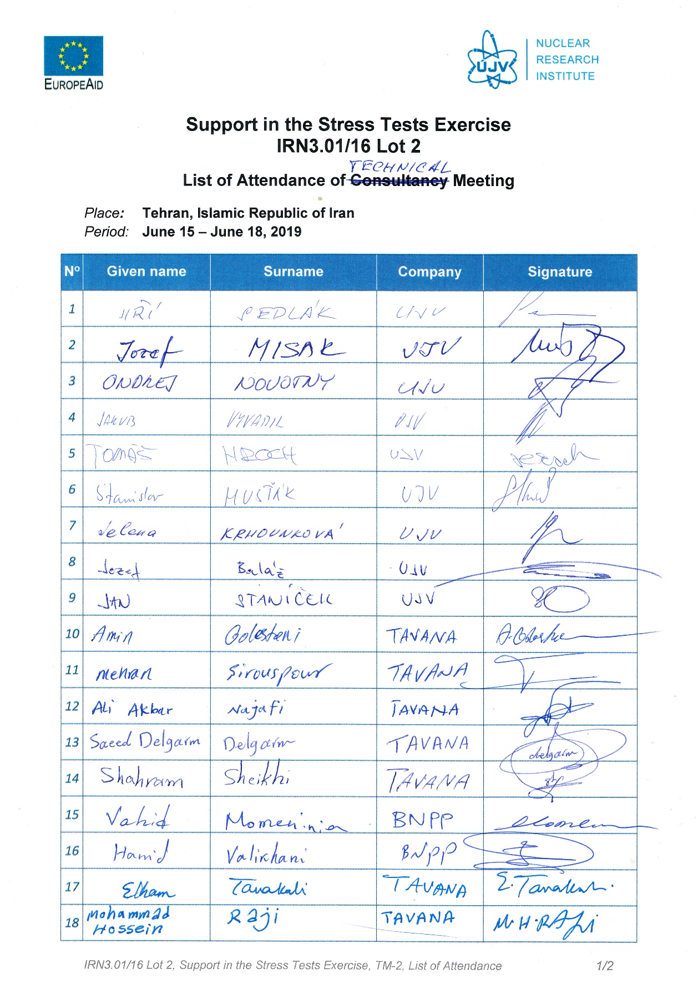

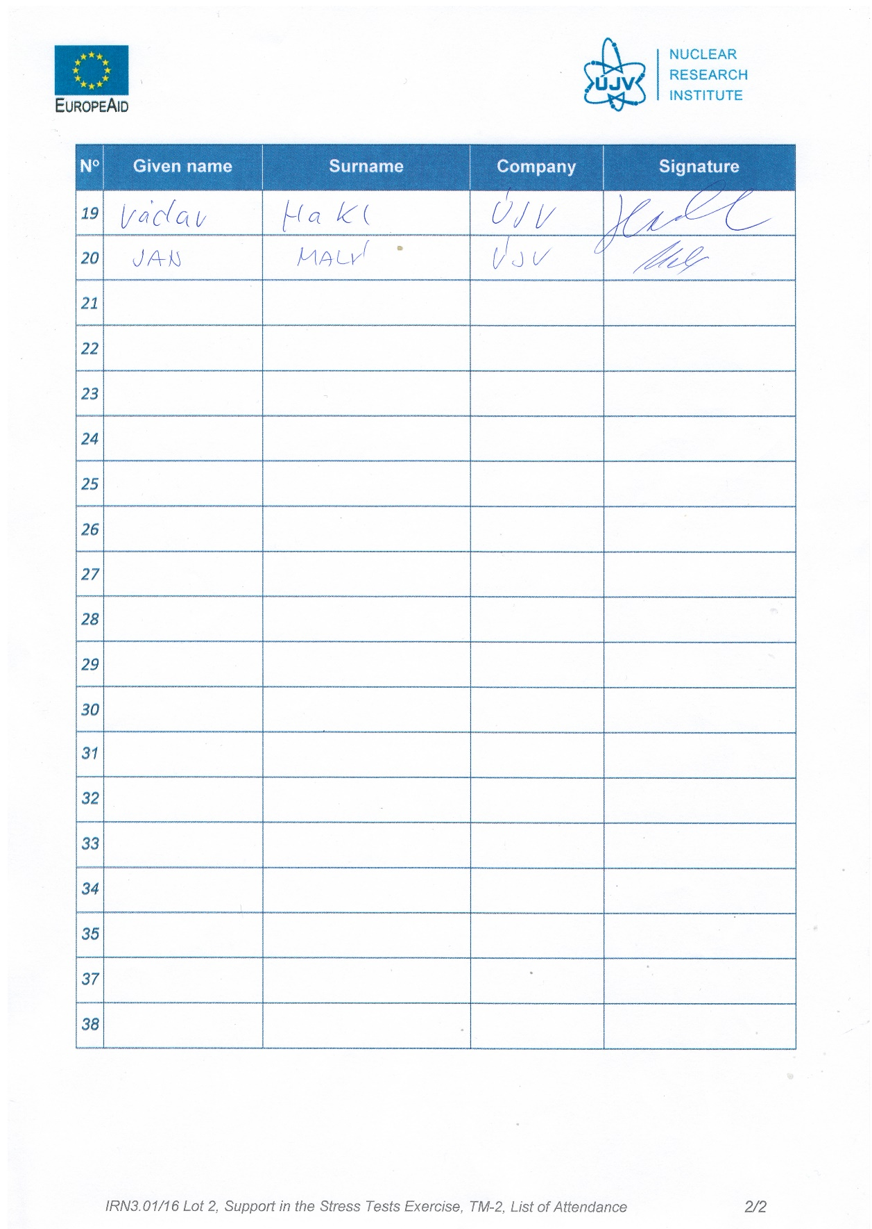

1. Presentations













