**IAEA technical meeting on the evolution of the Operational Safety Review Team(OSART) service over the last 30 years**

**SBO concealment event and safety culture at Kori 1**

**Presenter : Mr. Mansu Kim**

**29 Oct. ~ 1 Nov. 2013**

**Busan city, KOREA**



C

**CONTENTS**

1. Introduction
   1. Kori 1 NPP history
   2. Key parameters
2. Event summary
3. Prompt actions and decisions for the moment
4. Contributing causes
   1. Station black out
   2. Not reporting SBO including not declaring Emergency Action level ‘Alert’
   3. Violation of Technical Specifications
   4. Some aspects of Korean culture
   5. Contributing causes/Broken barriers to the SBO event
5. What has been employed to enhance the safety
   1. The reporting system improvement
   2. Safety culture proliferation in-depth
   3. Enhancement of power supply system reliability
   4. Refueling outage activities improvement
   5. At the corporation level
   6. At the regulatory body level
6. Suggestion
7. Conclusion
8. Reference
9. **Introduction**

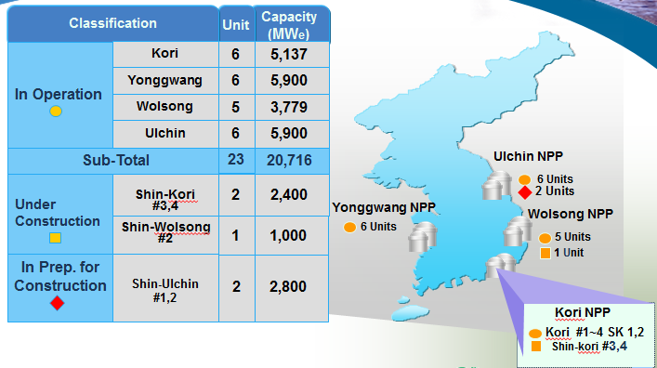Korea Hydro and Nuclear Power Co. has 23 units operating (8 WEC type PWR + 11 OPR1000 PWR + 4 CANDU PHWR), providing approximately 30% of the total domestic electric power supply, 5 units (1 OPR1000 + 4 APR1400) under construction.

[NPP sites in Republic Of Korea]

Kori nuclear unit 1 is the first reactor built in Korea nuclear history. It commenced the operation since 1977. After 30 year operation, the licensed design life time was expired, the license renewal was introduced since 2007. It has shown excellent operational performance with 587 MWe capacity. WEC designed Kori 1 accommodates 121 fuel assemblies in the reactor, amount to 43 MTU. In addition, in last August, the EDG, the reactor head and the main control board were replaced to extend the life time and enhance the reliability of critical equipment.

**1.1 Kori 1 NPP history**

• May 1972 : Construction Permit (CP) and Operating License (OL) issued

• Jun 1977 : Initial Criticality

• Jun 1977 : First grid synchronization

• Apr 1978 : Commercial operation

• Jun 1997 : Rotor of LP turbine replaced

• Sep 1998 : SGs and process control/protection system replaced

• Oct 2001 : Main transformer replaced

• Dec 2007 : License renewal for continued operation till 2017

The first ever IAEA Operational Safety Review Team (OSART) mission was conducted at Kori NPP in 1983. The IAEA Safe Long Term Operation Mission (SALTO) was conducted at Kori 1 NPP in July 2007 prior to the license renewal.

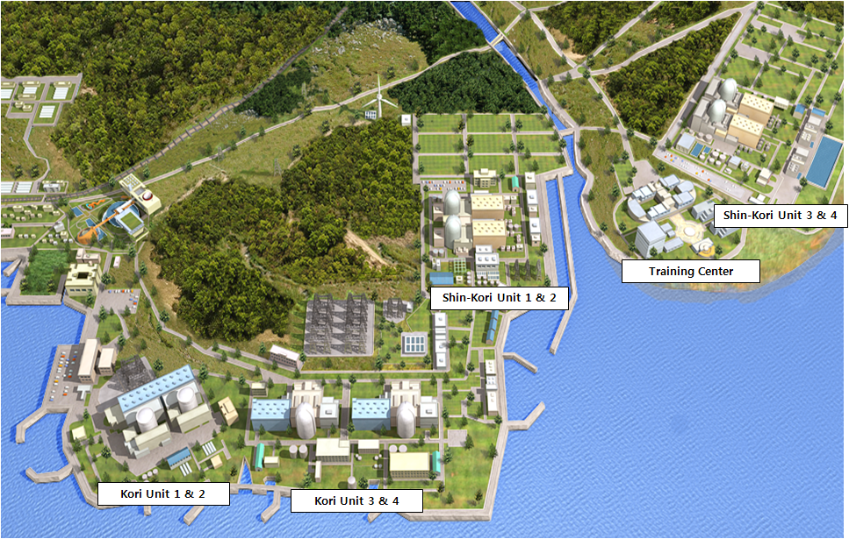

[ Bird’s eye view of the Kori site ]

**1.2 Key parameters**

Reactor type PWR, two loops

Net electrical output (MWe) 610 MWe

Thermal power output (MWth) 1,723 MWth

Site design earthquake 0.2 g

Number of off-site power supplies 2

Number of high-voltage buses for on-site power supplies 2

Number of diesel generators, voltage, capacity 2 / 4.16kV/2,920kW

Other on-site backup power supplies 1

AAC D/G /4.16kV/5,500kW

Emergency Core Cooling

a. High pressure injection

Number of trains 2

Number and type of pumps 2 Electrical, Centrifugal

b. Low pressure injection (RHR)

Number of trains 2

Number and type of pumps 2 Electrical, Centrifugal

1. **Event summary**

On February 9 2012, during the 29th refueling outage of Kori 1, loss of off-site power occurred and emergency diesel generator B failed to start while EDG A was out of service for 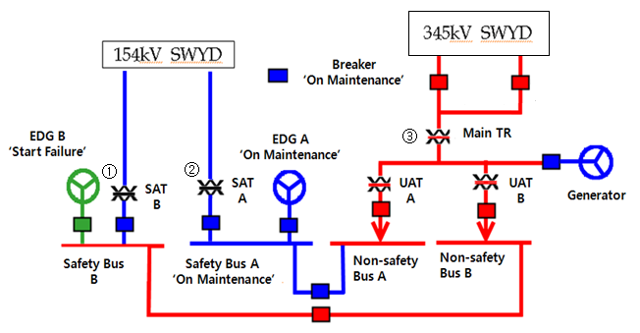scheduled maintenance, resulting in a station blackout.

[Electric switchgear configuration before SBO event]

Three (3) power sources were available at the time of the event, one offsite power (③ 345kV) via main transformer, EDG "B", and AAC D/G. Two standby offsite power sources (①, ②, 154kV) were isolated for planned maintenance. Operating offsite power (③) was terminated in course of the generator protective relay test resulting in loss of offsite power (LOOP). Operating one (1) offsite power source (③) was terminated because of subcontractor's incorrect manipulation of generator protective relay test equipment (human error). EDG-A was under maintenance, EDG-B failed to start on an automatic demand signal and resulting in a loss of all AC power. The SBO led the loss of RCS shutdown cooling and spent fuel pool cooling.

In response to the SBO, the MCR operators restored the electrical power by connecting to SAT 'A' rather than to AAC DG (in stand-by state and in arrangement with Kori Unit-4), and subsequently restored the power supply to the RHR pump 'B' in accordance with the procedure by establishing cross-tie of 480V bus 'A' with 480 bus 'B' because RHR 'A' was under maintenance. One (1) offsite power source (①) which had been under maintenance condition was restored and powered to the assigned Class 1E bus after 11 minutes 43 seconds. The shutdown cooling was lost for 19 minutes. At the moment when the SBO occurred, all the fuels were still in the reactor with the reactor head removed from the reactor and the reactor cavity was flooded. As a result of the event, the reactor coolant maximum temperature in the hot leg increased from 37℃ to 58. 3℃(approximately 21.3℃ increase) and the temperature of spent fuel pool was increased slightly from 21℃ to 21.5℃.

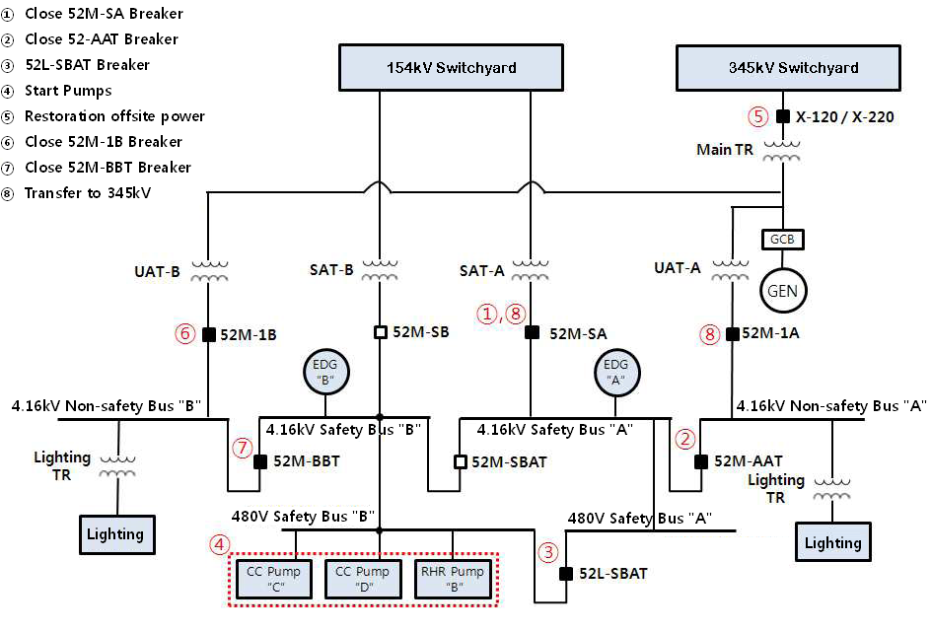

[Restoration sequence]

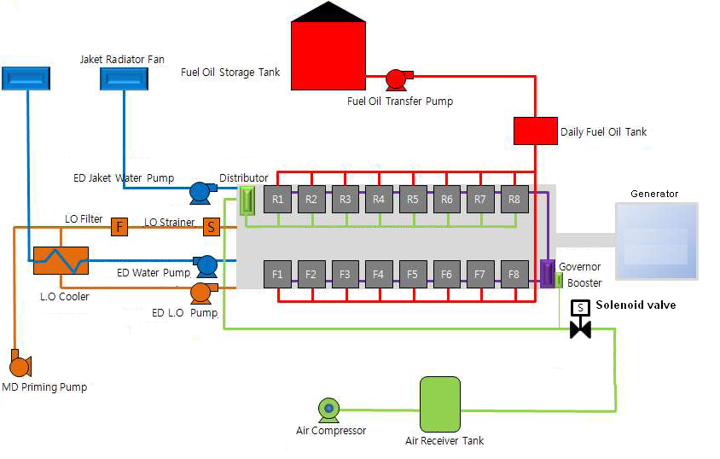

[EDG starting air supply line schematic]

No fuel damage was identified based on RCS I-131 activity analysis and thermal hydraulic audit calculation by regulatory investigation team.

1. **Prompt actions and decisions for the moment**

The plant manager and his staff in control room decided not to report SBO. The plant manager opted to hide this event due to heavy feeling of a burden to preempt public critics and a fear of worsening the plant management’s credibility. This event occurred at the time when the antinuclear sentiment was rampant since Fukushima Daiichi nuclear disaster swept world nuclear industry a year ago. And the same day as the SBO occurred, the CEO of the KHNP announced the action plan to operate the nuclear power plants with the government and made a promise without events in front of the mass media and had the interview with the reporters.

There was no adverse effect on plant safety as a result of SBO, no radiation exposure to the workers and no release of radioactive materials to the environment. However, inconsistent with the requirements, Kori 1 did not report the SBO event in accordance with the plant emergency plan.

After this concealment was leaked out to the public, the impact to the society was colossal. The plant was immediately ordered to do shutdown by NSSC. KHNP requested IAEA to conduct the expert mission last year. The plant was shut down for 5 months with nothing from the negative influence of the public. And the regulatory body did not approve the plant startup until the enhancement plan of the safety culture were drawn

One of the ways to show the safety was thought to get the inspection from the independent nuclear expert institute and show the inspection result to the public including the local community and the environment group. In order to regain public trust and recover the tarnished reputation, it was necessary to improve the safety culture through both its structure and mindset renovation. IAEA EM was thought to be the only way. IAEA EM was very helpful to restart the reactor.

From the concealment event, five employees including the plant manager were indicted on charges of the concealment. One of them was sentenced to one year in prison and fines. Personally, the presenter, myself, was also interrogated from the prosecutor as a suspicious man proceeding the core alteration with not being EDG operable. Unfortunately, at the time of event, I was not reported of being EDG not in operable from the MCR operator. Anyway, it is shame of me. I was ruled innocent.

Following is the brief milestone of the 29th core cycle which the SBO event was involved. Almost one year was shutdown.

* Feb 4 2012 Shutdown for refueling outage
* Feb 9 20:34 2012 SBO occurred
* Mar 4 2012 Reactor criticality for cycle 29
* Mar 9 2012 SBO leaked, one(1) month after the event occurred
* Mar 13 2012 Forced shut down, 9 days after the reactor startup
* June 4 ~June 11 IAEA EM
* Aug 10 2012 Plant restart, 5 month after the forced shutdown
* Apr 12 2013 Plant shut down for the major compartments replacement
* Sep 11 2013 Scheduled plant startup
* Sep 29 2013 Reactor criticality, 18 days after the scheduled startup
* Feb 12 2014 Refueling outage(Schedule)

**4. Contributing causes**

**4.1 Station Black Out (SBO)**

Direct cause (why it happened): Mis-operation of the protective relays of the main generator

Contributing causes/broken barriers:

* Scarcity of contractors qualified for test of generator protection system – this was the reason for rescheduling the test, because of time pressure for the available contractors to move to next work site
* Rescheduling the generator protection system test bypassing established process (to be approved by Outage Control Centre), this resulted in lack of additional risk analysis for the unusual lineup for the test
* Maintenance of SAT B was started although SAT A was not returned to operation, this resulted elevated shutdown
* Design: single solenoid valve for startup air for DG. Corrective action: As a part of a root cause analysis of the SBO event the plant should extend conditions of the EDG-B solenoid valve failure and perform analyses of other plant’s equipment and systems important to safety to identify and manage critical parts and components and its vulnerabilities (similar to EDG-B solenoid valve), to avoid repeat events.
* Maintenance: no complete preventive maintenance, ‘lost’ rubber cap was replaced by a plastic cover not providing proper protection
* Human error of communication: supervisor instructed “do not proceed to next step”, worker activated next channel during generator protection test
* Human factor: overconfidence of worker due to long experience with this test
* Procedure: preconditions, potential risk and consequence of error not described; no requirement to sign off completed steps
* Pre-job brief was performed one day before the test, although “it should be used as means of avoiding personal errors, difficulties in communication and misunderstandings”

**4.2 Not reporting** **SBO including not declaring Emergency Action Level “Alert”**

Direct cause (why it happened)

: Kori 1 plant manager and other staff decided not to report SBO

* Contributing causes/broken barriers:
* Reputation risk: That time plant manager stated he decided to hide this event due to heavy feelings of a burden to preempt public critics and a fear of worsening the plant's credibility
* Decrease of public trust in Kori 1 NPP associated with Fukushima accident, reactor trip at Kori 1 in April 2011 and two cases of corruption related to supply of spare parts for Kori 3 and 4
* Undue pressure from KHNP to operate without events
* The prevailing high respect for authority of supervisor prevented other staff involved to disagree with plant manager, although several elements of safety policy and administrative procedures were violated
* Kori 1 safety culture survey from May 2012 indicates that:
  + Relatively few (only 23.2%) of plant staff provided positive response to whether “safety culture is regarded as the most overriding priority in performing any activity”
  + Relatively few (only 19.5%) of plant staff provided positive response to whether “business environment that put an importance on the safety is created”

**4.3 Violation of Technical Specifications**

The plant Technical Specificationswere violated by

a)not immediately starting to take action to restore EDG to operable condition by the afternoon shift on 9 February;

b) starting of fuel movement with no operable EDGs by the afternoon shift 10 February ( in fact the same shift was on duty on the two occasions).

Direct cause (why it happened): EDG B was not declared inoperable as a part of ignoring the previous SBO

Contributing causes/broken barriers:

* Decision of Kori 1 plant manager not to report SBO
* Other involved staff did not oppose/disagree with plant manager’s decision, although several elements of safety policy and administrative procedures required that action
* Incoming night shift failed to identify status change (increase of primary coolant temperature on chart recorder, alarm of “RHR flow low” and “RHR trip” on the alarm printer); although relevant checks are required in general, but detailed checklist does not exist
* Kori 1 internal oversight failed to identify SBO event
* NSSC/KINS inspectors failed to identify SBO event

**4.4 Some aspects of Korean Culture**

The Korean national culture attributes of respect for elders and superiors came to have significance. The strength of this cultural attribute is that compliance with line manager’s requirement and expectations is good but puts a reliance and greater responsibility onto the leader to show an exceptionally good code of conduct, standards and leading the team to excellence. This attribute also has an implied effect on ‘questioning attitude’ which needs to be accommodated to ensure that this safety culture characteristic is working inside KHNP. Where a line manager chooses to work outside policy and procedures there may not be an acceptable cultural route for a worker to raise a question.

A cultural aspect of ‘working hard and fitting as much activity into the time as possible’ emerged. The strength of this characteristic is that managers can use the Korean work ethic to complete tasks efficiently and quickly, however the difficulty with the characteristic is that detail and systematic completion may be compromised. ‘Check lists’ and quality/procedural ‘hold points’ that are used extensively at the site could help counter the problem.

**4.5. Contributing causes/broken barriers to the SBO event**

Wider Cultural influences leading to behavior:

* High respect for authority of supervisor prevented other staff involved to disagree with plant manager, although several elements of safety policy and administrative procedures would require that the plant blackout was a situation that required onward reporting and initiation at the time of a readiness emergency arrangement response.
* Decrease of public trust in Kori 1 NPP associated with Fukushima accident, reactor trip at Kori 1 in April 2011 and two cases of corruption related to supply of spare parts for Kori 3 and 4

Internal Kori cultural influences

* Reputation risk: At that time the plant manager stated he decided to hide this event due to heavy feelings of burden to preempt public critics and a fear of worsening the plant's public credibility
* Undue pressure from KHNP to operate without events, the performance oriented mission as OCTF(One Cycle Trouble Free)

In a subsequent Safety Culture survey at Kori 1, the results supported the view that the Kori 1 workforce and managers felt that business priorities are put ahead of the safety priorities.

What kind of culture was immersed in Kori 1 management so that management thought to not report, and which actions have been taken to improve the safety culture was discussed. That high respect of authority and seniority which is rampant in Korea culture and led to the concealment was pointed out by IAEA EM. 22 actions have been employed so far to enhance the safety including internal and external oversight organization, remote plant monitoring system around clock, multiple off-site power source etc. The anonymous reporting scheme for employee concerns has also been introduced. Other than these software improvements, number of major equipments have been replaced to enhance the reliability. Unfortunately, once the trust was lost, it is not easy to recover it from the public. The public doesn’t like to trust Kori 1 although KHNP paid a lot of efforts to enhance the safety. Only their demand is to shut down the reactor. IAEA expert mission played the critical role to restart the reactor last year after 5 month shutdown. As one of the management at Kori 1 when these activities was implementing, I want to share this resources with participants including the interrogation from the prosecutor after being accused of by NSSC.

**5. What has been employed to enhance the safety**

* 1. The reporting system improvement
* Why : SBO concealment at the Kori 1 management was possible due to only one line reporting system in working which the plant manager can seizure all information flow
* How to improve : Introduce the multiple oversight and reporting system, in a way the concealment cannot be rooted in operating structure

|  |  |  |
| --- | --- | --- |
| No | item | Description |
| 1 | Remote oversight and automatic alerting system, software system | * Remote online monitoring system for plant operation parameters oversight during the startup and shutdown   : In Seoul office, all plants can be oversighted   * NEWS, Nuclear Event Warning System   It is newly designed to send the major alarms to the nuclear related reporting line in KHNP job site, KHNP Seoul office, KINS, NSSC residency office, NSSC head office. Major alarms are consisted of the reactor trip, Safety injection, Loss of Voltage, Radiation high alarm, natural disaster etc   * This system is equipped with the UPS |
| 2 | Independent safety supervisory organization | * New independent safety oversight organization * 4 shift work, assigned 6 at each site * Round the main control room, major equipment and safety related surveillance and maintenance. * Reporting the safety concerns to Seoul office directly, independent from the plant manager, check the decision made at the plant. |
| 3 | Monitoring with the CCTV | * Safety oversight staff are newly allowed to oversight the plant in remote with 64 CCTVs which were already installed at job site |
| 4 | Nuclear operation status website opened to the public | * Nuclear operation parameters are opened on real time basis * Significant issues/resolutions are posted |

* 1. Safety culture proliferation in-depth
  + Why : To root out the view that the business priorities are still put ahead of the safety priorities, and proliferate the safety culture in all areas
  + How to improve : Draw the findings to be improved, consulting from the outside safety experts and implement the appropriate following actions, but should be tangible
  + Basic philosophy : Safety is a recognized value, Leadership for safety, Questioning attitude, Safety is learning driven, Safety in integrated into all activities and communication, rigorous approach

|  |  |  |
| --- | --- | --- |
| No | item | Description |
| 5 | Draw the findings to be improved and implement the following actions | * Consulting from the outside safety culture experts * Excellons, 7 areas including diagnosing leadership of executive, CEO, corporation mission and vision and safety culture policy at the corporation level * National safety culture reviewers, 13 from industry, university. 5 findings were made * 12 actions have been implemented at the plant level   + Safety dialogue between plant manager and each employee   + Anonymous reporting mail box system for irrational safety culture to be improved   + Team based meeting to enhance the safety communication   + Safety culture message proliferation during the meeting every morning   + Safety culture meeting between KHNP and the contractor   + Speak loudly the safety slogan every morning, shift turnover, pre-job briefing   + Rewards to the employee, contributed to the safety culture   + Special lecture on safety culture   + Training program participation for safety culture |
| 6 | IAEA review for safety culture area | * 6 improvement proposals for safety culture were advised and its resolutions are being implemented |
| 7 | Revise the safety indicator | * The effort factor of safety culture enhancement is emphasized to evaluate the individual evaluation and management performance * Safety attitude is a significant factor in approving a promotion |

* 1. Enhancement of power supply system reliability
  + Why : Power supply system was designed, manufactured in 1970s. More offsite power lines are thought to be needed. The system is vulnerable to triggering the LOV while doing the maintenance.
  + How to improve : Preparing the maintenance schedule to avoid any fault and Replacing the major components with new ones

|  |  |  |
| --- | --- | --- |
| No | item | Description |
| 8 | Enhance offsite power stability by adding more 345 KV transmission line | * Offsite transmission line enlarged to 6 from the previous 2 lines |
| 9 | Reinforce the supervising activity during power line test | * Categorized the work unit which can be caused to LOV, 119 items were drawn |
| 10 | Deploy additional portable diesel generator | * One 4.16 KV, 3,200KW EDG deployed for each site |
| 11 | Duplicate the starting air system in the EDG | * The redundancy air supply system was introduced |
| 12 | Perform special test and inspection on all operating plant’s EDG’s | * Completed |
| 13 | Replace Kori 1 EDG with new one | * 2,920kWe → 3,500 kWe * 2 EDGs were replaced |

* 1. Refueling outage activities improvement
* Why : Refueling outage activities has been more targeted to shorten the maintenance hours than safety first management
* How to improve : Separation and serial work scheduling of the activities which are vulnerable to LOV

|  |  |  |
| --- | --- | --- |
| No | item | Description |
| 14 | Simplified the stand-by transformer maintenance schedule | * To prevent the SBO occurring fundamentally, the maintenance of stand-by transformer is scheduled one by one, not by overlapped * The potential work item vulnerable to triggering the LOV is separated from each other, no overlapped |
| 15 | Extending the refueling outage schedule | * Allotting more time to secure the safety * 1 or 2 days more |
| 16 | Intervene the maintenance expertise of the contract | * Workmanship * Safety culture |

* 1. At the corporation level

- To educate the qualified RO/SRO candidates

- To train the operators using the simulator in preparation for the emergency as SBO

- To review the 880 operational procedures and revise them

- To add the more manpower for the area of operation and maintenance

- To inspect the EDGs at all operating plants

- To replace the major components for over 20 year operation plants

* 1. At the regulatory body level

- To add the safety culture as the regulatory inspection item

- To enlarge the inspectors in residence

**6. Suggestion**

Fukushima nuclear disaster and SBO concealment event have deepened the mistrust of Korean nuclear industry, not limited to the Kori unit 1 operation. And the corruption scandal in relation with the substandard parts use and the faking safety tests for critical plant equipment have highlighted the nuclear safety in negative way in Korea. These led to involve the prosecution investigation and the political issues. Nuclear industry in Korea was publicly even defined as a mafia. The scandal makes it difficult to continue claiming to build reliable nuclear power plants cheaply. The plant shut down in conjunction with the falsified quality certificate made the power shortage in muggy summer of 2013. Kewaunee (Kori 1 reference plant , 556MWe) closed, the expected decommissioning price will bo 1 billion dollars, For Kori 1 has invested 300 million dollars to enhance the reliability for both license renewal and improvement prompted by Fukushima nuclear disaster. The decommissioning is expected to 600 million dollars. These associated events have been making Kori 1 difficult to restart even after finishing the refueling outage.

KHNP requested IAEA review the expert mission after SBO concealment event while the reactor was forced shutdown, 3 months had been passing. Kori 1 planned to persuade the local communities its safety with the outcome of the IAEA EM. IAEA EM findings were said to be not critical elements to restart the reactor. Unfortunately, the local communities (Busan city, legislate politicians) were not likely to believe the IAEA evaluation report. They even blamed IAEA EM team for the nuclear mafia

Following pictures are the banners which were posted at the Kori 1 main gate, without being alphabet correction made.

|  |  |
| --- | --- |
| Reativating of Gori-1 nuclear plant taking Gijang people's life,  as security!  We object to the deceitful IAEA inspection.  - Jangan-eup develop committee - | EMB000015ec1b57 |
| We never accept evadable inspection of IAEA, nuclear mafia.  IAEA Draw back at once!  - Jangan-eup develop committee - | EMB000015ec1b58 |
| IAEA has lost Gori resident's confidence.  IAEA must withdraw form Gori.  - Jangan-eup develop committee - | EMB000015ec1b59 |

Why have these things happened in Korea

First, nuclear accident (Chernobyl, Fukushima) has proved that nuclear is no more safe at all. Those accident was jolt to the nuclear industry

Second, Korean government and Kori 1 lost the trust from the public while they have operated the nuclear

Third, IAEA has not been recognized the authoritative UN organization

Now the CDF, core damage frequency, 10-4, the earthquake and tsunami frequency, once-in-a -thousand occurrence are not important at all to the public

IAEA has to be reborn as the authoritative international nuclear experts institute and has to be played independent role from any country and any utility which the trust has been decreased. In case, any country is tried to regain the trust, IAEA can be the big role

IAEA kept silence at the moment when many countries want to be told from the authoritative experts.

What has IAEA told to the Korean government at the time when the personnel involved in SBO concealment were accused of, knowing that this was violating the safety culture requirement

What has IAEA told to the countries adjacent to Fukushima sea, Japan, not to eat the seafood and agricultural products from Japan. IAEA website is just delivering the announcement of the Japanese government’s implementation plan. No warnings were found. IAEA delivers the Japanese government’s plan to control the contaminated water discharging to the pacific. IAEA is playing the messenger role. IAEA is Japanese’s parrot repeating their concealment word, saying that the contaminated water is safely controlled. The ground water is reported to be contaminated with the radioactive tritium, strontium and cesium. I don’t want to feed my children, family, young Koreans and baby on the fish and agricultural products from Fukushima area.

IAEA has to strongly recommend Japanese government to close all reactors earlier because of its vulnerability to the earthquake. The ring of fire has been known to be very closely located to Japanese coastal line. But I have not seen any statement about this from IAEA. If this is the OSART’s responsibility, Mr. Lipar, Scientific secretary, Division of nuclear installation safety/Department of nuclear safety and security, has to take the responsibility. IAEA is believed to be inferior to New York Times from the view point of alerting the public about the safety.

IAEA is the international organization. It must not be the slave to power nation.

IAEA has to open the mouth whenever it has to play for the peaceful use of nuclear.

IAEA has to say even a word if it founds something is going wrong way.

IAEA has to play as a needle in compass to indicate the direction of nuclear industry.

IAEA has to seek to guard the global citizens from the nuclear terror.

IAEA has to be scientist’s conscience.

IAEA must be a fare front runner of the global nuclear industry, not biased, not passive.

**7. Conclusion**

The first ever IAEA operational Safety Review Team mission was conducted at Kori unit 1 1983. The Kori 1 employees are very proud of working at the first nuclear reactor built in 1977 since Korea nuclear history embarked. High standard of ethic and integrity is believed to require to operate the nuclear in parallel with nuclear operation technic advance. All nuclear workers have to be in mind, the story of shepherd boy who cried wolf in Aesop’s fables. Not losing the trust from the public is believed to be very important element for the peaceful use of nuclear. The importance of safety culture is not finished, it’s still in progress without being stopped.

The trust between the KHNP and the public is not thought to be recovered even though the Kori 1 is now operating. Mistrust is still deep.

**8. Reference**

8.1 Report of the expert mission to review the station black out event that happened at Kori 1 NPP on 9 February 2012, Republic of Korea, 4-11 June 2012, Division of nuclear installation safety operational safety review mission, IAEA-NSNI/Expert mission

8.2 IAEA safety series INSAG-4 Safety Culture

8.3 New York Times dated Aug 4 2013 Scandal in South Korea over nuclear revelation

8.4 New York Times dated May 7 2013 As price of nuclear energy drops, a Wisconsin plant is shut

8.5 New York Times dated July 26 2013 Delay in disclosing leaks at Fukushima is criticized

8.6 KHNP internal report, Safety improvement results at Kori unit 1, March 25 2013

8.7 Overview of contaminated water issue at TEPCO’s Fukushima Daiichi NPS, Agency for Natural Resources and Energy, METI of Japan, September 3 2013