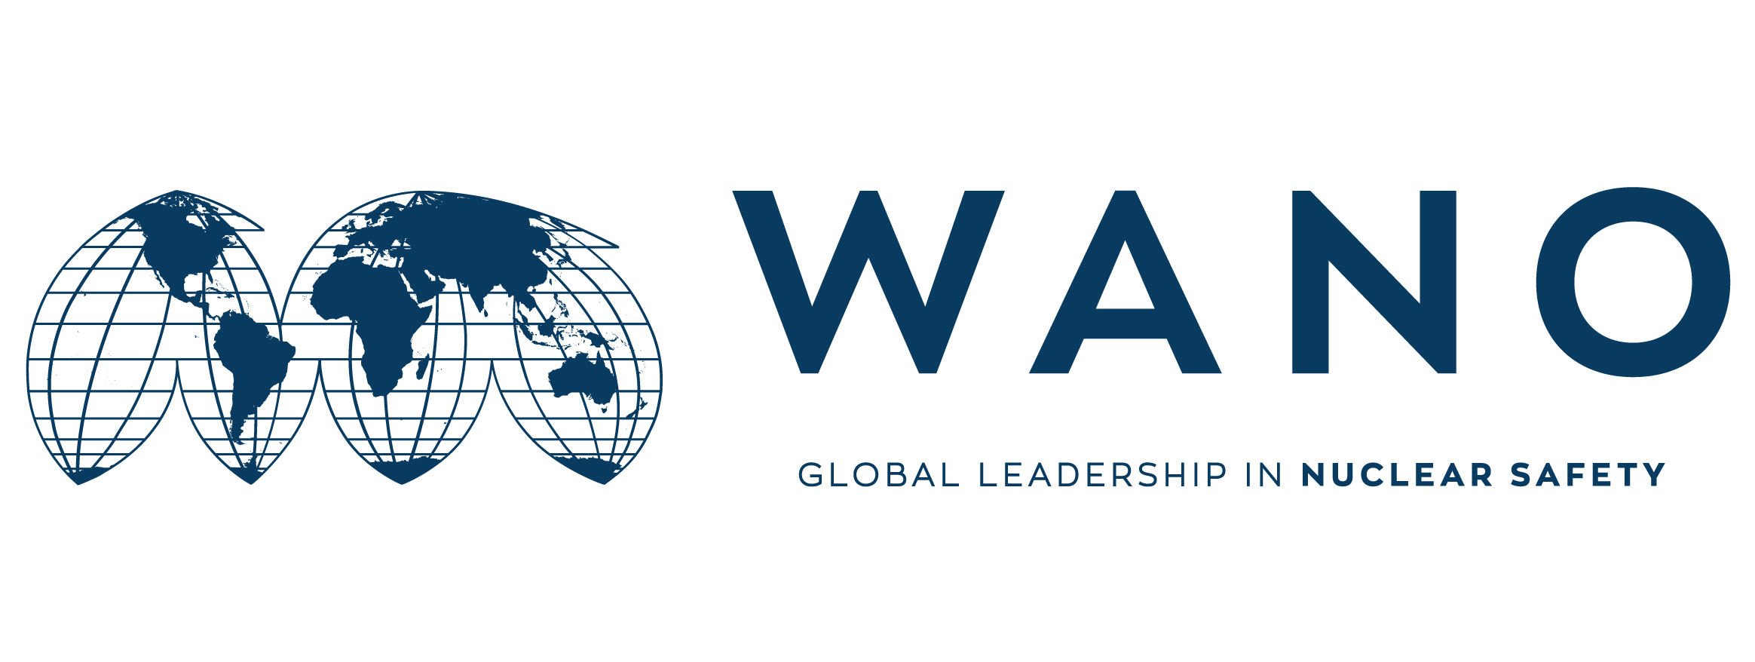 | Moscow Centre  WANO-MC  25 Ferganskaya, Moscow, 109507, Russia  Phone: +7 495 376 15 87  Fax: +7 495 376 08 97  info@wanomc.ru

MSM expert personal form

General information

MSM place: “Rosenergoatom” Company
MSM topic: Risk management
MSM date: from December 03 to December 06
MSM working language: English
MSM coordinator: EVGENY KOVALEV
Phone number: +7 916 244 59 19
e-mail: evkovalev@wanomc.ru

Expert data

Name | Hamid
Surname | Barjesteh
Date of birth | 1988-04-12
Place of birth | Iran, Tehran
Citizenship | Iran
Passport number  (please send the scan copy) | G10510093
Passport issue date | 01/09/2018
Passport expire date | 01/09/2023
Job Title | planning and control Project- Risk Management
Station | Expert
Company / Organization | Nuclear Power Production & Development Company of Iran
Work Address | No.8, Tandis St., Africa Ave.
Telephone | +982127882513
Home address | No.6, Taheri St., Sani Ave., Narmak.
Fax | +982122058480
Work e-mail | Barjesteh@nppd.co.ir
Personal e-mail | Barjesteh.ie@gmail.com
Mobile phone | +989124701561
Laptop brand and serial number | Surface Tablet, Microsoft  022087251552
Size of clothing  Shoes  Height | Size of clothing= L  Shoes= 42  Height=178
Presentation title | Risk Management System In NPPD

Technical experience in the MSM area
__________________________________________________________________
__________________________________________________________________
__________________________________________________________________
__________________________________________________________________

Foreign languages knowledge

Native language(s)
Foreign languages | Poor | Medium | Good | Excellent
English
Others: 1)
2)
3)

