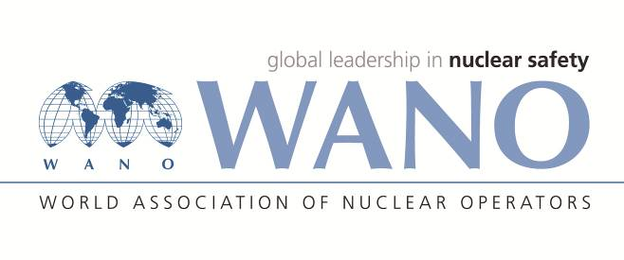 | World Association of Nuclear Operators  Moscow Centre  WANO – MC  25 Ferganskaya, Moscow, 109507, Russia  Phone. +7 495 376 15 87  Fax: +7 495 376 08 97  info@wanomc.ru

REQUEST
to provide technical and organizational information via WANO

- NPP/Organization: Kola NPP, “Concern Rosenergoatom”, Russia

- The topic of information request: Equipment operation and technological parameters with low frequency of electrical grid
- The goal of information request: Gain operating experience of plant operation during low frequency in electrical grid (electrical grid accidents), and frequency decrease during generator transition to house needs.
- Problem description: Decrease of main equipment efficiency due to low frequency operation could cause actuation of the reactor protection.
- Specific questions:
1. Low frequency protections (protected equipment, setpoints and time delays, actuation algorithm – what are disconnected).
2. Plant design modes for grid accidents with frequency decrease.
3. Low frequency values (setpoints) when plant is dedicated to supply house needs.
4. Techical Specifications frequency limits.
5. Influence of low frequency on NSSS operation.
6. Events with actuation of plant technological protections caused by frequency decrease.
- Proposed organizations for sending this request:
WANO MC members
- Department – request initiator: Kola NPP, Electrical Department
Contact details of the requester: Bykov Alexandr, ED Deputy Manager , Tel. (881532) 42376; E-mail: <BykovAL@kolatom.murmansk.ru>;
Kutilov Maxim, ED Lead Engineer, Tel. (881532) 43404;
E-mail: <KutilovMV@kolatom.murmansk.ru>
- Date of request: 28.05.2018

