**Bogomil Manchev, Ph.D.**

     Executive Director,  
     Chairman of Board of Directors and  
     Director, Marketing

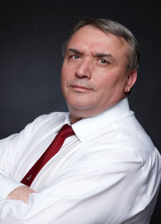

**George Halev, MSc.**

Director, Nuclear Energy Division and  
Deputy Chairman of Board of Directors

