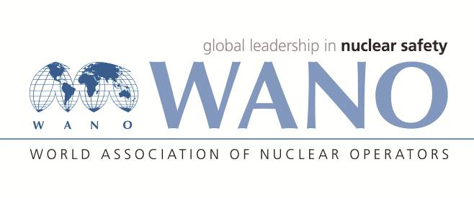 | Moscow Centre  WANO-MC  25 Ferganskaya, Moscow, 109507, Russia  Phone: +7 495 376 15 87  Fax: +7 495 376 08 97  info@wanomc.ru

TSM expert personal form

General information

TSM place: Novovoronezh NPP (Russia)
TSM topic: Development of the strategy for continuous improvement of the BNPP Training Centre
TSM date: 24 – 28 April, 2017
TSM working language: Russian (NPP will provide English speaking interpreter)
MC coordinator: Aleksandr Astapov
Phone number: +7 495 2210287
e-mail: astapov@wanomc.ru

Expert data

Name | Farzad
Surname | Sadeghi
Date of birth | 16.9.1967
Place of birth | Esfahan
Citizenship | Iran
Passport number  (please send the scan copy) | J34103824
Passport issue date | 16.6.2015
Passport expire date | 15.6.2020
Job Title | Administrative Renovation &Change Manager
Station | Nuclear Power Production and Development company (NPPD)
Company / Organization | Atomic Energy Organization of Iran(AEOI)
Work Address | H&R Department, Nuclear Power Production and Development company (NPPD),Tehran, Iran
Telephone | +982124882460
Home address | Tehran, Iran
Fax | +982122058480
E-mail | f.sadeghi@nppd.co.ir
Mobile phone | +989123018779
Laptop brand and serial number
Size of clothing
Shoes
Height
Presentation title

Technical experience in the TSM area
__________________________________________________________________
__________________________________________________________________
__________________________________________________________________
__________________________________________________________________

Foreign languages knowledge

Native language(s) | Persian
Foreign languages | Poor | Medium | Good | Excellent
English
Others: 1) Russian
2)
3)

