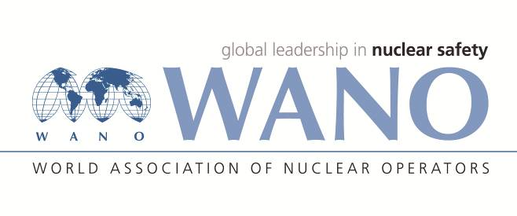 | World Association of Nuclear Operators  Moscow Centre  WANO – MC  25 Ferganskaya, Moscow, 109507, Russia  Phone. +7 495 376 15 87  Fax: +7 495 376 08 97  info@wanomc.ru

REQUEST
to provide technical and organisational information via WANO

- NPP/Organisation: Kudankulam NPP

- The topic of information request:
Main Turbine Condenser Vacuum extraction system

- The goal of information request: Getting relevant information from other member plants
- Problem description:
Presently KKNPP is having ejector system with power water as sea water for air evacuation from main condenser of turbine. Due to occasional sea water ingress into condenser, we are planning to replace the ejector air evacuation system to water seal ring type vacuum pump system. We would like to get following relevant information from other member plants in this regard.
- Specific questions:
      - Details of system used in Main Condenser Vacuum extraction system.
      - Complete lay out Operational Flow diagram of following systems.
        - Main condenser Air extraction system.
        - Condenser cooling water box Air extraction system.
        - Turbine gland sealing steam condenser Air extraction system.
      - Vacuum pump seal cooling system and source of cooling water (normal cooling or chilled water cooling)
      - Performance of Main Condenser Vacuum extraction system during start up and during normal operation (no. of vacuum pump unit operations with capacity).
      - Requirement/necessity of air flow measurement of air extraction system
6.Proposed organisations for sending this request:
WANO-MC
7.Department – request initiator:
Technical Services Group
8.Contact details of the requester:
Sanjeev Bhardwaj , +91-9489080628, sbhardwaj@npcil.co.in
9.Date of request: 07.08.2022

