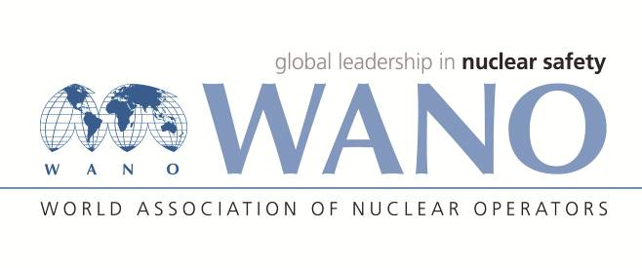 | World Association of Nuclear Operators  Moscow Centre  WANO – MC  25 Ferganskaya, Moscow, 109507, Russia  Phone. +7 495 376 15 87  Fax: +7 495 376 08 97  info@wanomc.ru

REQUEST
To provide technical and organizational information via WANO.
- NPP/Organization: Bushehr NPP Request Number -
- The topic of information request: design bases management activities in BNPP
- The goal of information request: investigation and the planning stage for the design bases management of BNPP
- The describing of problem: concerning the design bases management activities in BNPP we have been encountered a few problems through their detailed investigations for the design bases management of BNPP.
- Questions:
- What is the role and responsibility of operator in the design bases management?
- What is the role and responsibility of the technical support organization in the design bases management?
- What are the developed documents in the establishment of design bases management?
- What is the suggesting approach to investigate the sufficiency of the provided design bases in design documents of NPP?
- What is the suggesting approach to manage the design bases of structures and components when it comes to modernization and modification?
- What are the circumstances that dictate changes in design bases of NPP and what approaches are applied to implement these changes?
- Proposed organizations for sending this request: NPPs in (Hungary, Finland, Russian, Ukraine, Slovakia, China, Czech Republic, Bulgaria,),(WANO MC NPPs)
- Department – request initiator: Executive management TAVANA company
- Contact details of the requester: Hedayat Abbaspour, Executive Deputy TAVANA company at BNPP
- Date of request: 05.12.2018
Hamid Azarbad
Х. Азарбад
Представитель ВАО АЭС-МЦ на АЭС Бушер
WANO-MC OSR at BUSHEHR NPP
Phone: +98 773 111 2156
Fax: +98 773 111 2157
Сell: +98 917 351 6368
E-mail: azarbad@wanomc.ru

